Policy Number: | HS02 | Originator: | Kate Stradling
Issue Number: | 3 | Authoriser: | Mike Deacy
Issue Date: | 01/09/2023 | Service Type: | Health and Safety
Next Review Due: | 31/08/2024 | Policy Location: | Wessex Lodge School Policy File

1: Aim of the policy

It is the policy of Wessex Lodge School that there should be adequate and appropriate equipment, facilities and trained personnel to provide First Aid within Wessex Lodge School.

First Aid provision is available at all times while people are on the school premises and also off the premises whilst on school visits.

2: Policy

Wessex Lodge School exceeds the minimum first aid provision suggested in the DfES ‘Guidance on First Aid for Schools’.

The School provides suitably stocked first aid containers, kept in the following locations:

- Main Offices on both sites
- All vehicles
- Kitchen Areas both sites
- DT areas

These are located with a sign bearing a white cross on a green background.

At Wessex Lodge School there is a First Aider on each site daily to take charge when someone is injured or becomes ill. They will decide whether further medical treatment is advisable (e.g. hospital visit).

A designated First Aider on each site monitors the first aid containers and equipment, and is responsible for re-stocking on a regular basis.

All appointed persons have emergency first aid training. The Head Teacher carries the responsibility for informing the school community of the first aid arrangements. Details of who first aid personnel are, and where they are to be found, are displayed prominently as people walk into the school. Therefore, all visitors, staff and students are made aware of this information.

Staff take precautions to avoid infections and follow basic hygiene procedures. They have access to single-use disposable gloves and hand washing facilities, and take great care when dealing with blood or bodily fluids and disposing of pressings or equipment.

Wessex Lodge School has a procedure which records all accidents and provides for the reporting of fatal or serious accidents, injuries etc. to the Health & Safety Executive or RIDDOR.

The School records any first aid treatment given on site, and retains these records for inspection in the statutory accident recording system on Sleuth. Visitors to the school that have an accident would record this in the accident book, but make a note that they are a visitor. Emergency contact numbers and consent for medical treatment are obtained for all students. Parents, Carers and Guardians are informed of significant incidents immediately by telephone where possible, and followed up with the information in writing.

First Aid arrangements are the subject of regular and systematic checks.

3: Equality Impact Statement

All relevant persons are required to comply with this policy and must demonstrate sensitivity and competence in relation to diversity in race, faith, age, gender, disability and sexual orientation. If you, or any other groups, believe you are disadvantaged by this policy please contact the Regional Director. Acorn Education and Care will then actively respond to the enquiry.

This policy is written by Kate Stradling Date: 01/09/2023

Signed: Kate Stradling

This policy is quality assured by Mike Deacy, Regional Director.

Signed: 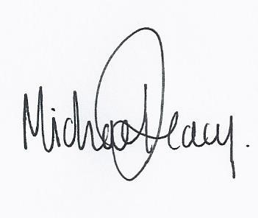
Date: 01/09/2023

