Policy Number: | SG09 | Originator: | Kate Stradling
Issue Number: | 3 | Authoriser: | Mike Deacy
Issue Date: | 01/09/2023 | Service Type: | Safeguarding
Next Review Due: | 31/08/2024 | Policy Location: | Wessex Lodge School Policy File

- Development, Monitoring and Review of this Policy
This On Line Safety policy has been developed by a working group made up of:
- School E-Safety Officer
- Headteacher / Senior Leadership Team
- Teachers / Tutors
- Enhanced Children’s Services IT Manager

Consultation with the whole school community has taken place through:
- School Council
- Staff meetings

- Scope of the Policy
The policy applies to all members of the school community (staff, pupils, volunteers, parents/carers, visitors and community users) who have access to and are users of the school ICT systems, both in and out of school. The Education and Inspections Act 2006 empowers Headteachers, to such extent as is reasonable, to regulate the behaviour of pupils when they are off the school site and empowers members of staff to impose disciplinary penalties for inappropriate behaviour. This is pertinent to incidents of cyber-bullying or other e-safety incidents covered by this policy, which may take place out of school, but is linked to membership of the school.

The school will deal with such incidents within this policy and associated behaviour and anti-bullying policies and will, where known, inform parents/carers of incidents of inappropriate e-safety behaviour that take place inside and outside of school.

- Context
We live in a digital age where technology is playing an ever increasing part in our lives; it is changing the way that we do things both inside and outside of school and although we recognise the benefits of technology we must also be aware of the potential risks and ensure that all staff, pupils and parents/carers associated with the school are able to use technology in a safe and responsible manner.

Some of the potential dangers of using technology may include:

- Access to illegal, harmful or inappropriate images or other content
- Unauthorised access to/loss of/sharing of personal information
- The risk of being subject to grooming by those with whom they make contact on the internet.
- The sharing/distribution of personal images without an individual’s consent or knowledge
- Inappropriate communication/contact with others, including strangers
- Cyber-bullying
- Access to unsuitable video/internet games
- An inability to evaluate the quality, accuracy and relevance of information on the internet
- Plagiarism and copyright infringement
- Illegal downloading of music or video files
- The potential for excessive use which may impact on the social and emotional development and learning of the young person.

Many of these risks reflect situations in the offline world but it is important that as a school we have a planned and coordinated approach to ensuring that all involved with the school use technology in a safe and responsible way. As with all risks it is impossible to eliminate them completely but with a planned and coordinated approach they can be significantly reduced and users can be taught to manage them effectively.

The policy applies to all members of the school community (staff, pupils, volunteers, parents/carers, visitors and community users) who have access to and are users of the school ICT systems, both in and out of school. The Education and Inspections Act 2006 empowers Headteachers, to such extent as is reasonable, to regulate the behaviour of pupils when they are off the school site and empowers members of staff to impose disciplinary penalties for inappropriate behaviour. This is pertinent to incidents of cyber-bullying or other e-safety incidents covered by this policy, which may take place out of school, but is linked to membership of the school.

The school will deal with such incidents within this policy and associated behaviour and anti-bullying policies and will, where known, inform parents/carers of incidents of inappropriate e-safety behaviour that take place inside and outside of school.

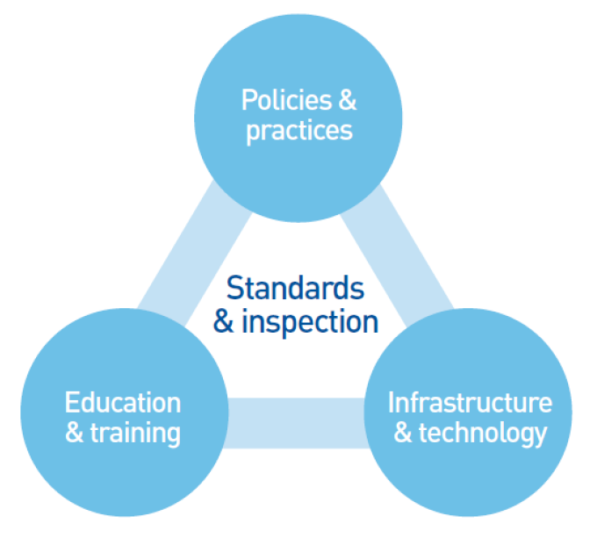

1) Policies and practices

The e-Safety policy outlines the importance of ICT within and outside of education. It provides guidance on the schools approach to E-Safety and details a code of conduct for school staff and pupils. The policy aims to provide an agreed, coordinated and consistent approach to E-safety. The code of conduct forms the basis of the schools expected behaviours regarding the use of technology and any infringements of the code of conduct will lead to disciplinary action against the perpetrator(s).

2) Infrastructure and technology

The school’s network infrastructure and access to the internet is provided OFG IT services. . The internet is filtered by ZEN network, sites are blocked or allowed depending on the category of site and can also be blocked/allowed individually.

All internet and network activity is logged and stored and can be retrieved if required in the event of an investigation. The infrastructure has been designed to minimise the risk of users accessing inappropriate material as well as providing protection against virus or malware threats.

The school is responsible for ensuring that the physical infrastructure/network is as safe and secure as is reasonably possible.

3) Education and training

As the use of technology and the potential risks associated with the use of the technology change rapidly, it is essential to ensure that the school community know how to use technology safely and responsibly. The school is committed to ensuring that staff receive regular training to keep up to date with new developments and ensure that they are sufficiently confident to educate pupils in the safe and responsible use of technology. The school have designed an E-safety curriculum that meets the needs of all pupils and ensure their safety and well-being. The curriculum is reviewed and revised on a regular basis to ensure that it remains current. The school will also endeavour to provide information and training opportunities for parents and carers to raise their awareness of the technologies that their children are potential using and the risks that they potentially face.

4) Standards and inspection

The school reviews its approach to On Line safety on a regular basis and uses the safe assessment tool to evaluate and improve its provision.

The school will ensure that all access to the internet and ICT systems by pupils is effectively managed and supervised.

Individual risk to students from social media and internet use is detailed in their Individual Risk Assessments and additional security actions detailed where necessary.

- Policy Statements
As part of the On Line safety policy the school will also manage:
- The use of digital images and video
- Data protection
- Digital communications
- Unsuitable/inappropriate activities
- Incidents of misuse

The use of digital images and video

The development of digital imaging technologies has created significant benefits to learning, allowing school staff and pupils instant use of images they have recorded themselves or downloaded from the internet. School staff and pupils are made aware of the potential risks associated with storing, sharing and posting images on the internet and must follow the good practice detailed below.

When using digital images, staff will inform and educate pupils about the risks associated with the taking, use, sharing, publication and distribution of images. In particular they will recognise the risks attached to publishing their own images on the internet e.g. on social networking sites.
- Staff are permitted to take digital images and video to support educational aims, but must follow school policies concerning the sharing, distribution and publication of those images. Those images should only be taken on school equipment; the personal equipment of staff should not be used for such purposes.
- Care will be taken when capturing digital images and video that pupils are appropriately dressed and are not participating in activities that might bring the individuals or the school into disrepute.
- Pupils must not take, use, share, publish or distribute images of others without their permission.
- Images and videos published on the school website, or elsewhere that include pupils will be selected carefully and will comply with good practice guidance on the use of such images.
- Pupils’ full names will not be used anywhere on a website or blog, particularly in association with photographs.
- Written permission from parents or carers will be obtained before photographs of pupils are published on the school website.
- Pupil’s work will only be published with the permission of the pupil and parents or carers.

Data Security and Protection

Personal data will be recorded, processed, transferred and made available according to the Data Protection Act 1998 which states that personal data must be:

- Fairly and lawfully processed
- Processed for limited purposes
- Adequate, relevant and not excessive
- Accurate
- Kept no longer than is necessary
- Processed in accordance with the data subject’s rights
- Secure
- Only transferred to others with adequate protection.

All school staff will ensure that:
- Care is taken to ensure the safe keeping of personal data, minimising the risk of its loss or misuse.
- Personal data is used or processed on only secure password protected computers and other devices and that these devices are properly “logged-off” at the end of any session in which they are using personal data.
- Data is transferred securely using encryption and secure password protected devices and email solutions.
- When personal data is stored on any portable computer system, USB stick or any other removable media:
  - the data must be encrypted and password protected
  - the device must be password protected (many memory sticks / cards and other mobile devices cannot be password protected)
  - the data must be securely deleted from the device, in line with school policy (below) once it has been transferred or its use is complete

Digital Communication

Digital communication is an area that is developing rapidly with new and emerging technologies, devices are becoming more mobile and information sharing/communication is becoming more sophisticated.

When using communication technologies the school ensures the following good practice:
- The official school email service is regarded as safe and secure and is monitored. Staff and pupils should therefore use only the school email service to communicate with others when in school, on school business or on school systems.

Users need to be aware that email communications may be monitored
- Users must immediately report the receipt of any email that makes them feel uncomfortable, is offensive, threatening or bullying in nature and must not respond to any such email.
- Any digital communication between staff, pupils or parents/carers (email, chat, etc) must be professional in tone and content. These communications may only take place on official (monitored) school systems. Personal email addresses, text messaging or public chat/social networking programmes must not be used for these communications.
- Students may be provided with individual school email addresses for educational use.
- Pupils will be taught about email safety issues, such as the risks attached to the use of personal details. They should also be taught strategies to deal with inappropriate emails and be reminded of the need to write emails clearly and correctly and not include any unsuitable or abusive material.
- Personal information will not be posted on the school website and only official email addresses should be used to identify members of staff.

Unsuitable/inappropriate activities

School ICT systems are only to be used for agreed, appropriate and suitable work related activities. Internet activity which is considered unsuitable or inappropriate will not be allowed and if discovered will lead to disciplinary action. Internet activity which is illegal will be reported and could lead to criminal prosecution.

Responding to incidents of misuse

It is hoped that all members of the school community will be responsible users of ICT, who understand and follow this policy. However, there may be times when infringements of the policy could take place accidently, through careless or irresponsible or, very rarely, through deliberate misuse.
In the event of an e-safety incident it is important that there is a considered, coordinated and consistent approach. Incidents will be managed using the incident flowchart below:

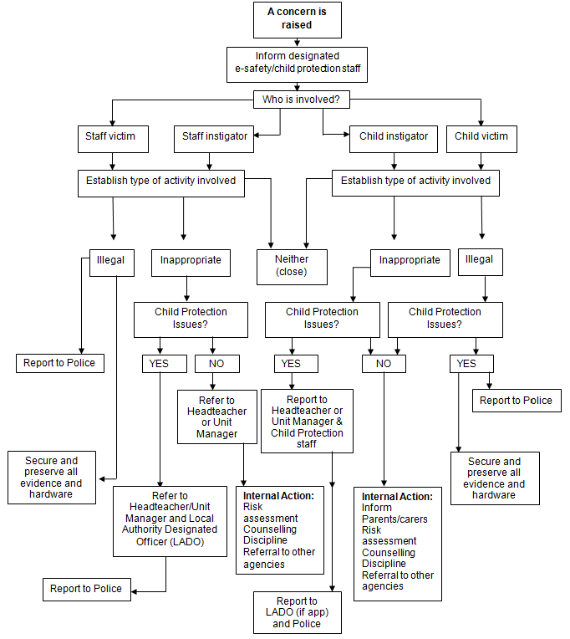

- Risk Assessment

It is important to support people with learning difficulties to access the internet for use in learning, employment, home, social and leisure contexts. However, we recognise that people with learning difficulties may be vulnerable online and we must do everything possible to ensure they are safe, and that they know what to do should a situation arise that they are unsure about.
Wessex Lodge School review ESAFETY Risk Assessment at least annually or as when as required.
Some of the Internet content is blocked for safety reasons. All items marked ‘X’ are blocked:

Academic Fraud
Adult Themes | X
Adware | X
Alcohol | X
Anime/Manga/Webcomic
Auctions
Automotive
Blogs
Business Services
Chat | X
Classifieds | X
Dating | X
Drugs | X
Ecommerce/Shopping
Educational Institutions
File Storage | X
Financial Institutions
Forums/Message boards | X
Gambling | X
Games
German Youth Protection
Government
Hate/Discrimination | X
Health and Fitness
Humour
Instant Messaging | X
Jobs/Employment
Lingerie/Bikini | X
Movies
Music
News/Media
Non-Profits
Nudity | X
P2P/File sharing | X
Parked Domains
Photo Sharing | X
Podcasts
Politics
Pornography | X
Portals
Proxy/Anonymizer | X
Radio
Religious
Research/Reference
Search Engines
Sexuality | X
Social Networking | X
Software/Technology
Sports
Tasteless | X
Television
Tobacco
Travel
URL Shortener
Video Sharing | X
Visual Search Engines | X
Weapons | X
Web Spam
Webmail

Pupils Acceptable Use Policy Agreement

New technologies have become integral to the lives of children and young people in today’s society, both within schools and in their lives outside school. The internet and other digital information and communications technologies are powerful tools, which open up new opportunities for everyone. These technologies can stimulate discussion, promote creativity and stimulate awareness of context to promote effective learning. Young people should have an entitlement to safe internet access at all times.

This Acceptable Use Policy is intended to ensure:
- that young people will be responsible users and stay safe while using the internet and other communications technologies for educational, personal and recreational use.
- that school ICT systems and users are protected from accidental or deliberate misuse that could put the security of the systems and users at risk.

The school will try to ensure that pupils will have good access to ICT to enhance their learning and will, in return, expect the pupils to agree to be responsible users.

Acceptable Use Policy Agreement

I understand that I must use school ICT systems in a responsible way, to ensure that there is no risk to my safety or to the safety and security of the ICT systems and other users.

For my own personal safety:
- I understand that the school will monitor my use of the ICT systems, email and other digital communications.
- I will treat my username and password like my toothbrush – I will not share it, nor will I try to use any other person’s username and password.
- I will be aware of “stranger danger”, when I am communicating on-line.
- I will not disclose or share personal information about myself or others when on-line.
- If I arrange to meet people off-line that I have communicated with on-line, I will do so in a public place and take an adult with me.
- I will immediately report any unpleasant or inappropriate material or messages or anything that makes me feel uncomfortable when I see it on-line.

I understand that everyone has equal rights to use technology as a resource and:
- I understand that the school ICT systems are primarily intended for educational use and that I will not use the systems for personal or recreational use unless I have permission to do so.
- I will not try (unless I have permission) to make large downloads or uploads that might take up internet capacity and prevent other users from being able to carry out their work.
- I will not use the school ICT systems for on-line gambling, internet shopping, file sharing, or video broadcasting (eg YouTube), unless I have permission of a member of staff to do so.
- I will not steal, disable or cause any damage to school equipment, or the equipment belonging to others.

I will act as I expect others to act toward me:

- I will respect others’ work and property and will not access, copy, remove or otherwise alter any other user’s files, without the owner’s knowledge and permission.
- I will be polite and responsible when I communicate with others, I will not use strong, aggressive or inappropriate language and I appreciate that others may have different opinions.
- I will not take or distribute images of anyone without their permission.

I recognise that the school has a responsibility to maintain the security and integrity of the technology it offers me and to ensure the smooth running of the school:

- I will only use my personal hand held/external devices (mobile phones / USB devices etc) in school if I have permission. I understand that, if I do use my own devices in school, I will follow the rules set out in this agreement, in the same way as if I was using school equipment.
- I understand the risks and will not try to upload, download or access any materials which are illegal or inappropriate or may cause harm or distress to others, nor will I try to use any programmes or software that might allow me to bypass the filtering / security systems in place to prevent access to such materials.
- I will immediately report any damage or faults involving equipment or software, however this may have happened.
- I will not open any attachments to emails, unless I know and trust the person/organisation who sent the email, due to the risk of the attachment containing viruses or other harmful programmes.
- I will not install or attempt to install programmes of any type on a machine, or store programmes on a computer, nor will I try to alter computer settings.
- I will only use chat and social networking sites with permission and at the times that are allowed

When using the internet for research or recreation, I recognise that:

- I should ensure that I have permission to use the original work of others in my own work
- Where work is protected by copyright, I will not try to download copies (including music and videos)
- When I am using the internet to find information, I should take care to check that the information that I access is accurate, as I understand that the work of others may not be truthful and may be a deliberate attempt to mislead me.

I understand that I am responsible for my actions, both in and out of school:

- I understand that the school also has the right to take action against me if I am involved in incidents of inappropriate behaviour, that are covered in this agreement, when I am out of school and where they involve my membership of the school community (examples would be cyber-bullying, use of images or personal information).

- I understand that if I fail to comply with this Acceptable Use Policy Agreement, I will be subject to disciplinary action. This may include loss of access to the school network/internet, detentions, suspensions, contact with parents and in the event of illegal activities involvement of the police.

Please complete the sections on the next page to show that you have read, understood and agree to the rules included in the Acceptable Use Agreement. If you do not sign and return this agreement, access will not be granted to school ICT systems.

Pupil Acceptable Use Agreement Form

This form relates to the Pupil Acceptable Use Policy (AUP), to which it is attached.
Please complete the sections below to show that you have read, understood and agree to the rules included in the Acceptable Use Agreement. If you do not sign and return this agreement, access will not be granted to school ICT systems.

- I have read and understand the above and agree to follow these guidelines when:
- I use the school ICT systems and equipment (both in and out of school)
- I use my own equipment in school (when allowed) eg mobile phones, tablets, cameras etc
- I use my own equipment out of school in a way that is related to me being a member of this school eg communicating with other members of the school, accessing school email, website etc.

Name of Pupil ________________________________________

Group/Class ________________________________________

Signed ________________________________________

Date ________________________________________

Staff/Volunteer Acceptable Use Policy Agreement

New technologies have become integral to the lives of children and young people in today’s society, both within schools and in their lives outside school. The internet and other digital information and communications technologies are powerful tools, which open up new opportunities for everyone. These technologies can stimulate discussion, promote creativity and stimulate awareness of context to promote effective learning. They also bring opportunities for staff to be more creative and productive in their work. All users should have an entitlement to safe internet access at all times.

This Acceptable Use Policy is intended to ensure:
- that staff and volunteers will be responsible users and stay safe while using the internet and other communications technologies for educational, personal and recreational use.
- that school ICT systems and users are protected from accidental or deliberate misuse that could put the security of the systems and users at risk.
- that staff are protected from potential risk in their use of ICT in their everyday work.

The school will try to ensure that staff and volunteers will have good access to ICT to enhance their work, to enhance learning opportunities for students / pupils learning and will, in return, expect staff and volunteers to agree to be responsible users.

Acceptable Use Policy Agreement
I understand that I must use school ICT systems in a responsible way, to ensure that there is no risk to my safety or to the safety and security of the ICT systems and other users. I recognise the value of the use of ICT for enhancing learning and will ensure that students / pupils receive opportunities to gain from the use of ICT. I will, where possible, educate the young people in my care in the safe use of ICT and embed e-safety in my work with young people.

For my professional and personal safety:
- I understand that the school will monitor my use of the ICT systems, email and other digital communications.
- I understand that the rules set out in this agreement also apply to use of school ICT systems (eg laptops, email, etc) out of school.
- I understand that the school ICT systems are primarily intended for educational use and that I will only use the systems for personal or recreational use within the policies and rules set down by the school.
- I will not disclose my username or password to anyone else, nor will I try to use any other person’s username and password.
- I will immediately report any illegal, inappropriate or harmful material or incident I become aware of, to the appropriate person.

I will be professional in my communications and actions when using school ICT systems:
- I will not access, copy, remove or otherwise alter any other user’s files, without their express permission.

- I will communicate with others in a professional manner, I will not use aggressive or inappropriate language and I appreciate that others may have different opinions.
- I will ensure that when I take and / or publish images of others I will do so with their permission and in accordance with the school’s policy on the use of digital / video images. I will not use my personal equipment to record these images, unless I have permission to do so. Where these images are published (eg on the school website) it will not be possible to identify by full name, or other personal information, those who are featured.
- I will only use chat and social networking sites in school in accordance with the school’s policies.
- I will only communicate with students/pupils and parents/carers using official school systems. Any such communication will be professional in tone and manner
- I will not engage in any on-line activity that may compromise my professional responsibilities.

The school have the responsibility to provide safe and secure access to technologies and ensure the smooth running of the school:
- When I use my personal hand held/external devices (laptops/mobile phones/USB devices etc) in school, I will follow the rules set out in this agreement, in the same way as if I was using school equipment. I will also follow any additional rules set by the school about such use. I will ensure that any such devices are protected by up to date anti-virus software and are free from viruses.
- I will not use personal email addresses on the school ICT systems.
- I will not open any attachments to emails, unless the source is known and trusted, due to the risk of the attachment containing viruses or other harmful programmes.
- I will ensure that my data is regularly backed up, in accordance with relevant school policies.
- I will not try to upload, download or access any materials which are illegal (child sexual abuse images, criminally racist material, adult pornography covered by the Obscene Publications Act) or inappropriate or may cause harm or distress to others. I will not try to use any programmes or software that might allow me to bypass the filtering / security systems in place to prevent access to such materials.
- I will not try (unless I have permission) to make large downloads or uploads that might take up internet capacity and prevent other users from being able to carry out their work.
- I will not install or attempt to install programmes of any type on a machine, or store programmes on a computer, nor will I try to alter computer settings, unless this is allowed in school policies.
- I will not disable or cause any damage to school equipment, or the equipment belonging to others.
- I understand that data protection policy requires that any staff or pupil data to which I have access, will be kept private and confidential, except when it is deemed necessary that I am required by law or by school policy to disclose such information to an appropriate authority.
- I will immediately report any damage or faults involving equipment or software, however this may have happened.

When using the internet in my professional capacity or for school sanctioned personal use:
- I will ensure that I have permission to use the original work of others in my own work
- Where work is protected by copyright, I will not download or distribute copies (including music and videos).

I understand that I am responsible for my actions in and out of school:
- I understand that this Acceptable Use Policy applies not only to my work and use of school ICT equipment in school, but also applies to my use of school ICT systems and equipment out of school and my use of personal equipment in school or in situations related to my employment by the school.
- I understand that if I fail to comply with this Acceptable Use Policy Agreement, I could be subject to disciplinary action. This could include a warning, a suspension, referral to Governors and in the event of illegal activities the involvement of the police.

I have read and understand the above and agree to use the school ICT systems (both in and out of school) and my own devices (in school and when carrying out communications related to the school) within these guidelines.

Staff/Volunteer Name ________________________________________

Signed ________________________________________

Date ________________________________________

Parent/Carer Acceptable Use Policy Agreement

New technologies have become integral to the lives of children and young people in today’s society, both within schools and in their lives outside school. The internet and other digital information and communications technologies are powerful tools, which open up new opportunities for everyone. These technologies can stimulate discussion, promote creativity and stimulate awareness of context to promote effective learning. Young people should have an entitlement to safe internet access at all times.

This Acceptable Use Policy is intended to ensure:
- that young people will be responsible users and stay safe while using the internet and other communications technologies for educational, personal and recreational use.
- that school ICT systems and users are protected from accidental or deliberate misuse that could put the security of the systems and users at risk.
- that parents and carers are aware of the importance of E-safety and are involved in the education and guidance of young people with regard to their on-line behaviour.

The school will try to ensure that pupils will have good access to ICT to enhance their learning and will, in return, expect the pupils to agree to be responsible users. A copy of the Pupil Acceptable Use Policy is attached to this permission form, so that parents/carers will be aware of the school expectations of the young people in their care.

Parents are requested to sign the permission form below to show their support of the school in this important aspect of the school’s work.

Permission Form

Parent/Carers Name ________________________________________

Pupil Name ________________________________________

As the parent/carer of the above pupil(s), I give permission for my son/daughter to have access to the internet and to ICT systems at school.

I know that my son/daughter has signed an Acceptable Use Agreement and has received, or will receive, E-safety education to help them understand the importance of safe use of ICT – both in and out of school.

I understand that the school will take every reasonable precaution, including monitoring and filtering systems, to ensure that young people will be safe when they use the internet and ICT systems. I also understand that the school cannot ultimately be held responsible for the nature and content of materials accessed on the internet and using mobile technologies.

I understand that my son’s / daughter’s activity on the ICT systems will be monitored and that the school will contact me if they have concerns about any possible breaches of the Acceptable Use Policy.

I will encourage my child to adopt safe use of the internet and digital technologies at home and will inform the school if I have concerns over my child’s E-safety.

Signed ________________________________________

Date ________________________________________

5. Equality Impact Statement

All relevant persons are required to comply with this policy and must demonstrate sensitivity and competence in relation to diversity in race, faith, age, gender, disability and sexual orientation. If you, or any other groups, believe you are disadvantaged by this policy please contact the Regional Director. Acorn Education and Care will then actively respond to the enquiry.

This policy is written by Kate Stradling Date: 01/09/2023

Signed: Kate Stradling

This policy is quality assured by Mike Deacy, Regional Director.

Signed: 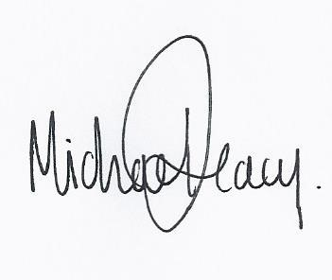
Date: 01/09/2023

