Policy Number: | SS06 | Originator: | Kate Stradling
Issue Number: | 3 | Authoriser: | Mike Deacy
Issue Date: | 01/09/2023 | Service Type: | Student Support
Next Review Due: | 31/08/2024 | Policy Location: | Wessex Lodge School Policy File

1. Overview:
The Pupil Premium is additional funding given to publicly funded schools in England to raise the attainment of disadvantaged pupils and close the gap between them and their peers.

It is paid to schools according to the number of pupils who have been:
• Registered as eligible for free school meals at any point in the last 6 years
• Been in care for 6 months or longer
• One of their parents is serving in the regular armed forces
• One of their parents served in the regular armed forces in the last 3 years
• One of their parents died while serving in the armed forces and the pupil is in receipt of a pension under the Armed Forces Compensation Scheme (AFCS) and the War Pensions Scheme (WPS)

2. Objectives for use of pupil premium in Wessex Lodge school:
• The Pupil Premium will be used to provide additional educational support to improve the progress and to raise the standard of achievement for these pupils.

• The funding will be used to narrow and close the gap between the achievement of these pupils and their peers.

• As far as its powers allow the school will use the additional funding to address any underlying inequalities between children eligible for Pupil Premium and others.

• We will ensure that the additional funding reaches the pupils who need it most and that it makes a significant impact on their education and lives. Wessex Lodge school has produced its policy on Pupil Premium and will provide annual updates.

3. Strategy for using the funding:
The school identified number of activities/interventions that could be used for those pupils receiving Pupil Premium funding during 2022/23:

- Ingredients for Home Cooking Skills
- Materials and Resources for Art lessons
- Clothing for ODE (Horticulture, Construction, Bike Maintenance, Forest School)
- Materials, supplies and equipment for ODE
- PC software (Acid Music 10) and ipad apps for Literacy and Numeracy skills
- Laptops
- Hiring of sports venues
- Field trips
- Good behaviour and engagement in lessons incentives
- Horse Riding
- English development programmes for low achievers: reader pen, reading and comprehension programmes, reading programmes, Toe by Toe, individual reading books
- Maths development programmes for low achievers: Power of 2, power of 2 time, power of 2 times tables
- Resources, supplies, material for individual projects
- Resources and materials to assist anger management and emotional regulation
- External professionals: Speech and Language Therapists, Educational Psychologists
- Transportation
- Additional study guides for home use
- Music Equipment
- P.E Equipment

4. Equality Impact Statement
All relevant persons are required to comply with this policy and must demonstrate sensitivity and competence in relation to diversity in race, faith, age, gender, disability and sexual orientation. If you, or any other groups, believe you are disadvantaged by this policy please contact the Regional Director . Acorn Education and Care will then actively respond to the enquiry.

This policy is written by Kate Stradling Date: 01/09/2023

Signed: Kate Stradling

This policy is quality assured by Mike Deacy, Regional Director.

Signed: 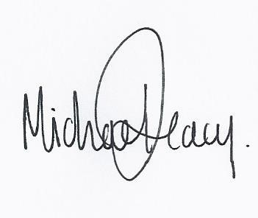
Date: 01/09/2023

