Wessex Lodge School Curriculum Policy

Policy Number: | C01 | Originator: | Kate Stradling
Issue Number: | 4 | Authoriser: | Mike Deacy
Issue Date: | 01/09/2023 | Service Type: | Curriculum
Next Review Due: | 31/08/2024 | Policy Location: | Wessex Lodge School Policy File

- Aim of the policy
This document aims to outline Wessex Lodge School’s Policy for the Curriculum.

SCHOOL ETHOS:

- An individualised curriculum for all students
- A bespoke timetable that meets individual needs
- Specific measured starting points
- Improve life outcomes

- Policy

  - Curriculum Statement Wessex Lodge School

Wessex Lodge School is registered by the DfE to provide education for students between the ages of 8-18. Our curriculum covers Key Stages 2, 3, 4 and 5.

Introduction
Everything we do at Wessex Lodge School is focused on an individualised experience for our students to support and improve their future lives. For this reason, we hold ‘an individualised education to improve life outcomes’ at the core of our practice and our interactions with our students.
We have a unique opportunity at Wessex Lodge School that is provided by our students, our environment, and our staff, to provide a bespoke experience to each of our students. Using our farm site and incorporating both primary and secondary models in a ‘stage not age’ approach allows our students to have an individualised and adaptive education delivery that fits them and enables them to make progress both academically and within SEMH.
For our cohort SEMH is at least as much an area of progress as is academic knowledge and skills. For this reason, our staff and curriculum take this into account in their planning and delivery, ensuring that all students are given an environment in which to succeed. This may involve teaching outside of the classroom, sectioning tasks over several lessons, chunking learning between low stakes tasks, or many others. This is what makes teaching and learning so individual and different at Wessex Lodge School and is what helps our students to succeed.
The future success of our students is at the heart of everything we do and the dedication of our staff enables us to have a comprehensive understanding of how this looks for each and every child.

Intention
Our cohort of students are with us as they haven’t accessed education in a mainstream setting, or the expectations associated with one. The structure of a mainstream primary or secondary setting and the timetable that students have whilst in one hasn’t been successful for our students and this is considered at every level of the teaching and learning at our school. We engage with the National Curriculum as the baseline for the skills and knowledge students require to advance in their school career and develop the knowledge to access life beyond their school. The National Curriculum is however, an advisory document and we have a group of subject specialists who adapt and alter this to suit the needs of their students.
In addition, there is an individualised approach to which students access the subjects and content we offer. Students are given work at an academic level that matches the stage they are at, rather than their age. For a subject like Science this is based on their Maths and English attainment as well as their ‘gaps’ in knowledge from their time missed in education. For other subjects the decision of their stage relies on their skills. For instance, if a student has a reading age this is markedly below their chronological age, they may have additional English lessons.
Interest and engagement are also considered in terms of students’ non-core learning. Taking into account out environment some students are given additional time on the farm, working with specialists and gaining knowledge with the possibilities for qualifications that will be relevant to their futures. For other students this may be Home Cooking Skills, or Art. We give students opportunities to discover their likes and dislikes then use this to create a timetable that will directly benefit them.

Implementation
Subjects
We are increasing and enhancing what we offer at Wessex Lodge School all the time. We now have a wide range of subjects to suit the needs and wants of our learners. This is a crucial part of getting our students engaged in their learning and the combination of academic, vocational, enrichment, and therapeutic sessions on their timetable is a core part of what we do. Below is a list of our subjects with a brief overview of how they are taught and the benefits they have to the wellbeing and progress of our students.
Art
Enrichment Medium Term Plans are provided to classes across all sites by the Art subject lead. The subject lead teaches some students at a KS4 level who are engaged and making good progress, and will finish their time with us gaining added qualifications.
ASDAN
ASDAN creates cross curricular between many different subjects and uses a project based approach to support student’s progress in their academic skills. It also enhances student’s real world experiences and their ability to engage in the world around them independently.
Drama
This is being taught alongside English by one of our English specialists. We are currently teaching Drama as an Enrichment opportunity for those students who it will benefit. There are, however, conversations happening about the introduction of LAMDA awards over the next few years.
DT
This is a new subject at Wessex Lodge School and our DT teacher is focusing on introducing this subject across the school and increasing engagement. Over the course of the next term those students who could benefit from more focused teaching in this area will be identified.
English
This is a subject that is taught consistently across the Orchard, Ark, and Farm. The subject lead creates centralised Medium Term Plans that teachers adapt specifically for their classes. These MTPs are organised by key stage rather than year to create more opportunities for the mixed ability classes our schools have. The curriculum is informed by the National Curriculum, however the speed of working and processing for our students is taken into account with the amount of content being delivered.
Equine
This subject has developed dramatically over the course of the last year and we have several students who are interested in pursuing this further. Those students have been identified and there has been the introduction of theory to the curriculum and teaching.

Farm
Whilst this was an enrichment subject last year some students have been identified who would benefit from learning the theory behind farm management. We are incorporating this into the curriculum and this will continue to be an area of development. Students are able to work on certified AQAs and other qualifications within this subject area.

Forest School
An enrichment activity, Forest School is taught by trained members of staff who support the engagement of students in the world around them. The lessons focus on embedding skills in students and building their confidence to become more independent.

HCS
All students across the school engage in a series of cooking skills that will support independence and safe food preparation later in life. In addition to this theory is integrated into the HCS curriculum to support healthy choices for our students.

Humanities
Throughout the course of the academic year students will cover Geography, History, and Religious Education. Medium Term Plans are prepared centrally by the Humanities subject lead and are then differentiated by classroom teachers.

Maths
White Rose Maths is used across the school from KS1 up to KS4. The Maths subject lead guides teachers to teach at the appropriate level for their class based on Maths levels. Medium Term Plans are provided to classes which support teachers in adapting their teaching alongside the White Rose Maths resources.

Outdoor Education
Taught in full day sessions, Outdoor Education covers a wide range of cross curricular skills. In addition to being highly active, the sessions and courses also support planning, literacy, numeracy, and many other skills as well.

P.E
Since the installation of our new gym equipment the engagement and active participation in P.E lessons has had a marked improvement. The P.E subject lead provides a wide range of foci throughout the year. A part of the P.E curriculum action plan is to increase engagement so that all students have a dedicated P.E lesson every week. However, alongside this there are also opportunities for physical education around the site and in other lessons.

PSHE
PSHE is taught using Jigsaw, which we are a flagship school for. Unlike our other subjects PSHE is taught in specific age groups so that students are receiving the correct information and knowledge for their chronological age. This is taught by all teachers across the school, supervised by the PSHE subject lead.

Reparative Thrive
Thrive itself is embedded across the school in everything we do. However, there are also designated thrive sessions in the timetable for students to have one-to-one sessions with their designated Thrive practitioners. These are kept as consistent as possible to ensure that students are able to make good
SEMH progress.

Science
Using White Rose Science all primary students engage in a range of topics chosen by the Science subject lead. These are then differentiated and taught by the class teachers. The Science subject lead uses a discovery program for KS3 students and at KS4 students who are capable and engaged are taught the KS4 curriculum.

Environment
The location of our school has a huge influence on our curriculum, both in what we deliver and how we deliver it. Certain subjects we deliver, such as Equine and Farm, are specific to our Newmead Farm site and this incredible resource is used by students across all sites. These subjects create the opportunity for those students who haven’t succeeded in the more academic focused setting of mainstream education to learn and make progress, whilst also encouraging students to consider a wider range of future careers and job opportunities.
The environment of the farm also influences how we teach our academic subjects. We are able to use the outdoor space to create wider engagement around Maths, English, Science, and others. Some examples of this are subject specific, such as using spaces around the farm for creative writing stimuli or going into our allotment area to look at the minibeasts and habitats. In addition to this, there are a die range of teaching spaces around the farm. Whilst there are traditional classrooms there are also outdoor spaces in barns, wooded areas, fields, and others that staff use to teach their students and encourage engagement.
The environment of our primary focused Ark site has also got many benefits. The smaller space creates an environment of safety for students. For those students who have found a mainstream environment overwhelming it is a space that is secure, safe, and easy to navigate. The classrooms in the Ark are based on a primary model and so students are able to take ownership of their space. This includes decorating it with pictures of what they enjoy, but also teaching students lesson about keeping their space clean and tidy. All of this support students in making good progress academically and for them engage in a wider variety of subjects across the curriculum.

Impact
Assessment
We use the Renaissance Place product STAR Assessment to track progress and attainment in students’ Literacy and Numeracy. Every term there is a two-week assessment block where all students will complete their STAR Assessments. All students will complete the Maths assessment and either the Reading or Early Literacy Assessment depending on their reading levels.
Not only do these tests assess the levels of students, but they also create targets to support teachers in focused planning. After each assessment staff will download the targeted planning sheet and use this to support them in their teaching for the next term. This information means that the Medium-Term Plans provided by the Subject Leads are differentiated and targeted to support our intention of ‘an individualised curriculum to improve life outcomes’.
Evidence for Learning allows us to evidence, assess, review and plan for meeting the unique needs of all of our learners. Evidence for Learning supports an Inquiry-based approach to education and provision, that allows all stakeholders in a young person’s learning and development to gather photo and video evidence quickly and easily, linked to the individual’s profound curriculum. EFL also supports any assessment framework and any assessment model – including evidencing and tracking progress against individual learning intentions and targets related to EHCPs. EFL has transformed how parents/carers and the learner themselves are engaged and involved in the entire learning process and journey. Not only can photos, videos and notes be easily and securely shared by the school, but parents/carers can capture and submit their own photos, videos and notes to reflect the learner’s development and experiences at home and outside in the community. Each subject has their own internal assessments throughout the academic year. These are based on a combination of skills and knowledge with each subject deciding on the most effective assessment format. For example, in Science students will complete end of term quizzes to check knowledge, whereas in Humanities knowledge organisers are used. These enable our subject specialists to gauge the progress and development of the students to inform future planning.

Monitoring
SLT complete learning walks regularly, with an aim of seeing every teacher once a half term. These learning walks are informal drop ins and are no longer than 15 minutes long. The member of SLT who is completing the learning walk will be looking for evidence of the focus for that term, in addition to the engagement and opportunities for progress in lessons. Once the learning walk is complete then the teacher will sit down with whoever completed the learning walk where there will be feedback given. This feedback is done in a discursive manner, led by questioning and discussion about the lesson, rather than a top-down approach.
In addition to learning walks supporting monitoring of teaching and engagement, they are also used in the departmental deep dives. Each half term two or three subjects are chosen to have a deep dive from the Heads of Education. By having an in depth look at each subject over the course of the year the Subject Leads have a clear idea of their subject and how it is being taught across the school. They inform the curriculum action plans for different departments and identify where additional support may be needed for teachers and Subject Leads. These deep dives focus on four different aspects.

Teaching
This looks at how each lesson in the subject is being taught across the school. Learning walks will be done on the Subject Lead, but also on staff who are teaching the subject across the rest of the school. The subject knowledge of staff will be assessed as well as how prepared each teacher is to deliver the lesson. This will include the differentiation of resources, the questioning of students, and the accuracy of knowledge.

Learning
Over the course of the deep dive week for each subject we will take examples of work from the Ark, the Orchard, and the Farm. The focus will be on the work that has been completed, the feedback given, and the progress made throughout the Medium-Term Plans. Whilst it should be clear that the ‘Intention’ of each lesson as set by the Subject Lead should be met it is up to the teacher how to complete the ‘Implementation’ part of each lesson to ensure that the needs of individual students should be met within each class.

Progress tracking
For each subject there is an expectation that some record of progress made is kept by the Subject Lead. This enables staff to adjust their planning and develop resources that target misconceptions and areas that need development. During a deep dive the Heads of Education will ask Subject Leads for their data tracking. This is not evaluated on how much data has been collected but instead on the access that staff have, the consistency of data collection, and the range of students that are included.
Staff and Student voice
Whilst each subject has a Subject Lead there may be staff across the school who deliver this subject to students. For this reason, all staff will be asked to give comments on how they feel this subject is taught across the school. In addition, students will also be asked about their experiences with the subject, focusing on their feelings of achievement and how they are supported rather than their enjoyment of the subject.

Reporting
Each week both Heads of Education have one to one sit downs with the headteachers where they discuss any actions that are required for the following week. This can include staff who need additional support or a review of a piece of planning that is required. By meeting each week there is a consistent development of education across the school and the curriculum remains a priority.
These meetings are further supported through weekly SLT meetings where an update to SLT from the Heads of Education is given. This is the opportunity for the team to contribute opinions and ideas of the development of Education and how the curriculum will continue its progress.
These meetings and work accumulate in written form once a term for the Governor’s Report. Alongside the other aspects of the school an in-depth report is given on the progress made with the curriculum and the impact it is having on the students and staff. Throughout this process, students are provided with a high level of therapeutic support and a consistently broad, rich range of learning experiences. Students may temporarily move between pathways within a lesson or the day as their states of regulation and needs change.Our personalised learning programmes provide students with a relevant learning journey which progresses towards clearly defined aims and outcomes. This is a nationally recognised framework for learning programmes aimed at students who are working predominately towards Entry Level, Level 1 and Level 2. Thus, we work alongside our learners to identify personal progression pathways and create a programme that consists of initial engagement closely linked to their pathway, Vocational learning, Personal and Social Development and Functional Skills (English, Maths and Science). Throughout these programmes, students receive ongoing support, advice and guidance. In line with national expectations, our learning programmes work to enable students to progress towards relevant and realistic outcomes;
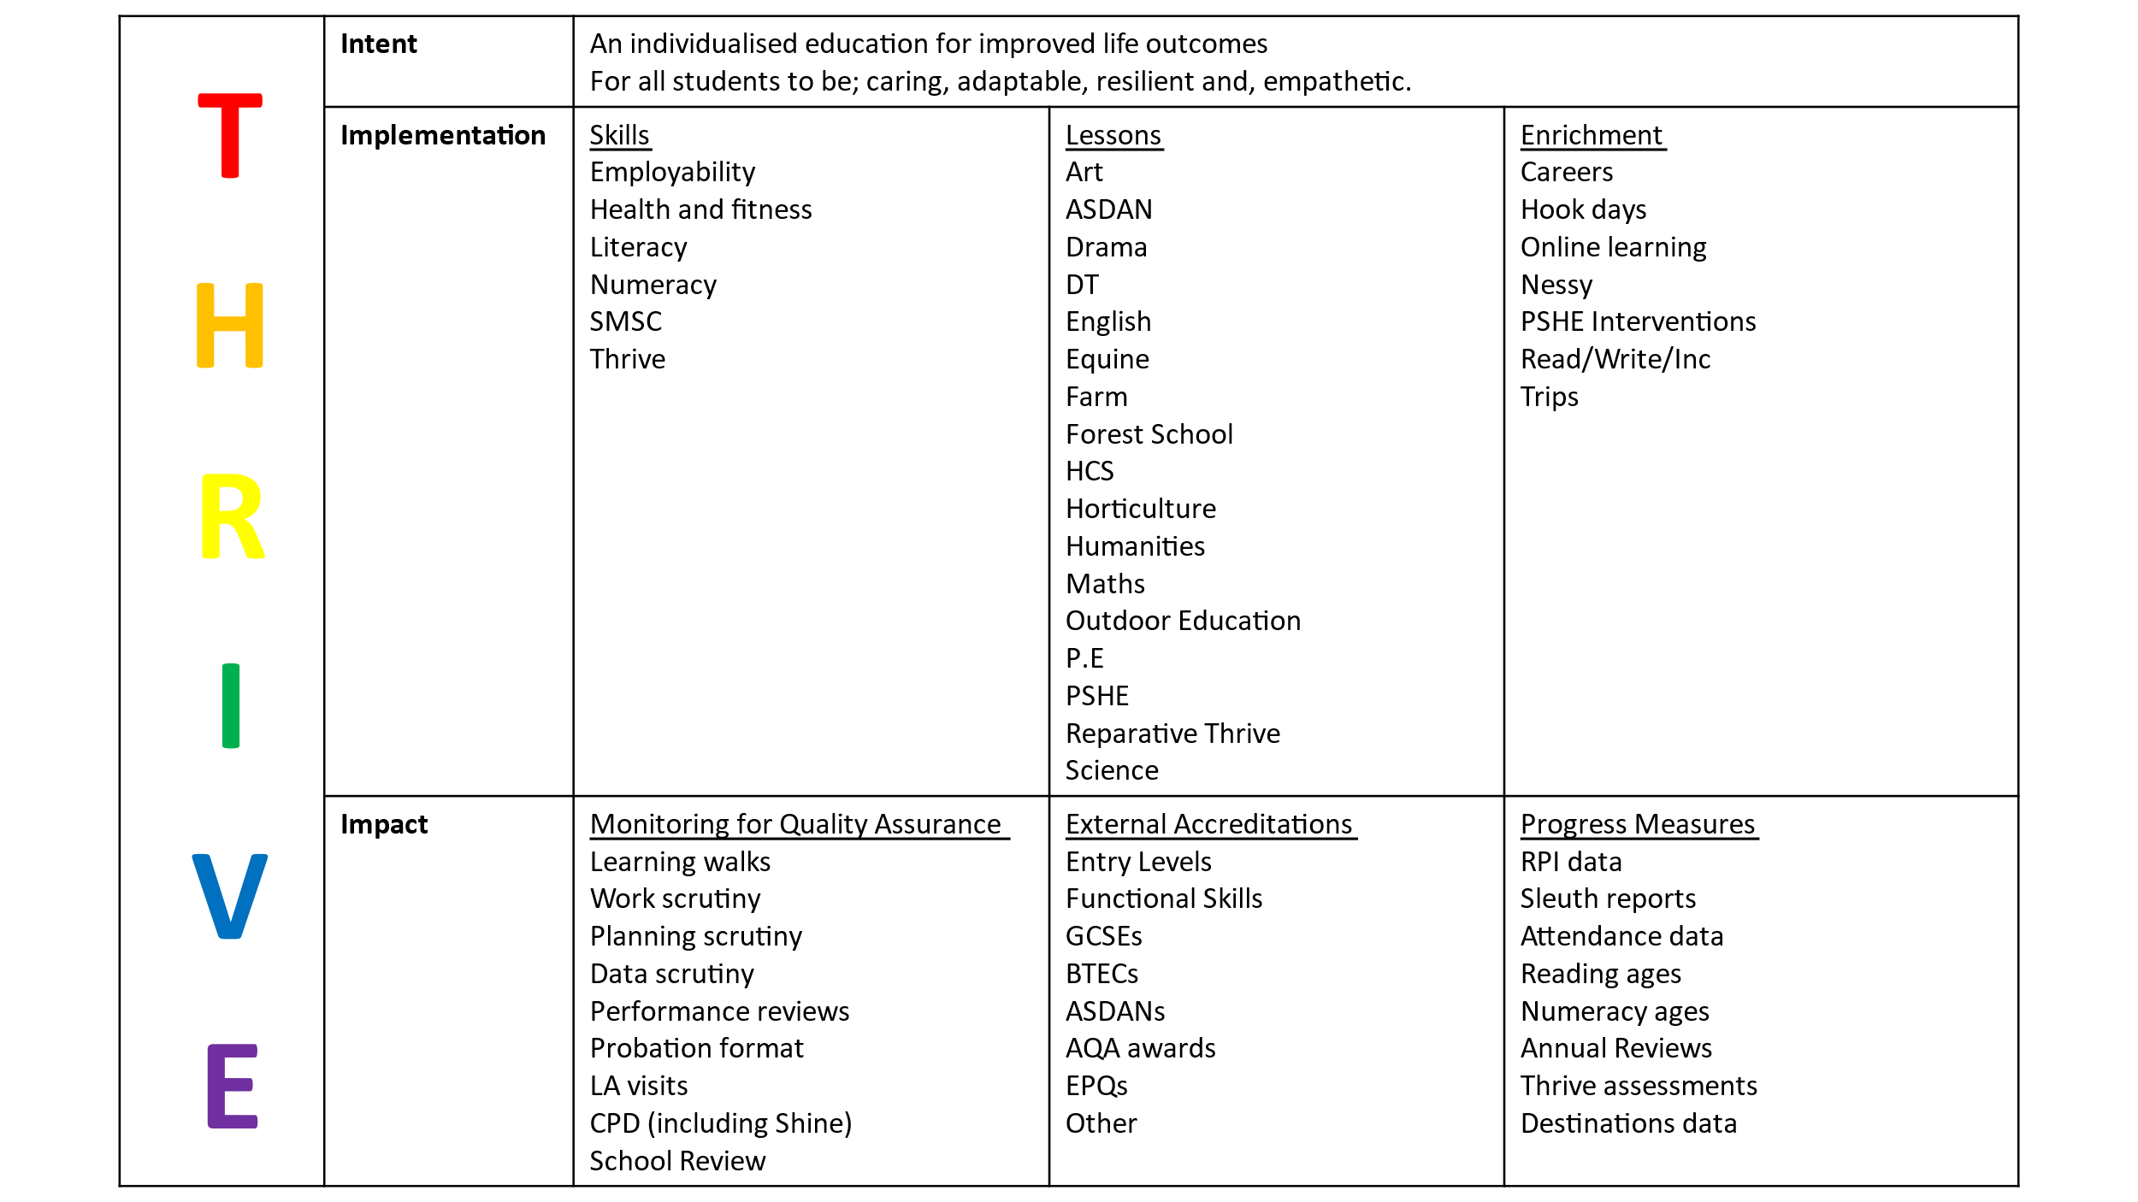

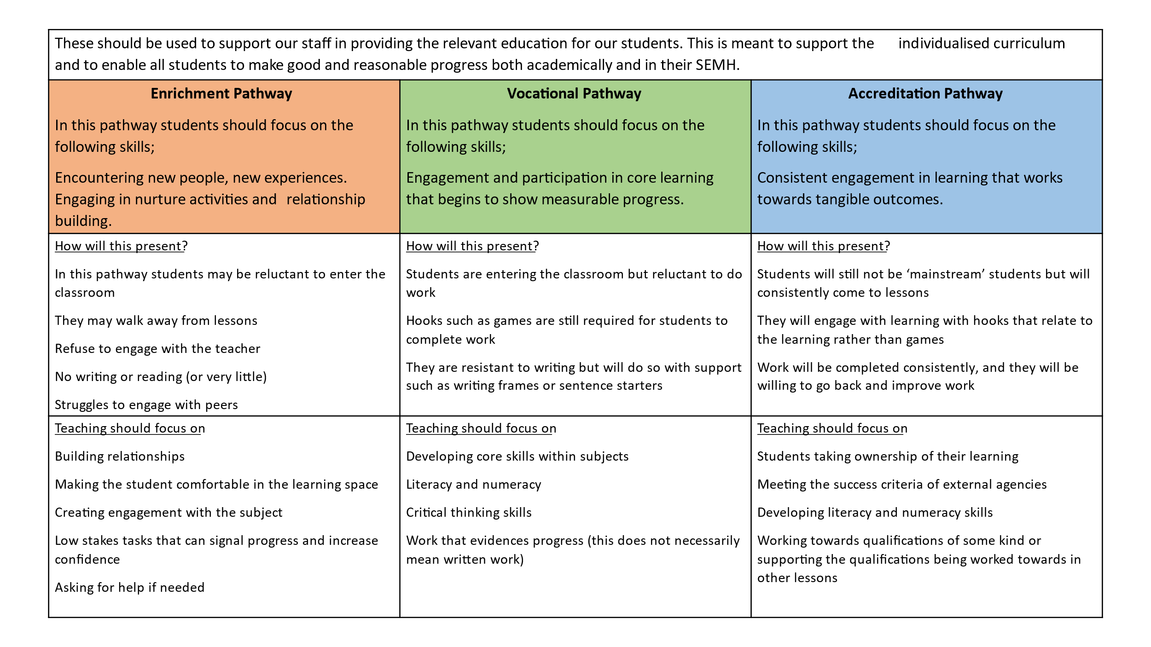

We wholeheartedly believe that our curriculum actively promotes personalised learning and holistically prepares students to experience success and achievement every day, whilst developing the life skills required for a safe, healthy and aspirational independent future.

Equality Impact Statement
All relevant persons are required to comply with this policy and must demonstrate sensitivity and competence in relation to diversity in race, faith, age, gender, disability and sexual orientation. If you, or any other groups, believe you are disadvantaged by this policy please contact the Regional Director for Acorn Education and Care. Outcomes First Group will then actively respond to the enquiry.

This policy is written by Kate Stradling, Principal

Signed: Kate Stradling

Date: 01/09/2023
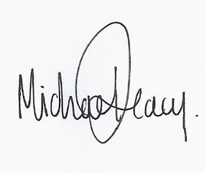
This policy is quality assured by Mike Deacy, Regional Director. Signed:
Date: 01/09/2023

