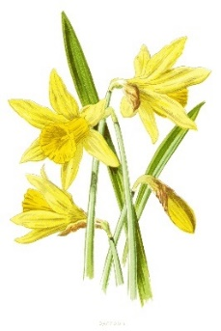

Spring 2023 Newsletter

As we approach the end of spring term I reflect and celebrate on an incredibly busy and successful term. We have invited external visitors into our school for World Book Day, Careers Day and PSHE intervention workshops. It’s always valuable for our students to have external input and enrichment experiences that increase their social and emotional skills.
We continue to welcome new students into our school to join our successful, broad curriculum allowing them to improve and increase their life outcomes, like our existing students already on roll. I am always incredibly proud of our hard-working, passionate staff who care so much about our students and their progress.

This term we have undertaken our first English trip to the Globe in London, which was a huge success, and we have many more trips in the upcoming terms.
Our school continues to develop the outside and inside environments on both sites for the benefits of our students: this includes the Horticulture area, the Farm, and a PE/gymnasium which will soon to be ready to use. We have had significant investment with a purpose-built kitchen to deliver home cooking skills qualifications for all our students to access.

We continue to welcome new staff to further promote our strong curriculum offer and we are very proud of our staff survey results which demonstrate that our school and the wider Outcomes First Group is a great place to work.

Adding to our drive for staff wellbeing is our 4 Day week project. This is an OFG companywide initiative which has been very successful in increasing staff productivity and wellbeing. It’s very exciting as a school leader to be part of such an innovative initiative that we hope will enhance the 5 day week program for students.

I want to take this time to wish all you a wonderful and peaceful Easter break, and we look forward to welcoming everyone back on Monday the 17th April for Summer Term.

Kate Stradling

Principal Wessex Lodge School

Newmead News
This has been another busy term as we continue to grow and develop the site. Alongside some significant efforts from the Gardeners who have made the site look incredible we have seen huge changes on the farm.
The animals continue to give us all a great sense of pleasure and relaxation even when they do occasionally decide their pen or field is no longer where they want to be. We regularly see students leading ponies across the site, goats up the drive and we have even had rabbits out on the lead going for a walk! As well as the ‘regulars’ we have recently welcomed new lambs who are busy playing in their barn before heading out into the fields in time for Easter, Spring is on the way!
The horticulture area is blossoming. The veg beds are prepped and ready indeed I was shown the newly planted cabbages recently alongside the variety of plants presently under cover of the greenhouse. There has also been great work in the sensory garden where there has been a huge effort to be ready for spring. The horticulture area and the areas outside the Thrive room are now ready for planting.
The products of these gardens will soon be able to be used as ingredients in the new teaching kitchen which opened at half term. All students now can learn to cook in this incredible facility which will I am sure prove to be money well spent and turn our young people into competent cooks and who knows future Master chefs!
As we all know we must eat and exercise in a balanced lifestyle. This year the PE department has grown in strength with PE on timetable 4 days a week. As we develop this aspect of our school, we will be adding a gym rig area to the site. This is due to be installed in the next few weeks and will be ready for the students to use during the summer. We are continually looking to expand the physical site so that we can offer a wide range of activities, it is now a common site to see students playing badminton and table tennis at break at lunch alongside some great games of football.
Thrive continues to underpin all that we do. We have created an extra Thrive room as well as a new sensory room on site. In order to support this work, we have trained up two new practitioners who are already supporting the delivery of Thrive across the site.
On behalf of all the staff on the farm site we wish you a Happy Easter and look forward to seeing you in the summer

Ben Coombes
Deputy Head Teacher – Newmead Farm

Ark News

The students have had an amazing half term, culminating in their trip to London to watch ‘The Tempest’ at the Globe Theatre. Those that didn’t go had a great day at school and had fun with a game of dodgeball in the park. The trip was a resounding success, and we must all thank Beth V. for organising and planning it so well. This has laid the foundations for more rewarding trips to other sites and facilities in the future.

The students have continued to play on the climbing jungle and the swing is as always, a firm favourite but we have ideas to further improve the site facilities over the coming year. The riding, swimming and Hydro have continued to be a resounding success and we have booked these sessions to continue for the foreseeable future.

We have a new hot food kitchen on site, and it is now set to be opened and delivering hot food to the students from the first day of next term, we are excited about this opportunity and are looking forward to hot food such as Roast Lamb and Gammon and Pineapple and other items on a 2week rota.

I would like to welcome Harriet C. as a new Education Support Worker here at the Ark, and Charlotte S. is our receptionist to support Caroline and Danielle. We would like to wish every success to Chloe as she moves to a new role in a different school.

WOLT has been such an amazing success this term we have booked it again and this time for the whole of the Summer term. The first half they will be completing tasks such as Orientation, Jacobs Ladder, Climbing Tower, Car skittles and stand up paddle boarding. Everyone really enjoyed their time with WOLT last term and we hope it continues, as they do such amazing work with the students.

All of our students have been amazing all term. They have all worked hard on their classwork and the football skills. I would like to single out VF, because he has taken on ambitious project to build a pond, with fish and other animals in it. He is taking a huge involvement in the project, and has budgeted for the whole thing including pond, work, numbers of fish etc.

Phil Redding
Site lead

It is our pleasure to introduce new roles within Wessex Lodge…

Caroline Stedman – School Business Manager
I started at Wessex Lodge School in 2019 as a Senior Administrator and feel proud to have now moved into the School Business Manager position. Alongside a fantastic admin team of Dani and Charlotte, we will continue to support students, staff, parents and the school, to continue to grow and develop further. The Business and Administration team are an integral part of the school and I have full confidence we will ensure the smooth running of this area whilst keeping students, staff, carers and parents at the heart of what we do.

Jemma Latham – Deputy Designated Safeguarding Lead & Inclusion and Engagement Lead (Farm/Orchard)
Safeguarding is at the very heart of everything we do here at Wessex Lodge School, and I am excited to be joining the Safeguarding Team as a Deputy Designated Safeguard Lead. I am passionate about continuing to create a safe and secure environment for our students, ensuring that students, parents and staff feel they are able to seek support advice and guidance from me when or if it is needed. I believe that keeping the child or young person at the heart of what we do is a key part of this and with a calm approach, good sense of humour and a wealth of experience and knowledge know that we can all work together to keep building a school community where our young people can feel the safety and security they deserve.

Rebecca Hull – Deputy Designated Safeguarding Lead & Inclusion and Engagement Lead (Ark)
In the last month I have become Deputy Designated Safeguard Lead and Inclusion and Engagement for The Ark site. I now work with all the students at The Ark in this dual role. I am passionate about ensuring that each and every student, and parent, has a happy, healthy and safe journey whilst they are with the amazing team at Wessex Lodge School.
I, and every staff member at school, seek to continue to build the school community, where each student has the feeling of being safe, and the understanding that each member of staff has their best interests at heart for the time the students are with us.

Bethany Vowles – English Lead and Head of Education Farm
I am very excited to be taking on the role of Head of Education at Wessex Lodge School. I hope that I am able to support staff in creating a positive environment in which students can flourish and make academic progress.

Ant West – Head of Education Ark & Orchard
I have been a part of the team at Wessex Lodge now for just over a year, and the only thing I would change is I wish I was here sooner! The last year has flown by, and I have loved every second of teaching in and out of a classroom environment. Adapting to change is challenging for anyone, and me changing job role is no different. What will I bring to Wessex Lodge as Head of Education? A fountain of knowledge from previous environments to enrich our curriculum and to improve the quality of the teaching experiences for our young people. I pride myself on delivering engaging, interesting yet challenging lessons with a range of pedagogies. We are soon to be rolling out TWO new app-based programs across the school, one which Beth will lead on and one I will head up. Developing the quality of education and evidencing individual progress will be at the forefront of my day-to-day duties as well as supporting staff and students over both sites. This is an exciting opportunity for both of us and I know we are chomping at the bit to get stuck in and bring our fresh ideas to the table.

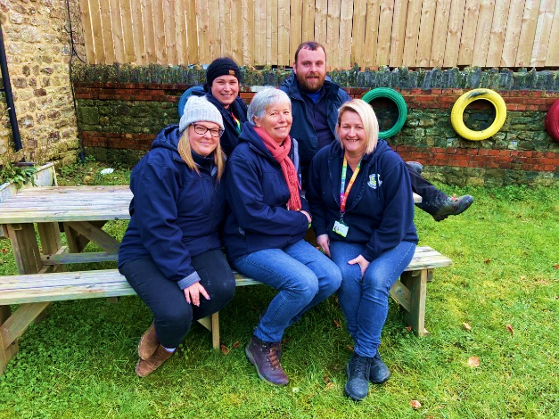

Thrive has continued going from strength to strength this term. Sean has completed his Adolescent Thrive practitioner training so that brings our total to five practitioners and one in training, who work across both sites delivering 1-1 and group Thrive sessions.
Next term will be receiving a plaque from Thrive during a small ceremony where the local authorities, the local MP and the local press will be invited to attend. The Plaque is being given to us in recognition of Wessex Lodge School obtaining a Thrive school of excellence status, so we are very much looking forward to celebrating this achievement.
We have nearly completed our first Family Thrive course where parents/carers have been able to discover what Thrive is, how we use the approach in school and how it supports student’s emotional wellbeing. So far, the feedback has been positive.
There will be another course running in October so don’t worry if you missed out on this one.
We are also looking to run parent café’s/coffee mornings in the near future so keep an eye out for this information.
For any further information that you may require on our Thrive Sessions please contact our Team on
Rebeccam@enhancedlearningservices.co.uk or Katrinac@enhancedlearningservices.co.uk


T H R I V E
Creations

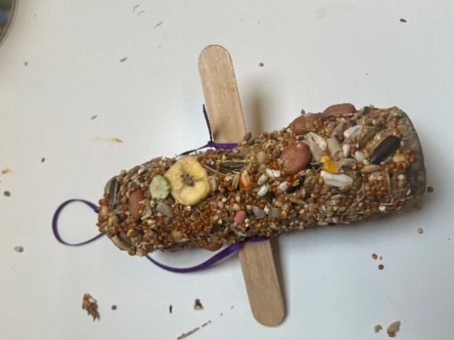
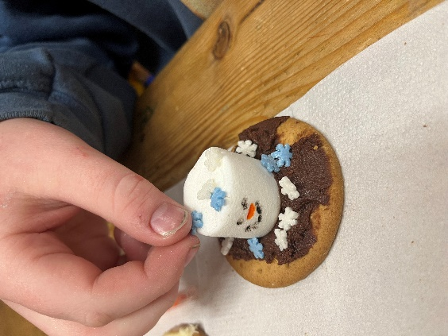
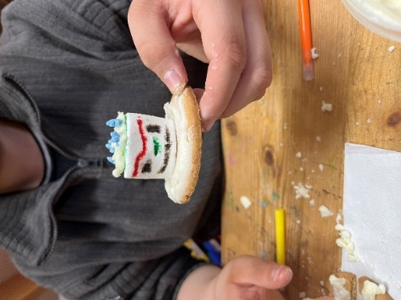

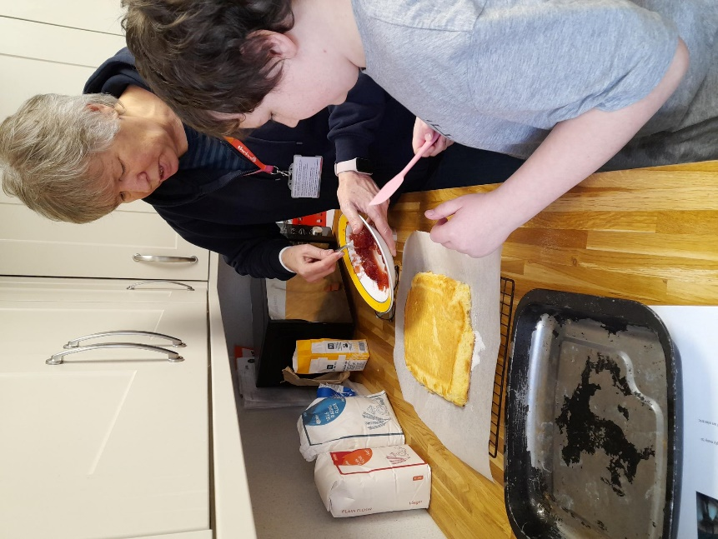
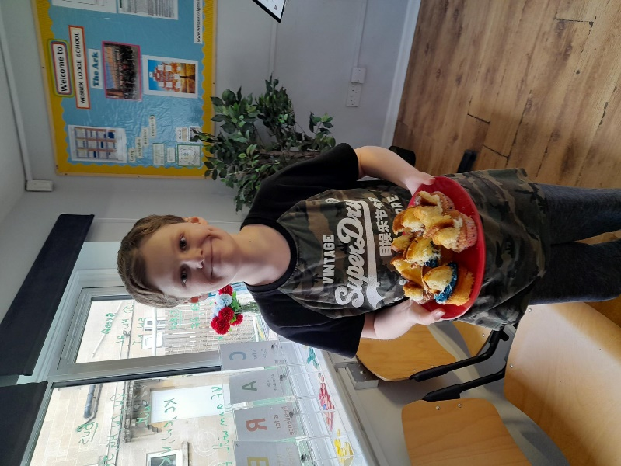
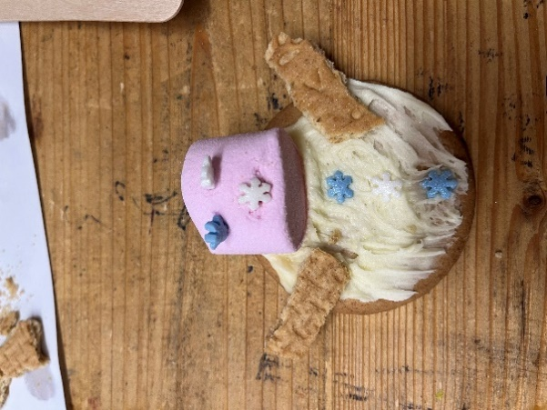



In science we have been running a few different experiments, firstly we have been looking at onion cells under a microscope. We collected the cells ourselves and used Iodine to stain the cells, looking for subcellular structures such as the nucleus, vacuole, cytoplasm and the cell wall. You can see our young scientist looking through the microscope at the cells.

Secondly, we have been creating our own mousetrap powered cars. Students have designed and planned the building of the cars. As you can see in the picture of the partly build cars that there is a range of designs. Once built we are going to do a range of tests to find out who’s is the fastest and who’s goes the furthest.

Finally, we have been testing food samples to find out what each sample contained. In the picture you can see the benedict’s test to find out if the sample contains sugar. With no sugar being blue turning green, with a little sugar turning orange, with more sugar and lots of sugar, being red. The second test is Biuret test to find out if the sample contains proteins. With no proteins staying pale blue turning purple if the substance contains proteins.
James Rigby – Science lead

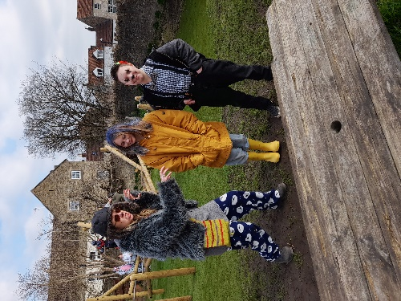
The English department were very excited to celebrate World Book Day this term! We celebrated across both sites, giving students the opportunity to dress-up as their favourite book character, meet a published author, and take part in a range of book related activities. It was wonderful to see how the students engaged and we had a group of very excited young people.
Every student was given a book to take home with them and there were prizes for the best (and most enthusiastic) costumes. Some of the staff costumes were outstanding, Mr Bump, Dorothy, Ms Trunchbull, and the Cheshire Cat were all spotted around Farm.
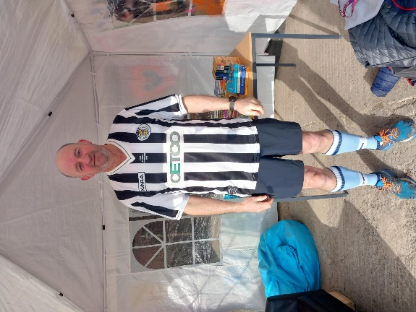
It was wonderful to have Julie McDonald in to discuss her books and process as an author which many of the students engaged with.
Bethany Vowles English, Reading, and Phonics Lead & Head of Education (Farm)

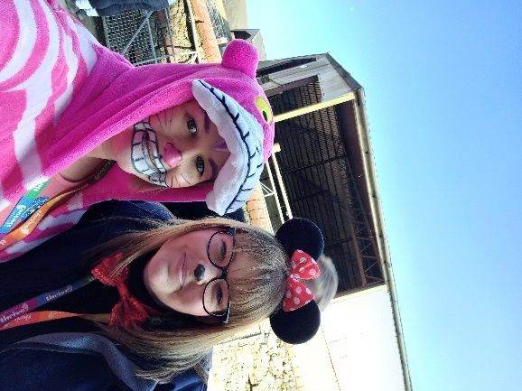
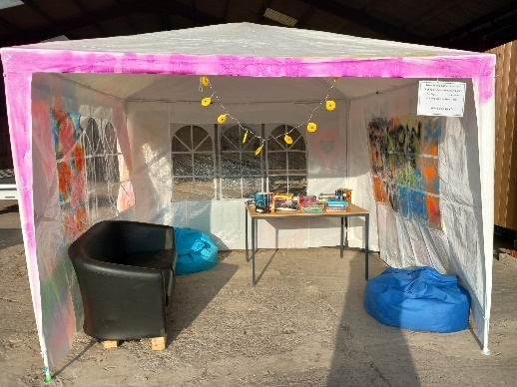
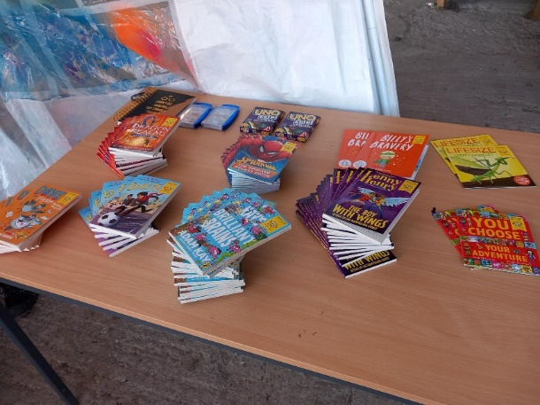
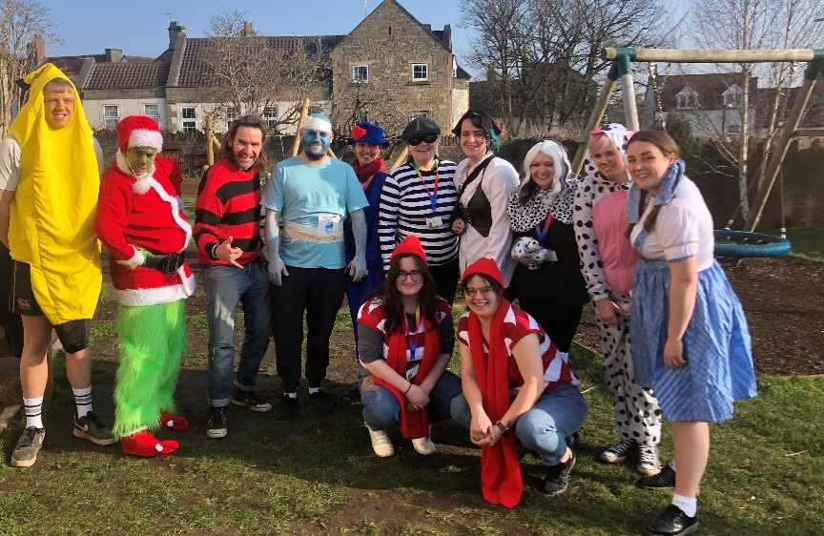
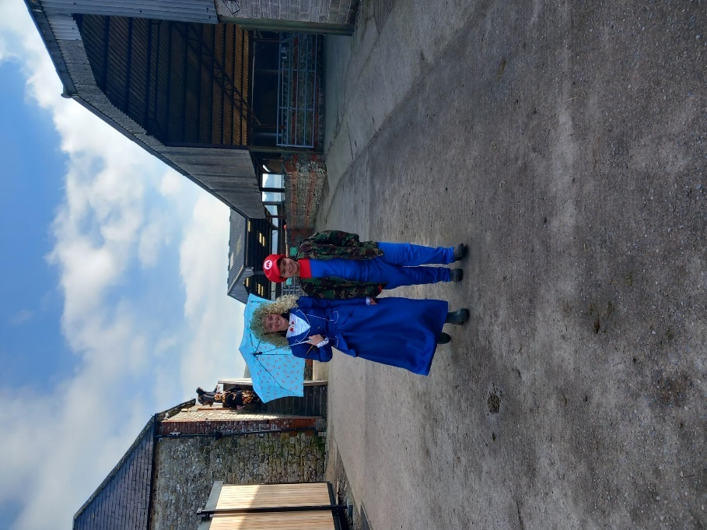

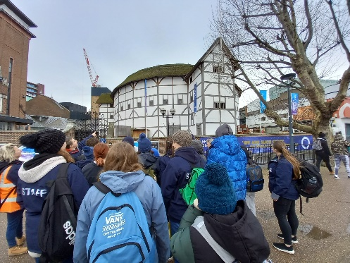
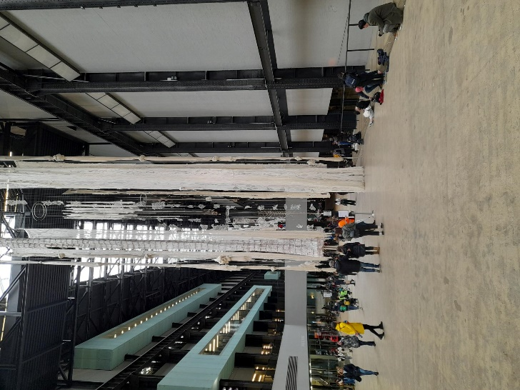
As well as celebrating World Book Day this year we also had our school trip to London to watch The Tempest at The Globe Theatre.
We were incredibly impressed with the behaviour and attitude of the students who were resilient and engaged throughout the day.

It was very rainy on the way up and students were watching out for the sites as we went by, Stonehenge got a big wave from lots of us. As we entered London we very much enjoyed the amazement of one or two students that they have Tesco in London as well. It was really good to see the students absorbing what, for many of them, is a whole new setting.

As we arrived in London the rain continued to pour so after having a quick look at the London Eye we walked along the Embankment to the Tate Museum. We didn’t have quite as long as we would have liked in the Tate, but long enough for some students to find an exhibit of white papers in frames. We are waiting for our Art teacher to explain what this meant!
From the Tate we walked over to the Globe and the students were fantastic. From the very start they were engaged in the play, even with the difficult language, and there were lots of shouts and gasps when Trinculo was slapped in the face by Stephano. The play was an excellent introduction to Shakespeare and we look forward to teaching the play to students when we come back to school after the holiday.
It stopped raining as we walked back to Jubilee Gardens, so students were able to have more of a look around the sites, spotting St Paul’s Cathedral over the river from The Globe and even spotting some people ‘mudlarking’ on the banks of the Thames.
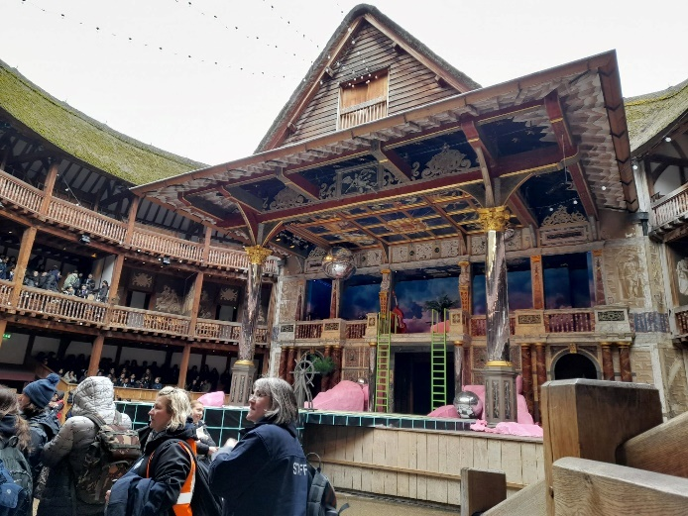
The students were considerate of the coach on the way back and got on well on what is a very long journey.
I am incredibly impressed with the good behaviour of our students and how well they managed a long day full of new experiences.
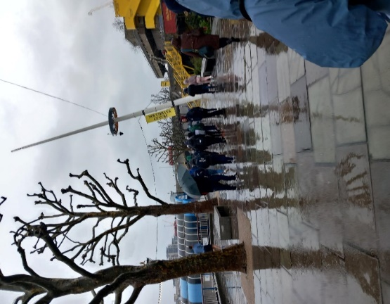

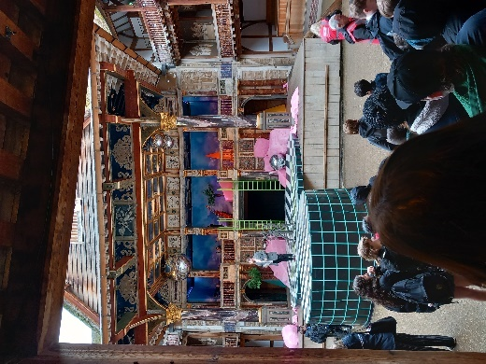
Down on the Farm…

Not much happens during this time of year apart from keeping all the animals fed, watered and warm. Lots of mucking out and soggy fields.

New arrival Dylan the pony has settled in lovely within the equine herd. Helping our young people understand the welfare of keeping horses.

Sadly Eric (the pig) passed away and we now have 4 new pigs called Mr Crunchie, Hetti, Hilda and Bubbles.
Again, these new arrivals have been a huge success.

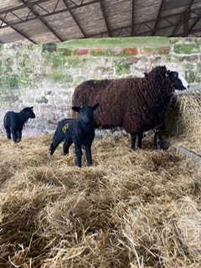
All animals and birds at the farm are looking forward to some sunshine and will soon be out of the sheds and eating some lush grass.

Last but not least I'm very pleased to announce the first Newmead lambs have been born and are thriving, again it won't be long till they are frocking in the paddock s for all to see.
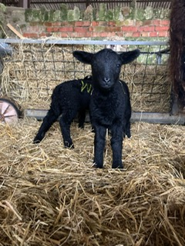
Roll on summer,
Nicky
Farm manager

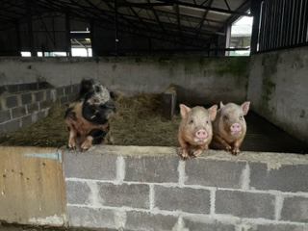

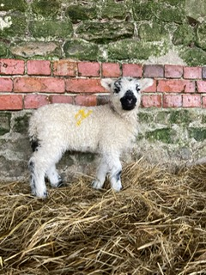

Wear Something Red…
Kat Critten – Inclusion & Engagement/ Family Liaison
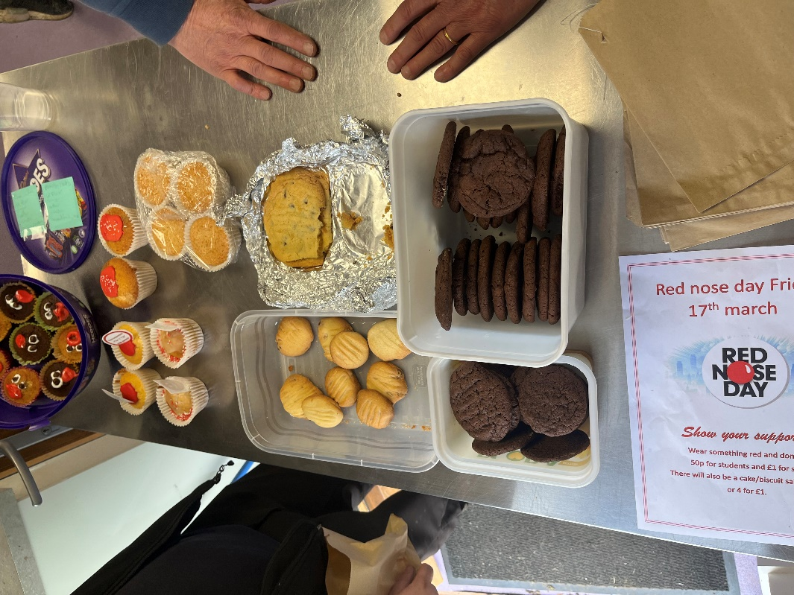
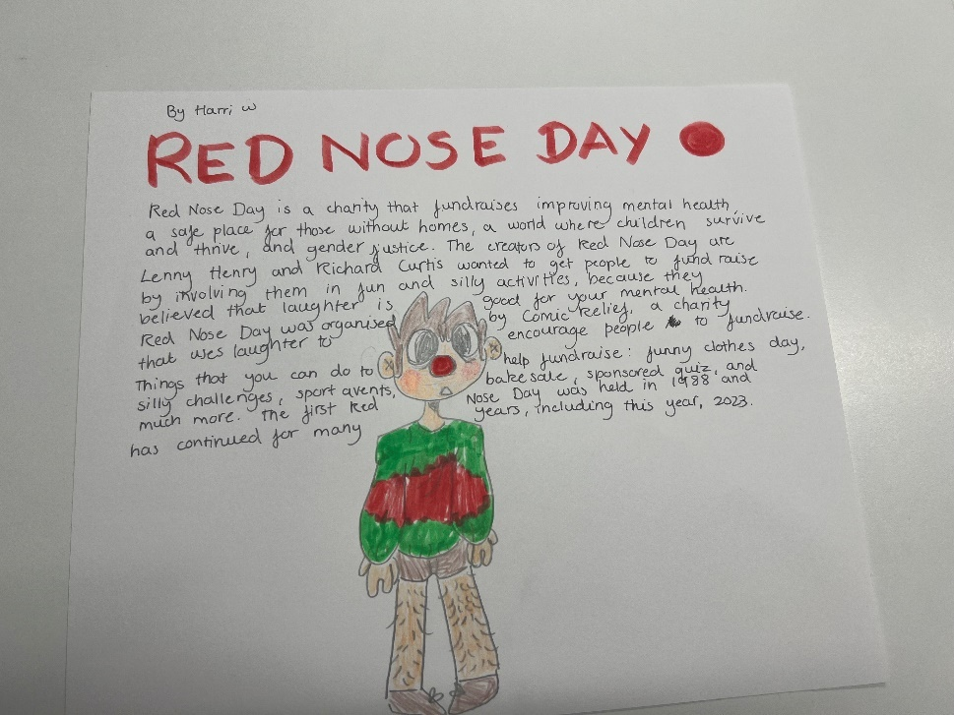

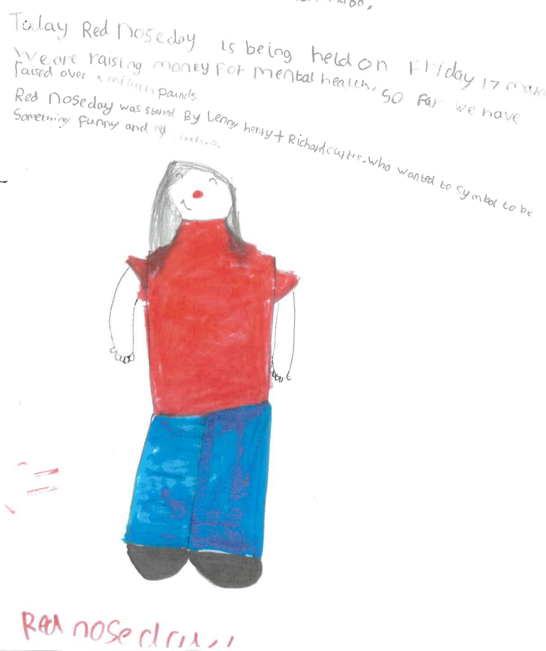

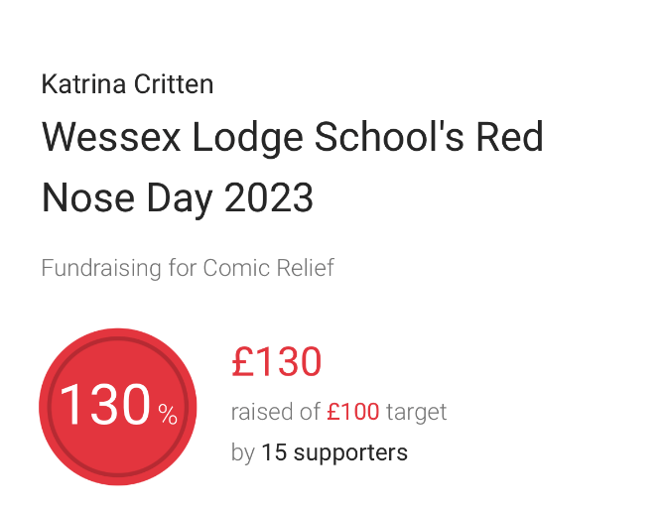

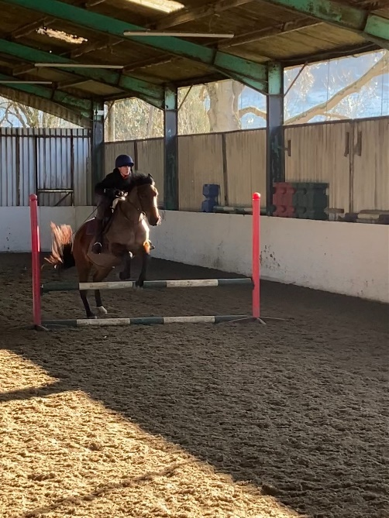

Equine Facilitated Learning

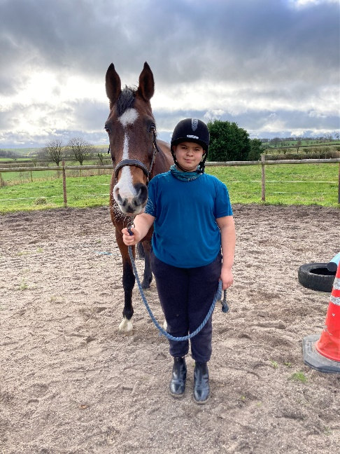
This term in equine, we have had to work in all weathers - we’ve had snow, rain and sunshine thrown at us! Due to working with the horses, we are outside for our lessons and the students have shown some great resilience when it’s come to working in some not so nice weather conditions. The students have been focusing on completing welfare checks on the horses and adding to their confidence and ability while leading the horses in different environments. They have all worked really hard and made some great progress.
The horses were due their yearly dentist checkup this term. The children were amazed by the size of the equipment used to file the horse’s teeth down and asked the dentist lots of great questions. The horses had to be sedated to receive the check up and the students behaved very calmly around the horses while they were feeling very sleepy!
Exciting news… We have had a couple of new equines arrive with us this term; one short term and one who is ours to keep! Our new pony is called Dylan, he is a 2 year old piebald cob (black and white) and he has settled in well and seems to be loved by the students already. We were also lucky enough to briefly look after a retired show jumper, called Callum, while his owner was pregnant. When Callum was with us, the students enjoyed working with him and learning how/why he was different to our herd of horses.
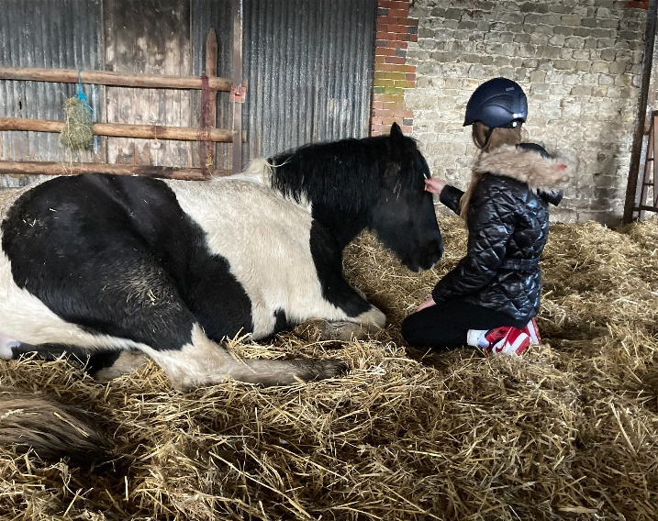
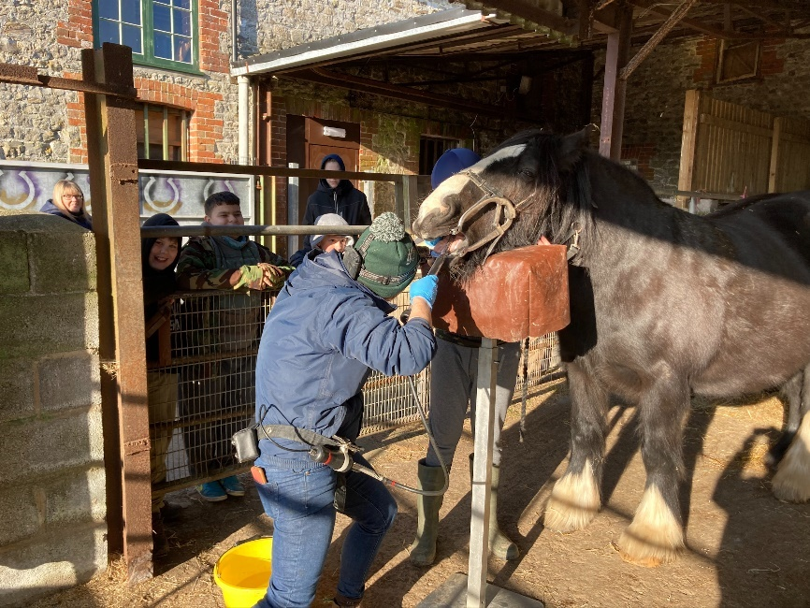
I think students and staff are looking forward to some sunny spring days on the farm! - Laura James - EFL

CAREERS

This term has seen the introduction of work experience, with the first 3 students attending a weeks placement each. We had one student in a primary school, assisting with the reception, year 2 and year 6 classes, another at a vet, shadowing operations and learning from a Veterinary Nurse and the last at a garage, completing minor mechanic jobs and gaining an insight into becoming an Automotive Mechanic. All 3 students valued the time they were given and enjoyed learning from the experience. We have more students booked in to complete placements in May and I look forward to hearing all about their experiences.
Laura Greg – Careers Lead & OE Support

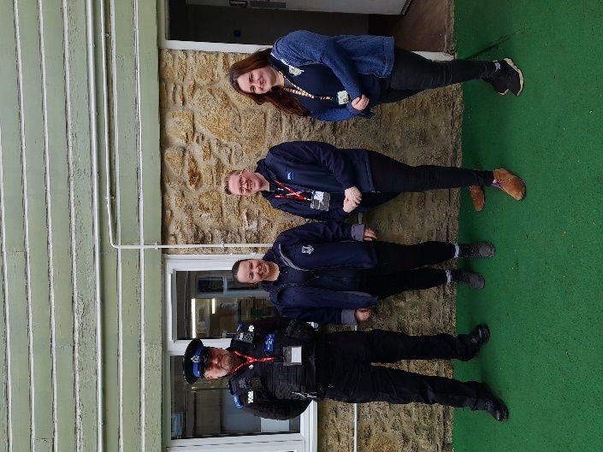
On 9th February Lauren O’Mahony led a Careers Day at The Ark, which was a massive success. We had visitors from the RSPCA and police along with a Nurse and Midwife. Students were also introduced to apprenticeships on the day as it was National Apprenticeships week. Following on from this success we will be holding a second Careers Day at the farm site on 26th May and hope to introduce all students to a wide range of employers, roles, and post-16 options.

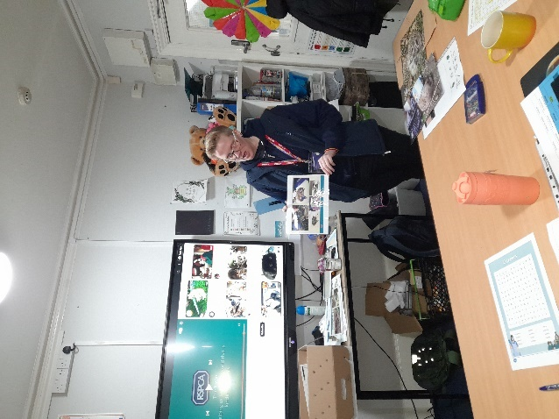
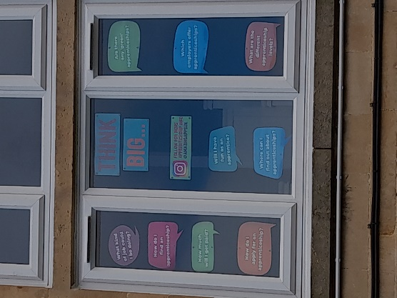

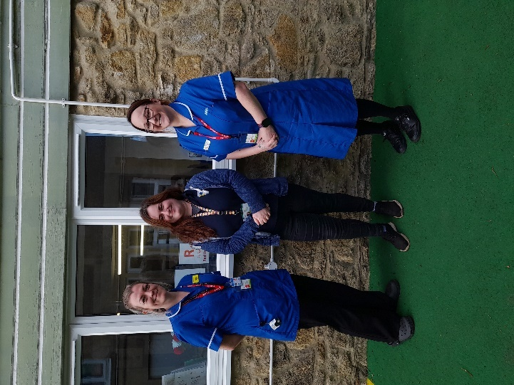

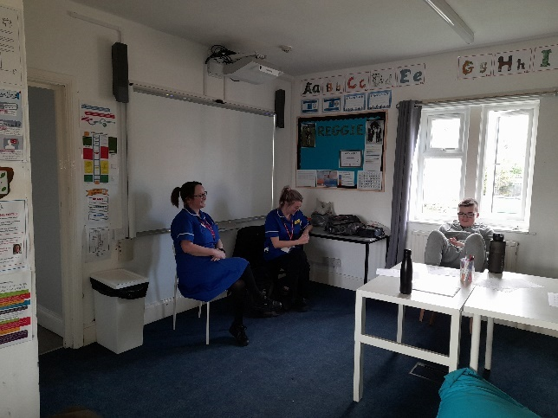
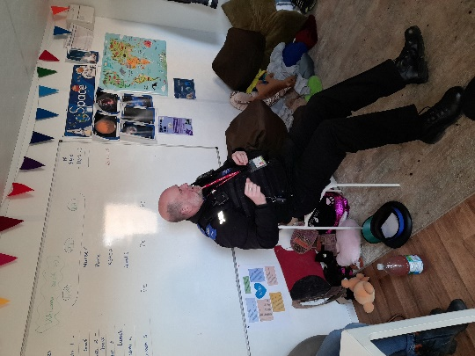

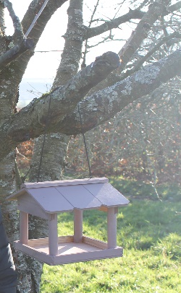
It has been a busy term in the ASDAN cabin with students building credits towards their Personal Development Programmes.

NQ finished painting his bird table, it was quickly in use and became a focal point for taking part in the RSPB Big Schools Birdwatch
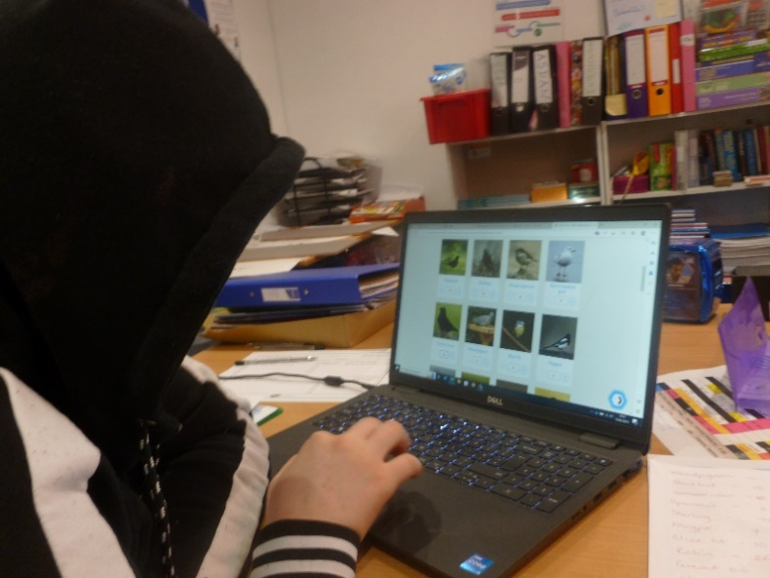

OM completed her write up of making bubble tea and started a new challenge to learn calligraphy – she practiced the lettering and chose an inspirational quote to write up for display:
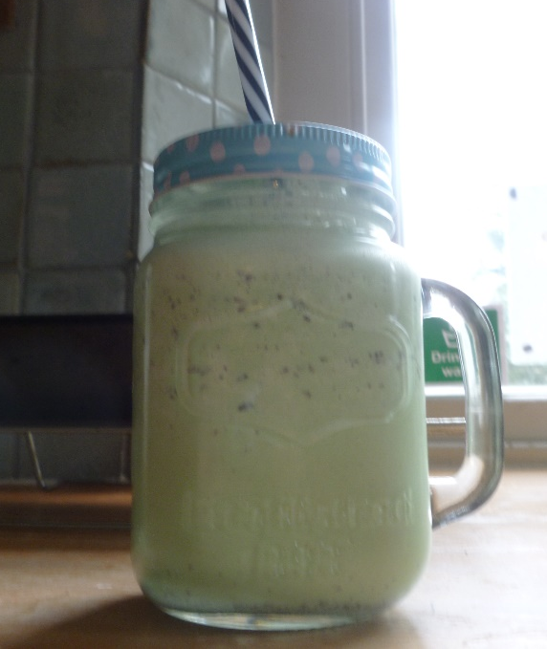
“Opportunity is missed by most people because it is dressed in overalls and looks like work.”
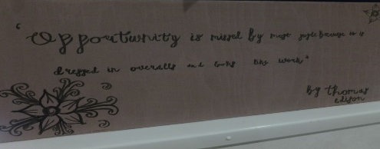
Thomas Edison

ASDAN

Some students have chosen to work on the Communication challenge – ‘Write a review for a piece of media’ and we have had a range of film choices so far – TP went for a romance and has written a great review of the film ‘Safe Haven’, giving it 5 stars and a recommended watch. LA chose an anime film ‘One Piece’ (and managed to explain to me what was happening!) 😊 I’m looking forward to him explaining the Manga book to me next.

TRP has been busy planning his charity bike ride to raise money for Alzheimer’s Research UK and has written a moving reflection in memory of his Grandad for his Just Giving Page – further details in this newsletter, so please take a look and support T.
TRP has still found time to be involved in our Eco-Schools work where we are making progress on an action plan, having chosen our key topics of ‘Waste’ ‘Water’ and ‘Marine’. We are in the process of applying for funding for recycling stations and seeds and plants for our allotment plots.

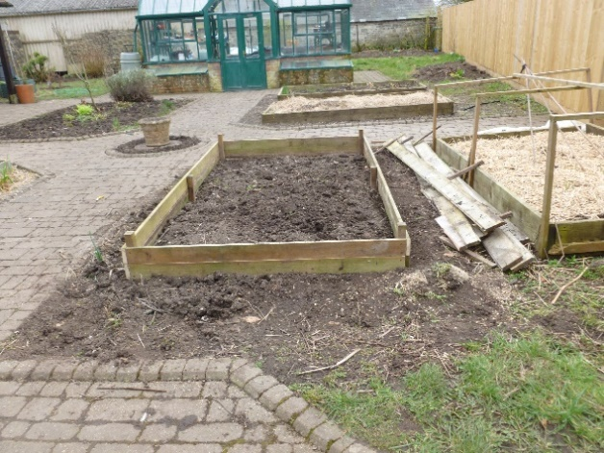
Some new students have joined ASDAN this term and are choosing challenges to work on. EH kicked off his ASDAN rather nicely with a mint ice milkshake in the Wellbeing module.

HAPPY EASTER EVERYONE
Jaki How – ASDAN
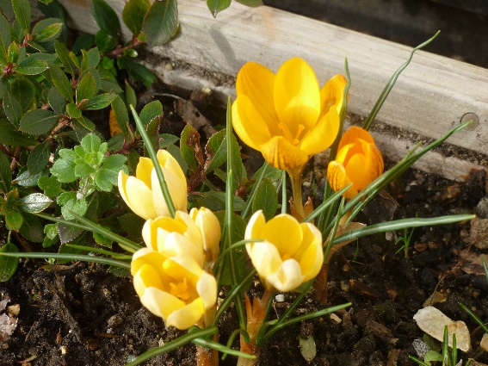


Butterflies Class

So far this in term in butterflies we have had a fantastic spring term! We have looked at fiction stories in English and had an amazing world book day! Butterflies thoroughly enjoyed the day, and their costumes were fabulous! In maths we have looked at fractions and decimals, lots of cake and money during these lessons. For topic we have covered subjects such as RE, Science and even History.

Butterflies have all engaged in these sessions and gave amazing contributions! We have thoroughly enjoyed WOLT as well as swimming. Also, we have started to have cooking lessons at our brand-new kitchen at our other site Newmead Farm. We have cooked cookies and pizzas so far with more yummy food to look forward to next term! Overall, it has been an amazing term for butterflies, Niki and I are tremendously proud of butterflies and their achievements! Keep up the good work guys! Skai Watts – Class Teacher

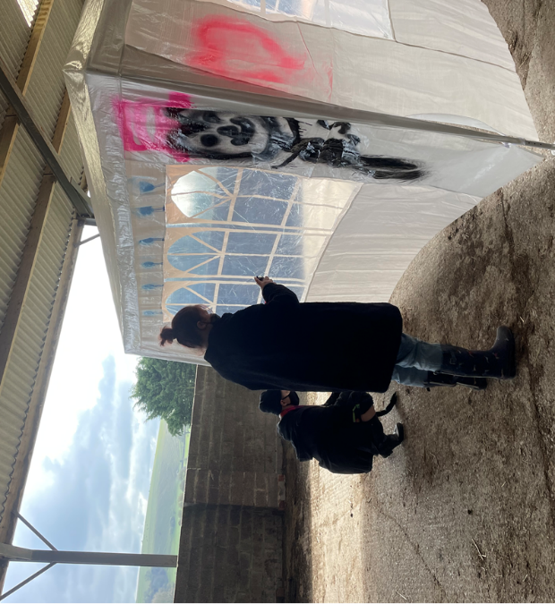
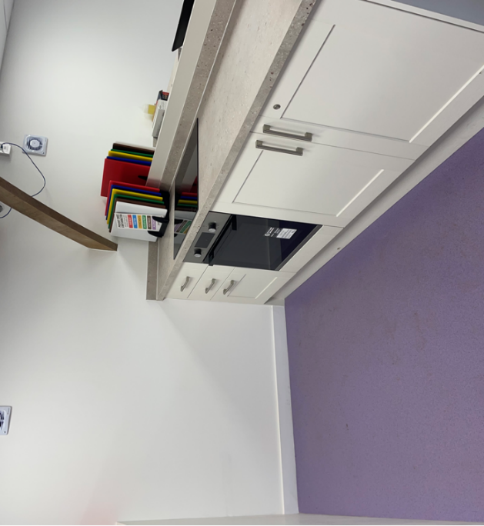

Wildcats Class

During the Spring term, LW, BA and PT had lots of fun together and learnt to be a team.
Horse riding was very successful. They supported one another and they improved their walking and trotting on their horses. Pedro, Pepper, Felix, Cookie, Dillon were very happy horses when they saw them each week!
We started cooking at the farm with Barry. They loved cooking in a professional kitchen with other children and they all listened well to Barry.
Yoga and Thrive were important sessions where they could relax, be themselves and explore their feelings.
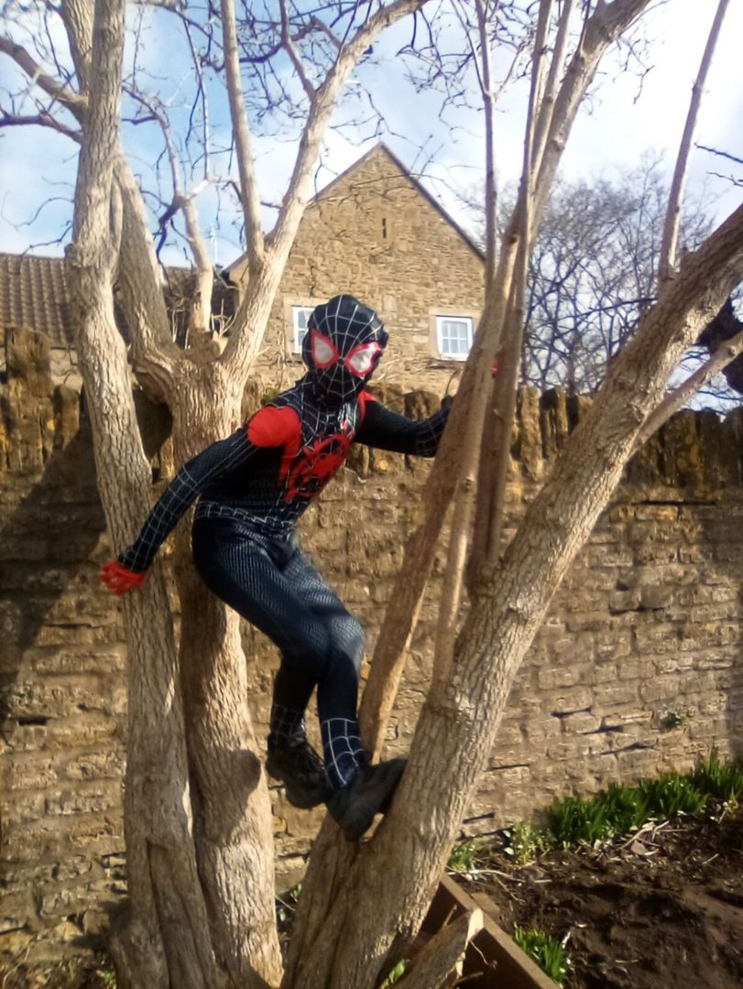
They kept engaging well in group sessions, helped one another by being kind and respectful and learnt to accept everybody’s uniqueness.
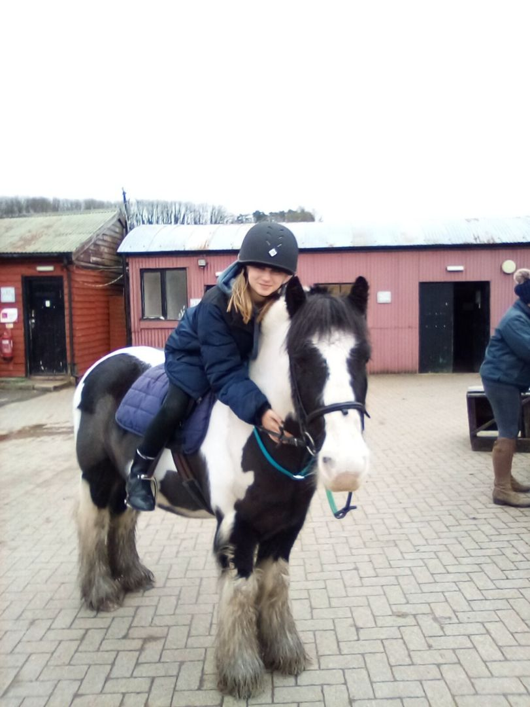
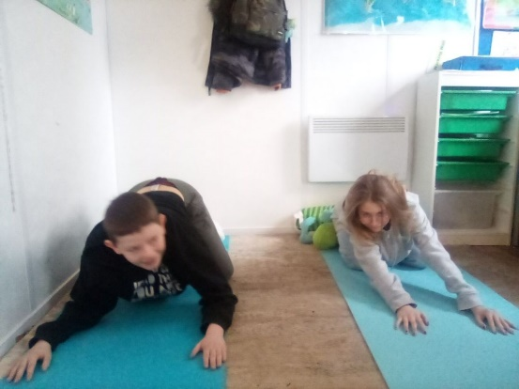
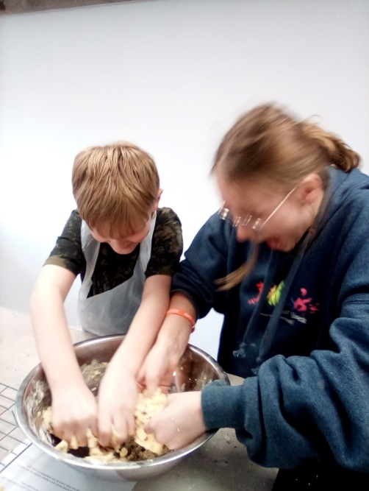
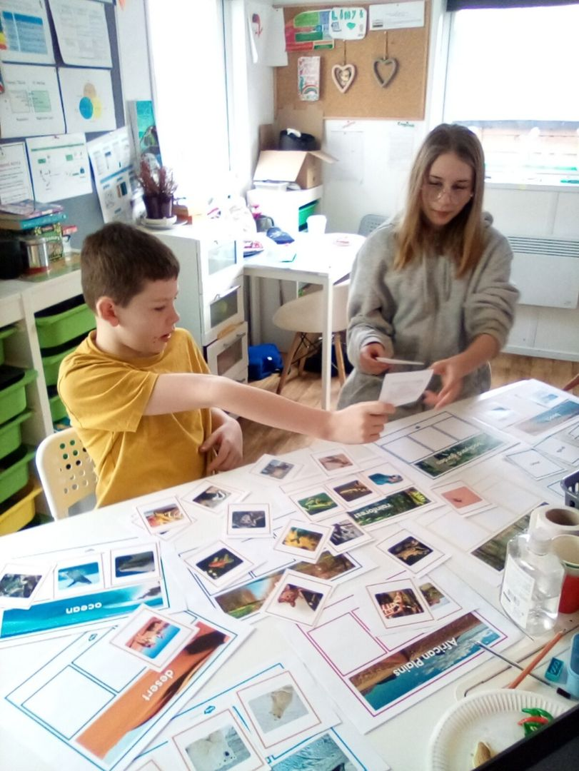
Well done! Rossana Sotgiu – Class Teacher
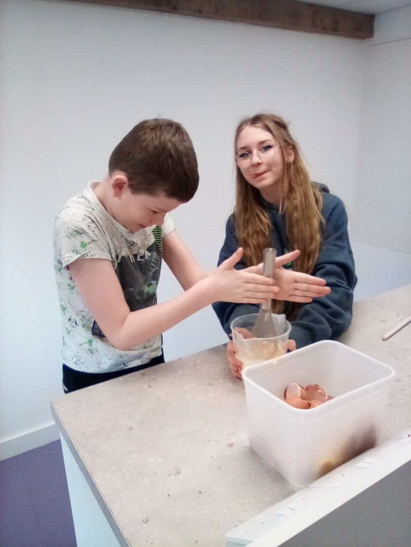

Sloths Class

It’s been a hardworking term in Sloths. All students have been pushed to their limits academically, and all have come out the end unscathed. In English, VF and RH have been working towards their Functional Skills Entry Level 2 and 3 qualifications. The boys have been working on writing and structuring emails, and working hard on understanding why and how we use English in different contexts daily. EA has continued working hard on his GCSE course and has been working on his poetry and creative writing.
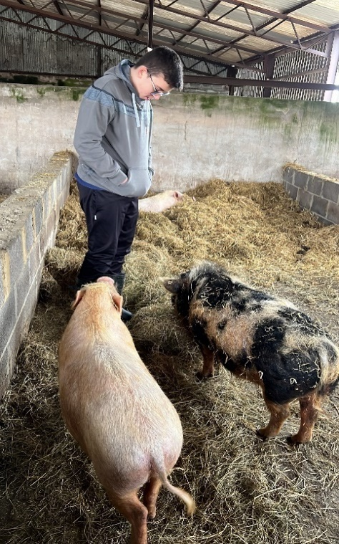
We have linked our Maths lessons to our further learning, as this term we started our ‘Enterprise’ project which have seen the boys create products and sell them in the school environment to raise money for classroom resources around the site. The boys have had to be careful with budgets and must use their spreadsheet, time keeping and sales skills to make this a roaring success. So far, the boys have made and sold pancakes and created luxury hot chocolate mugs, and they will soon be running a car wash – an easy sell as all staff cars are disgusting given the current weather conditions!
Out of the classroom has also been a success. We have enjoyed an educational visit to the Haynes Motor Museum where the boys were really engaged by the history and development of vehicles over time, and they even got the chance to create their own Mini! The boys have all enjoyed visits to the farm, to help with farm duties but to also learn about further animal care.

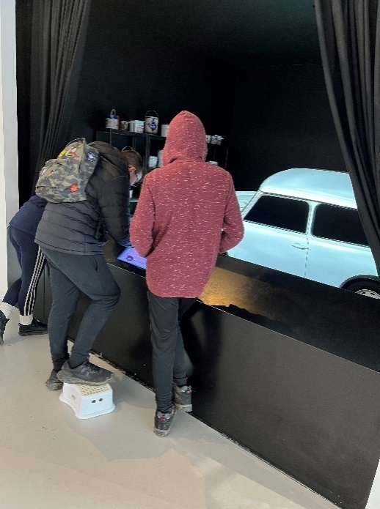
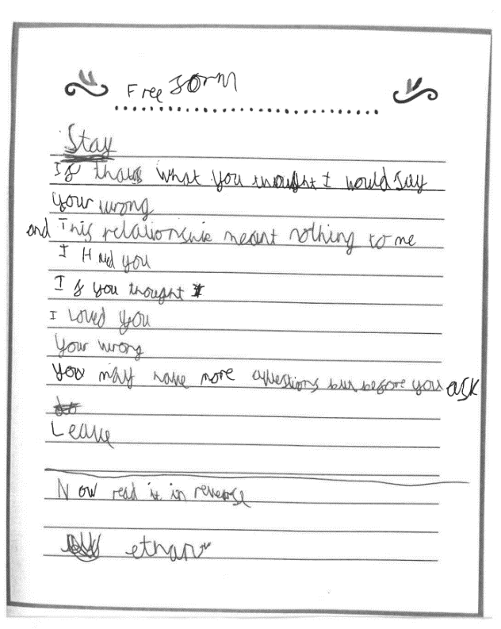
I hope my boys don’t eat too much chocolate over the half term break and that our PHSE topic of Healthy Living has been imbedded into their wonderful minds.

Lastly, I would like to congratulate Becks on her new role at Wessex Lodge – she will absolutely smash it!

Ant West – Class Teacher

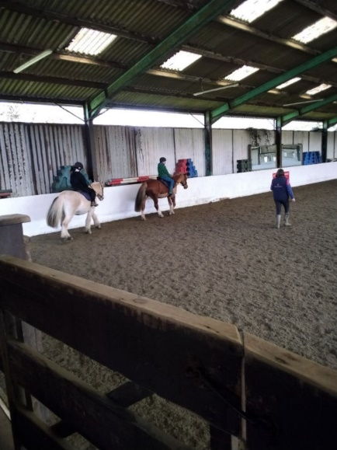
Cheetahs Class

We have had a really good and positive term, our Cheetah’s have enjoyed horse riding, they have worked hard to write their own pieces of creative writing. We enjoyed taking part in sensory play, developing friendships and were excited to visit London on the Globe Theatre.
We look forward to a new term in Cheetahs!

Lauren’O Mahony – Class Teacher
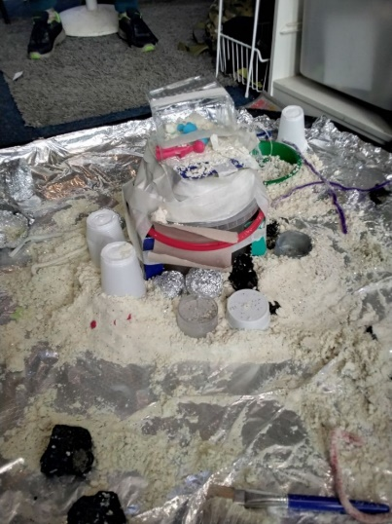
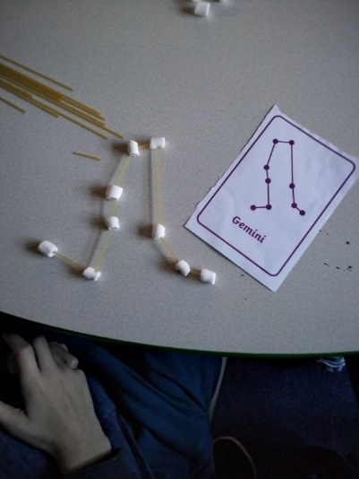

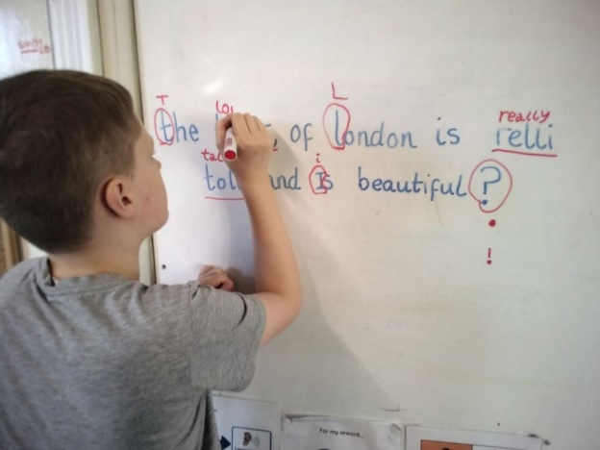

It has been an incredibly successful term in the PSHE department and students have taken part in learning about the future aspirations within our "Dreams and goals" topic and how to take responsibility for their own health in our topic, "Healthy me". Students have welcomed visitors into the school and engaged with workshops on careers, substance and alcohol misuse and Misogyny, social media and gender stereotypes.
Students have thought and developed their own beliefs and ideas within these topics and have been considerate in their learning of how to remain safe and healthy. Students at Wessex lodge should be incredibly proud of their PSHE development this term and the department are excited to deliver the relationships area of the curriculum to students, throughout the summer term!

Dire Wolves Class

This term has thrown new challenges, more changes and whole lot of fun at us in Direwolves class.

We’ve welcomed Kelly into the pack as our new support worker and she has made a fantastic start with making excellent relationships with the students and putting up with me as class teacher.

We’ve had a few difficult weeks with new students joining and finding their feet, but we have been able to get past this as a class and come out the other side in a stronger place. My highlight of the term has been seeing them build up new relationships with Kelly and other students in the school and I’m looking forward to what happens next.

Andy Smith – Class Teacher
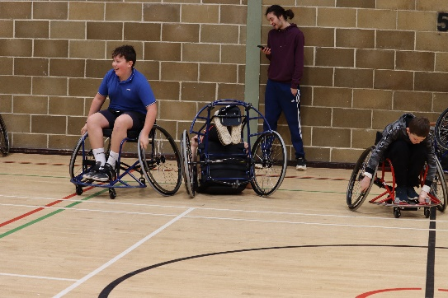
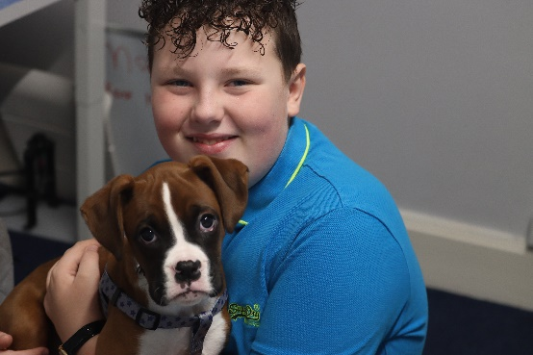



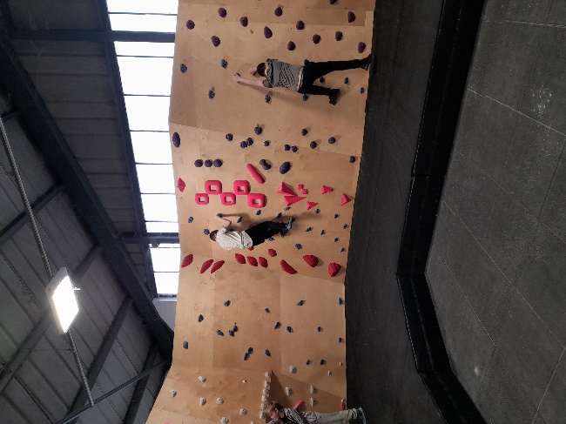
PE this term has been amazing! We’ve had the opportunity to learn new skills in our wheelchair basketball lesson with Nova sports, the kids loved it. It was amazing to see them respond positively to new staff leading the session and show Wessex lodge in such a positive way. This term we have also been attending sessions at Frome Boulder Rooms, playing rugby and for the type of sport it is, we’ve seen fantastic discipline and control when it comes to the more physical aspect of the game. It’s also been amazing to see the students make stronger relationships with staff who they wouldn’t usually work with through PE and being able to carry that relationship back into school. Next term we are looking forward to the warmer days and being able to move into our summer sports season and to start the planning of our Sport festival.
Andy Smith – PE

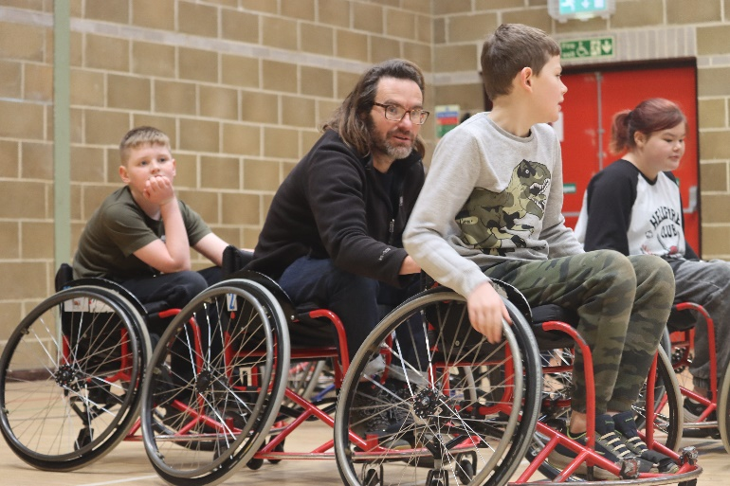

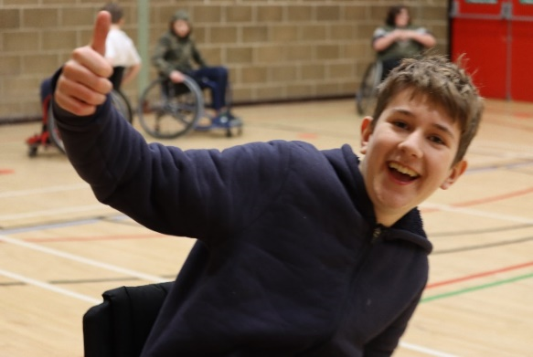

Offsite Explore

This term has been up and down for our Offsite Explore lessons. A combination of cold weather, rain and new faces have put our students through their paces and really tested them. Although we’ve seen a few students struggle it’s been amazing to see them pull together and support each other where possible. As most of our students struggle in group settings, we’ve seen the students work really well with new people and invite staff and students into their circle of trust.

Next term it will be amazing to be back working with WOLT learning new skills and facing new challenges.
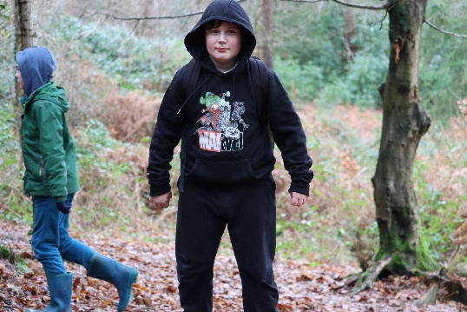

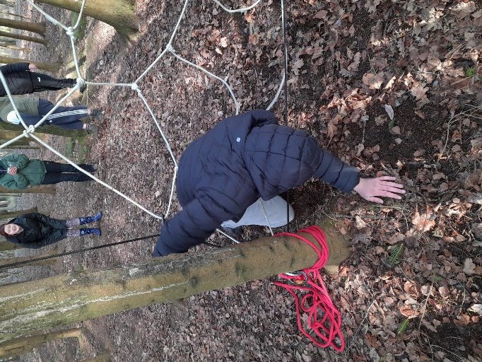

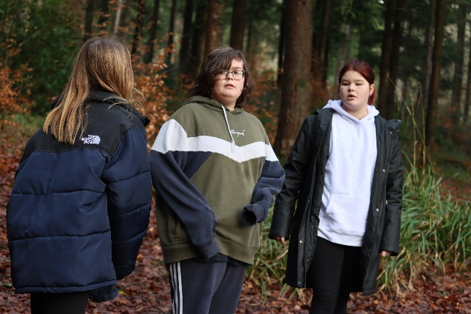

ART
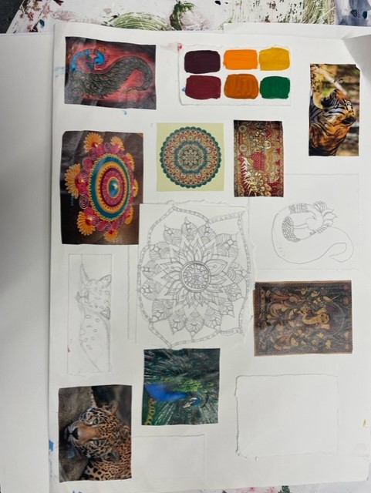
This term students have had the option to choose a culture that they wish to explore. Some of the chosen Cultures are India, Portugal, Jamaica, Africa, and Ancient Vikings. Their first task has been to create a mood board through research, looking at what type of clothing different cultures wear, to their religion, local animals and plants as well as Art work they create.
Students have then had to recreate some of those researched images in a way that they think is suitable, whether this be pencil drawings, collage, or painting.
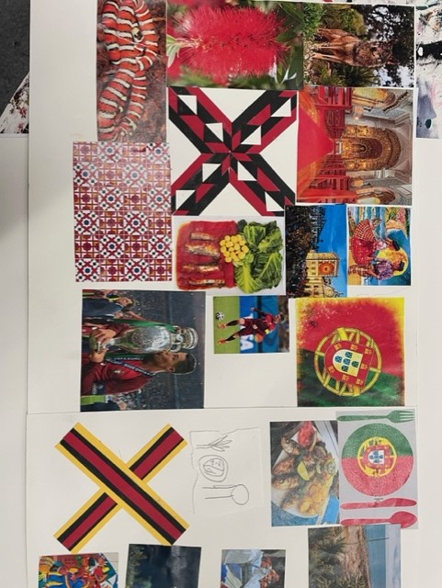
Students have then had an option to create what they like for this project, giving them the skills to drive their own projects for when and if they choose Art as GCSE subject.

One student has chosen to create a series of canvases portraying african sunsets with elephants, the second will be lions. She’s used a blending technique and silhouettes to complete the canvas.
A number of other students have chosen to create paper mache weapons based on their culure. They’ve done so by cutting out cardboard, gumm taping it all together and then building up areas with newspaper and gumm taping it again to make it secure. They will continue to use paper mache, and then can paint and decorate their weapons as they please.

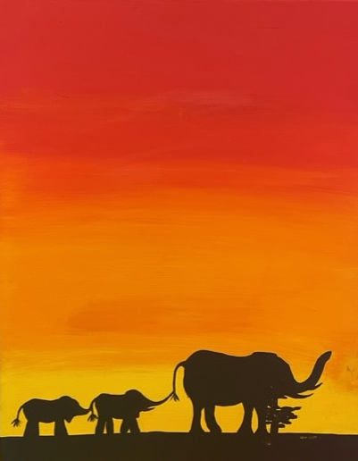
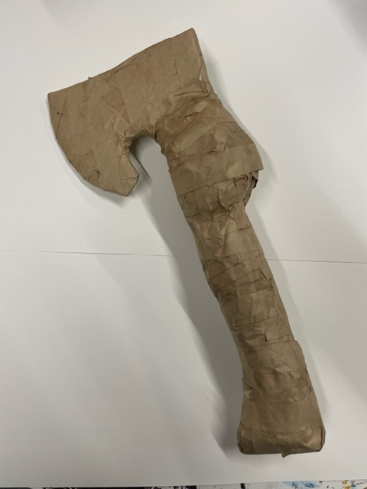
In the summer term, students will finish of their culture projects and then have the choice to continue doing 3D work, like paper mache and ceramics or can learn various printing techniques such as mono printing and lino printing and can do this on a subject of their own choosing.
Rhianne Tyson - Art



Cooking Class

The building work for a training kitchen at the farm has finally been completed, we now have a purpose-built kitchen for the students to use in their home cooking skills classes.
Students across both sites are now timetabled to come to the farm for their cooking lessons and work in an environment designed specifically for them to get the most from a subject that is close to my heart. This will allow them to develop the all-important life skill that will last with them as they grow in confidence in an area that some find challenging.

The aim is to remove barriers and fears around food and its preparation in a fun setting whilst incorporating core skills that are used day to day, we would like the students as they progress through the years to be able to gain a recognised qualification in their final years to take forward on their next steps.

Happy cooking,

Barry

Over in the Orchard…

We have had a number of positive changes in The Orchard this term! Some students have changed classes, we have welcomed some new staff into our corner of the school, and we have new animals on the farm. A lot has been going on and it has been amazing! One of the best things is that we’ve been able to expand our lessons outside of The Orchard; some have been going horse riding, some cooking, some going to P.E and Outdoor Ed… Hopefully more options to come in this next summer term which we’re all looking forward too!

Oak class have been really utilising the farm and the space around us for lots of additional outdoor learning.

Willow have been really enjoying equine sessions and their new weekly horse-riding trips and students have been working very well together this term, using the white board to write their findings and ideas for Science. This photo is one of a few lessons they completed on the board. Sometimes they will annotate over the projected lessons to help solidify their understanding.

Maple have been making all sorts of business plans to take over the world one day!

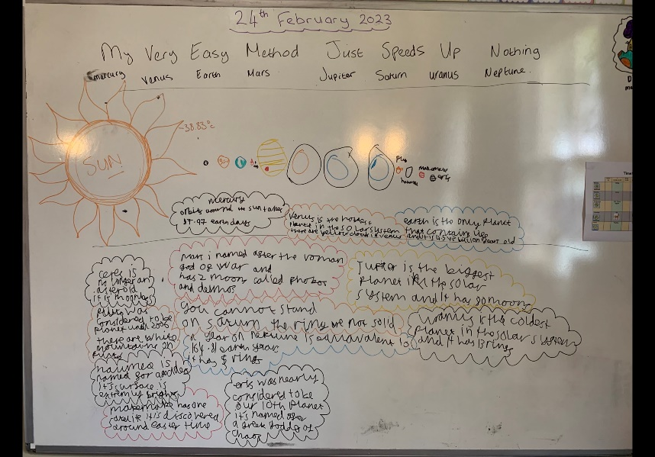
Spring has been great, and watching new things grow around us in different ways has been eye opening. But we are all looking forward to the warmer days and more adventures ahead!

Nigel Oak Class
Becca Maple Class
Marie Willow Class

TRP is fundraising for Alzheimer's Research UK (justgiving.com)
