**Wessex Lodge School Curriculum, Teaching, and Learning Policy**

|  |  |
| --- | --- |
| **Written** | Autumn 2023 |
| **Reviewed** | Summer 2025 |
| **Next Review** | Spring 2026 |

*'An individualised education to improve life outcomes.’*

**C**are

**A**daptability

**R**esilience

**E**mpathy

**Introduction**

Everything we do at Wessex Lodge School is focused on an individualised experience for our students to support and improve their future lives. For this reason, we hold ‘an individualised education to improve life outcomes’[1] at the core of our practice and our interactions with our students.

We have a unique opportunity at Wessex Lodge School that is provided by our students, our environment, and our staff, to provide a bespoke experience to each of our students. Incorporating both primary and secondary models in a ‘stage not age’[2] approach allows our students to have an individualised and adaptive education delivery that fits them and enables them to make progress both academically and within their Social, Emotional, Mental Health needs as defined by the SEMH website[3]. Every one of our students has an Education, Health, and Care plan[4] which is the core of their provision at Wessex Lodge School. These documents are used in deciding on their location within our three sites, the class dynamic they will be introduced to, their educational provision, and any other additional support they may have as a part of their timetable. These documents are reviewed regularly by our SENCO and other key members of staff.

For our cohort SEMH is at least as much an area of progress as is academic knowledge and skills. For this reason, our staff and curriculum take this into account in their planning and delivery, ensuring that all students are given an environment in which to succeed. This may involve teaching outside of the classroom, sectioning tasks over several lessons, chunking learning between low stakes tasks, or many others. In addition to these varied deliveries this is also achieved through the inclusion of Thrive[5] as the foundation of everything we do and Trauma Informed Practice[6] in all of our communication. This is what makes teaching and learning so individual and different at Wessex Lodge School and is what helps our students to succeed. In addition to TIP and EHCPs we also use our Wessex Lodge pathways [See Appendix 2] to support staff in identifying the needs of each student and to provide appropriate instructions in lessons.

The future success of our students is at the heart of everything we do and the dedication of our staff enables us to have a comprehensive understanding of how this looks for each and every child.

**Intention**

Our cohort of students are with us as they haven’t accessed education in a mainstream setting, or the expectations associated with one. The structure of a mainstream primary or secondary setting and the timetable that students have whilst in one hasn’t been successful for our students and this is considered at every level of the teaching and learning at our school. We engage with the National Curriculum[7] as the baseline for the skills and knowledge students require to advance in their school career and develop the knowledge to access life beyond their school. The National Curriculum is, however, an advisory document and we have a group of subject specialists who adapt and alter this to suit the needs of their students.

In addition, there is an individualised approach to which students access the subjects and content we offer which meets the criteria that ‘proper consideration should be given to ensuring that the written policy, plans and schemes of work meet the needs of all individual pupils in terms of their ages, needs and aptitudes, including those with special educational needs’ as is stated in the Independent School Standards[8]. Students are given work at an academic level that matches the stage they are at, rather than their age. These levels are based on their literacy and numeracy attainment as well as their ‘gaps’ in knowledge from their time missed in education. For other subjects the decision of their stage relies on their skills. For instance, if a student has a reading age this is markedly below their chronological age, they may have additional English lessons.

Interest and engagement[9] are also considered in terms of students’ non-core learning. Considering our environment some students are given additional time on the farm, working with specialists and gaining knowledge with the possibilities for qualifications that will be relevant to their futures, or to support their enrichment. For other students lessons such as Home Cooking Skills, or Design and Technology may be more appropriate, but all students are given these opportunities consistently. We give students opportunities to discover their likes and dislikes then use this to create a timetable that will directly benefit them. These enrichment lessons also have consistent links to literacy and numeracy so that students are able to make progress consistently in a way that relates these skills to the rest of the curriculum, and therefore, real life.[10]

**Implementation**

Subjects

We are increasing and enhancing what we offer at Wessex Lodge School all the time. We now have a wide range of subjects to suit the needs and wants of our learners. This is a crucial part of getting our students engaged in their learning and the combination of academic, vocational, enrichment, and therapeutic sessions on their timetable is a core part of what we do. Below is a list of our subjects with a brief overview of how they are taught and the benefits they have to the wellbeing and progress of our students, the subject can also be viewed within our curriculum model [See Appendix 1]. These subjects are offered to students at the most appropriate stage which is identified for each subject individually.

Art

Enrichment Medium Term Plans are provided to classes across all sites by the Art subject lead. The subject lead teaches some students at a KS4 level who are engaged and making good progress, and will finish their time with us gaining added qualifications. This subject is taught at Key Stages 1, 2, 3, and 4 by class teachers and the Subject Lead.

Drama

Drama is taught alongside English to enhance understanding and engagement of the core subject. Drama is taught by class teachers and English subject specialists. This subject is taught at Key Stages 1, 2, and 3 by class teachers and the Subject Lead.

DT

This subject focuses on engagement and has many employability links for students. Students complete projects that develop their woodworking skills, use of tools, and resilience. This subject is taught at Key Stages 2, 3 and 4 by the Subject Lead.

English

This is a subject that is taught consistently across the three sites. The subject lead creates centralised Medium Term Plans that teachers adapt specifically for their classes. These MTPs are organised by key stage rather than year to create more opportunities for the mixed ability classes our schools have. The curriculum is informed by the National Curriculum, however the speed of working and processing for our students is considered with the amount of content being delivered. There are consistent Reading assessments throughout the year using an external system which are further supplemented by Writing and Speaking and Listening assessments linking to the termly topics therefore meeting the criteria of the Independent School Standards.[11] All students have access to English both in school and within bespoke curriculum provision from Key Stage 1 to 4. Our younger cohort at the primary site have the opportunity to participate in the ‘Drawing Club’ program. This initiative enables students to engage with literature in an enjoyable and meaningful way, using carefully adapted resources tailored to support their SEMH needs. Through Drawing Club, students can access and benefit from an English-based curriculum in a supportive and inclusive environment.

Equine

This subject has developed dramatically over the course of the last year and we have several students who are interested in pursuing this further. Those students have been identified and there has been the introduction of theory to the curriculum and teaching. For those students who aren’t accessing qualifications in this subject it has an enormous SEMH benefit as was found in this study by the Faculty of Health and Social Sciences at Bournemouth University, ‘adolescents showed some significant positive improvements in self-esteem, mindfulness, resilience and psychological inflexibility for young people with mixed mental health problems.’[12] and has been used to support progress across the school. This subject is taught at Keys Stages 2, 3 and 4 by the Subject Lead.

Farm

Working on both enrichment for students and also theory and background to support student engagement. There are also consistent links with agricultural businesses in the area. Students are able to work on certified AQAs and other qualifications within this subject area. This subject is taught at Keys Stages 2, 3 and 4 by the Subject Lead.

Forest School

An enrichment activity, Forest School is taught by trained members of staff who support the engagement of students in the world around them. The lessons focus on embedding skills in students and building their confidence to become more independent. This subject is taught at Keys Stages 1, 2, 3 and 4 by class teachers and the Subject Lead.

Gateway

These qualifications cover different life skills required to support our students in their independent living. In addition to this Gateway provides English and Maths qualifications to support those students who may not yet be able to access Functional Skills. The focus that this program has on IT skills is also something we will be incorporating into our teaching, particularly at the secondary level. This subject is taught at Key Stages 2, 3 and 4 by class teachers and the Subject Lead.

HCS

All students across the school engage in a series of cooking skills that will support independence and safe food preparation later in life. In addition to this, theory is integrated into the HCS curriculum to support healthy choices for our students. This subject is taught at Keys Stages 2, 3 and 4 by the Subject Lead and subject specialists.

Humanities

Throughout the course of the academic year students will cover Geography, History, and Religious Education. Medium Term Plans are prepared centrally by the Humanities subject lead and are then differentiated by classroom teachers. This subject is taught at Key Stages 1, 2, 3, and 4 by the class teachers and Subject Lead.

IT

We will be using Gateway to support our IT curriculum for students who are working on our secondary provision. Students will be working on core IT skills that will enable them to access the workplace in the future. In addition, there will be exploration of basic programming to expand student interests. This subject is taught at Key Stages 2, 3 and 4 by specialist teachers.

Maths

White Rose Maths is used across the school from KS1 up to KS4. The Maths subject lead guides teachers to teach at the appropriate level for their class based on Maths levels. Medium Term Plans are provided to classes which support teachers in adapting their teaching alongside the White Rose Maths resources. This subject is taught at Key Stages 1, 2, 3, and 4 by class teachers and subject specialists both on site and in bespoke curriculum provision.

Outdoor Education

Taught in full day sessions, Outdoor Education covers a wide range of cross curricular skills. In addition to being highly active, the sessions and courses also support planning, literacy, numeracy, and many other skills as well. This subject is taught at Key Stages 2, 3, and 4 by the Subject Lead and subject specialists.

P.E

Since the installation of our new gym equipment the engagement and active participation in P.E lessons has had a marked improvement. The P.E subject lead provides a wide range of foci throughout the year, following the ISS by using both the local halls as well as the open spaces on the farm site.[13] A part of the P.E curriculum action plan is to increase engagement so that all students have a dedicated P.E lesson every week. However, alongside this there are also opportunities for physical education around the site and in other lessons. This subject is taught at Key Stages 1, 2, 3, and 4 by the Subject Lead and class teachers.

PSHE

PSHE is taught in specific age groups so that students are receiving the correct information and knowledge for their chronological age. These PSHE topics are structured with reference to the PSHE Association Long term Planning[14] to ensure that all core aspects of the subject are being covered effectively over the course of the year. This is taught by all teachers across the school, supervised by the PSHE subject lead. This subject is taught at Key Stages 2, 3, and 4 by the Subject Lead and class teachers.

Reparative Thrive

Thrive itself is embedded across the school in everything we do. However, there are also designated thrive sessions in the timetable for students to have one-to-one sessions with their designated Thrive practitioners. These are kept as consistent as possible to ensure that students are able to make good and consistent SEMH progress. This is delivered at Key Stages 1, 2, 3, and 4 by the Subject Lead and class teachers.

Science

Using White Rose Science all primary students engage in a range of topics chosen by the Science subject lead. These are then differentiated and taught by the class teachers. The Science subject lead uses a discovery program for KS3 students and at KS4 students who are capable and engaged are taught the KS4 curriculum. This is delivered at Key Stages 1, 2, 3, and 4 by the Subject Lead and class teachers.

Planning

Long Term Plans

Each subject will create a Long Term Plan to be used as a snapshot of their subject over the course of the academic year. These documents are not designed to give in depth detail about what is being taught, but instead to be an easy reference point for teachers and the Heads of Education.

An example of an English LTP for the academic year 2023-2024 is below and shows the level of detail that is expected of Subject Leads. These are adaptable documents where the headings and skills are adjusted to meet the criteria for each subject.

In addition to the subject LTPs those who are teaching in the primary model use a similar template to create an LTP for their class. This supports our teachers being able to make choices based on the stage and ability of their students rather than their chronological age. This will give the Heads of Education an overview of what each class is doing and will also enable Subject Leads to see the levels that each group are working at in their subject.

Medium Term Plans

Each topic covered in the Long Term Plans has a Medium Term Plan created as a reference and support for the teaching staff. The Subject Lead will create this centrally, focusing on the Skills and Intention for each session. It is then up to the individual class teachers to plan the Implementation that will best support their students.

At the front of each Medium Term Plan the Subject Lead should identify the Fundamental British Values, Employability, Community Thrive, and Spiritual, Moral, Social, and Cultural development targets that best fit with this Medium Term Plan [See Appendix Four]. Teachers should then reference these throughout their teaching in a manner which embeds them into the learning of all students and creates real world links as referenced in the Independent School Standards.[15] When the teachers receive these MTPs there is also the space to include individual EHCP, literacy, and numeracy targets for their students. These should come from reference to the EHCP, and the Instructional Planning Reports from the termly STAR Assessments completed by students.

Environment

In order to support our students in having a successful journey through their time at Wessex Lodge School the provision of each of our three sites is carefully considered. The links between these sites set students up for their next steps by building care, adaptability, resilience, and empathy alongside academic progress. A snapshot of this journey is given in the three site provision model [See Appendix 3].

**The Hive**

Each class at The Hive has a similar structure, following a primary model with their class teacher providing their learning being supported by an Education Support Worker. This learning is supported through the planning provided by the Subject Lead. It is up to the teacher’s discretion when during the day these sessions take place but each student will have dedicated literacy, numeracy, and PSHE on their timetable. Literacy lessons will be up to 30 minutes long and take place 4 times a week. There will be a focus on phonics for the younger students which will develop into comprehension and writing skills. The Rocket Phonics and Reading Planet programmes will be used to create consistency for students throughout their time at school. Numeracy lessons will also be for up to 30 minutes and take place 4 times a week using White Rose Maths KS1 and 2 curriculums. This also creates consistency for students in building their basic numeracy skills. PSHE lessons of up to 30 minutes will take place once a week and be planned with the PSHE Association supported planning provided by the Subject Lead.

Thematic learning will then take place over the rest of the day with an embedding of play throughout the curriculum. This will gives our young people the opportunity to broaden their experiences and increase their social and emotional skills. The Heads of Education and Subject Leads will identify a list of themes for each Key Stage which teachers will be able to choose from. Staff will then use these themes to access the rest of the curriculum. They will use these themes to shape and support the Implementation of the MTPs that are provided for them by the Subject Leads. In this way students will access Humanities, Science, Art, English, Drama, and other subjects in a way that is engaging. Studies on thematic learning, such as this study from the ‘Advances in Social Science, Education and Humanities Research’ journal have identified that this approach expands the learning of students, meaning that ‘students not only learn in a classroom but also outside the classroom.’[16]

**The Farm**

At The Farm site there is a blended model of both class-based learning and transition groups in order to prepare students for success in their next steps. The model chosen will depend on a combination of the academic and SEMH needs of the students with reference to each student’s EHCP targets and requirements.

Students who are working in a class based model will have a class base and a dedicated teacher. This teacher will cover lessons such as English, Maths, PSHE, Humanities, Science, and others. The planning for these subjects will be provided by the Subject Lead with a focus on accumulative acquisition and then adjusted and adapted to meet the needs of the students. The English teaching will be supplemented by the phonics program Rocket Phonics for those students who require this level of phonics support. In order to create a cohesive literacy program any students who require additional support will have intervention using the Reading Planet program. This intervention supports ISS 2.10[17] and prioritises each student meeting the level of functional literacy as a minimum during their time at Wessex Lodge School. These students in a class based model will have additional instruction from subject specialists in other subjects that require additional resources or a specialist environment. These lessons will include Equine, Farm, DT, Home Cooking Skills, and others. Each class’s education support worker will support them in these additional lessons to create consistency and support for all students.

The other model at The Farm will be a transition model. Through their academic and SEMH needs these students are identified as ready to become more independent and to move to a model more similar to a secondary one. English and Maths lessons will be taught by subject specialists who will also cover Humanities, Science, and PSHE teaching. Then these students will go to the subject specialists for those subjects where additional resources or a specialist environment are required. In addition to these students having additional teaching from subject specialists, this model also works as a transition to The Ark. Those students who can make both academic and SEMH progress in this model and are able to build their resilience to the changes of environment through the day will then be set up for a more successful move to The Ark. In addition to a transition to The Ark this will also support students in their next steps and, to reference our school mission, to improve their life outcomes. For those students who this model is revealed to be inappropriate for, more work can be done to support those students in move onto a movement rather than class-based model.

**The Ark**

At The Ark students are taught using a secondary model. They move around the school site depending on their classes. This enables those students who are working at a secondary level to have access to specialist equipment as well as the specialist teachers. In order to continue to support the SEMH needs of students an Education Support Worker will work with each class and will move around the school with them. The location of The Ark means that students are able to access the local community which will build on their life skills.

All students at The Ark will be taught by Subject Specialist staff, covering subjects including English, Maths, Science, Humanities, PSHE, IT, P.E and more. In addition, to maintain links with the environment of the farm students will have an Options block on their timetable. This Options block will enable students to choose one of the subjects that requires the specialist teaching environments located on the farm. They will then be able to access the farm environment for these lessons once a week.

**Impact**

STAR Assessment

We use the Renaissance Place product STAR Assessment to track progress and attainment in students’ Reading and Numeracy. Every term there is a two-week assessment block where all students will complete their STAR Assessments. All students will complete the Maths assessment and either the Reading or Early Literacy Assessment depending on their reading levels.

Not only do these tests assess the levels of students, but they also create targets to support teachers in focused planning. After each assessment staff will download the targeted planning sheet and use this to support them in their teaching for the next term. The ‘Learning Progressions’ included by Renaissance Learn support student progress and focused teaching whilst also not increasing staff workload.[18] This information means that the Medium-Term Plans provided by the Subject Leads are differentiated and targeted to support our intention of ‘an individualised curriculum to improve life outcomes’ and to support the Independent School Standard 2.26[19] so that progress and planning are intrinsically linked.

Evidence for Learning

Evidence for Learning allows us to evidence, assess, review and plan for meeting the unique needs of all of our learners. Evidence for Learning supports an ‘Inquiry-based approach’[20] to education and provision, that allows all stakeholders in a young person’s learning and development to gather photo and video evidence quickly and easily, linked to the individual’s profound curriculum. EFL also supports any assessment framework and any assessment model – including evidencing and tracking progress against individual learning intentions and targets related to EHCPs. EFL has transformed how parents/carers and the learner themselves are engaged and involved in the entire learning process and journey. Not only can photos, videos and notes be easily and securely shared by the school, but parents/carers can capture and submit their own photos, videos and notes to reflect the learner’s development and experiences at home and outside in the community. Each subject has their own internal assessments throughout the academic year. These are based on a combination of skills and knowledge with each subject deciding on the most effective assessment format.

Internal Assessment

Subjects across the school refer to the internal assessment descriptors in order to track progress for those students who aren’t able to access an external curriculum leading to a qualification. This means that for those students who may be working in the Enrichment or Vocational Pathways progress I still able to be tracked. It is also used to support teachers and Subject Leads in identifying those students who are able to move on to the Accreditation Pathway and begin to access external curriculums such as Functional Skills, BTECs, or GCSEs. By using word descriptors these assessments levels become more approachable for students and it also supports parent and carer engagement. Staff will be expected to complete a minimum of three data points throughout the school year that will align with the reports for students.

The image used for these is pictured below.

Students who are working along an external curriculum criterion from these qualifications will be used to assess students. These assessments should still take place at a minimum of three times a year.

Monitoring

SLT complete learning walks regularly, with an aim of seeing every teacher once a half term. These learning walks are informal drop ins and are no longer than 15 minutes long. The member of SLT who is completing the learning walk will be looking for evidence of the focus for that term, in addition to the engagement and opportunities for progress in lessons. Once the learning walk is complete then the teacher will sit down with whoever completed the learning walk where there will be feedback given. This feedback is done in a discursive manner, led by questioning and discussion about the lesson, rather than a top-down approach. These learning walks are a supportive process and have been embedded within school culture in order to make them consistently effective, as referenced in the education consultant article from ‘Teacher Head’.[21]

In addition to learning walks supporting monitoring of teaching and engagement, they are also used in the departmental deep dives. Each half term two or three subjects are chosen to have a deep dive from the Heads of Education. By having an in depth look at each subject over the course of the year the Subject Leads have a clear idea of their subject and how it is being taught across the school. They inform the curriculum action plans for different departments and identify where additional support may be needed for teachers and Subject Leads. These deep dives focus on four different aspects. These different aspects have been chosen based on the education inspection framework in order to make this a supportive experience for staff that will prepare staff for external inspections in the future.[22]

Teaching

This looks at how each lesson in the subject is being taught across the school. Learning walks will be done on the Subject Lead, but also on staff who are teaching the subject across the rest of the school. The subject knowledge of staff will be assessed as well as how prepared each teacher is to deliver the lesson. This will include the differentiation of resources, the questioning of students, and the accuracy of knowledge.

Learning

Over the course of the deep dive week for each subject we will take examples of work from the Ark, the Orchard, and the Farm. The focus will be on the work that has been completed, the feedback given, and the progress made throughout the Medium-Term Plans. Whilst it should be clear that the ‘Intention’ of each lesson as set by the Subject Lead should be met it is up to the teacher how to complete the ‘Implementation’ part of each lesson to ensure that the needs of individual students should be met within each class.

Progress tracking

For each subject there is an expectation that some record of progress made is kept by the Subject Lead. This enables staff to adjust their planning and develop resources that target misconceptions and areas that need development. During a deep dive the Heads of Education will ask Subject Leads for their data tracking. This is not evaluated on how much data has been collected but instead on the access that staff have, the consistency of data collection, and the range of students that are included.

Staff and Student voice

Whilst each subject has a Subject Lead there may be staff across the school who deliver this subject to students. For this reason, all staff will be asked to give comments on how they feel this subject is taught across the school. In addition, students will also be asked about their experiences with the subject, focusing on their feelings of achievement and how they are supported rather than their enjoyment of the subject.

Reporting

Each week both Heads of Education have one to one sit downs with the headteacher where they discuss any actions that are required for the following week. This can include staff who need additional support or a review of a piece of planning that is required. By meeting each week there is a consistent development of education across the school and the curriculum remains a priority.

These meetings are further supported through weekly SLT meetings where an update to SLT from the Heads of Education is given. This is the opportunity for the team to contribute opinions and ideas of the development of Education and how the curriculum will continue its progress.

Once a term these meetings and work accumulate in written form for the Governors’ Report. In this report an in-depth report is given on the progress made with the curriculum and the impact it is having on the students and staff. This is further enhanced by yearly Quality of Education deep dives that occur at each of the Governor cluster schools as part of a wider quality assurance system.

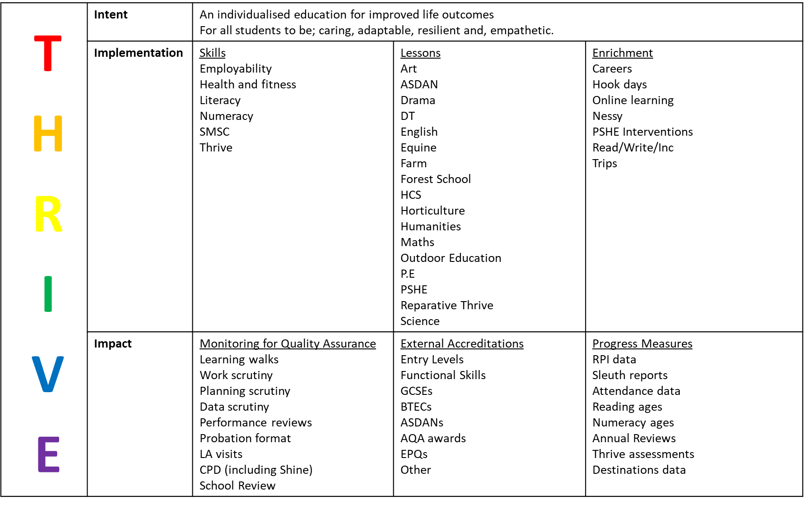Appendix One

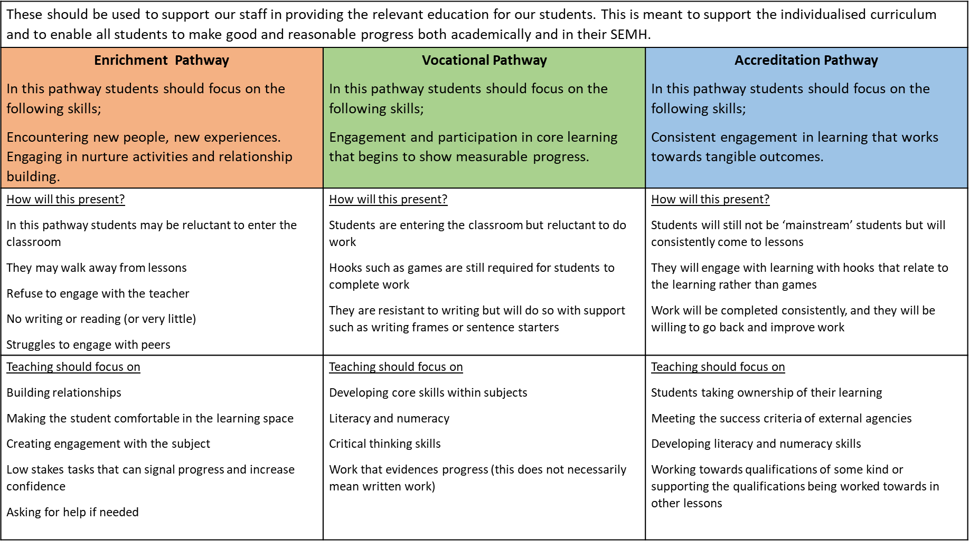Appendix Two

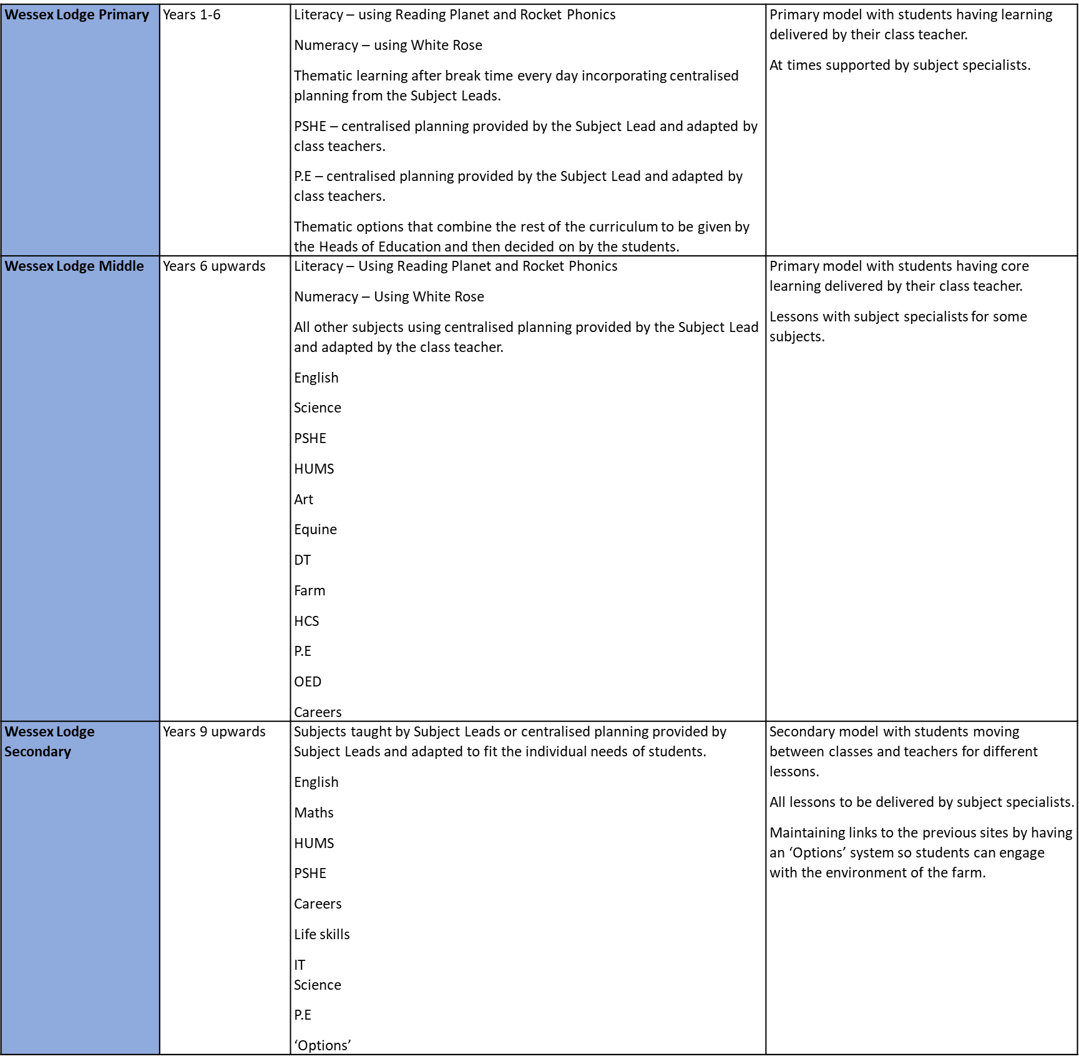Appendix Three

Appendix Four

1. Wessex Lodge School <https://www.wessexlodgeschool.co.uk/> Accessed on 22.2.24
2. Tes magazine <https://www.tes.com/magazine/archive/stage-not-age-key-better-learning-specialist-schools-told> Accessed on 22.2.24
3. SEMH <https://semh.co.uk/> Accessed on 22.2.24
4. Gov.uk <https://www.gov.uk/children-with-special-educational-needs/extra-SEN-help> Accessed on 22.2.24
5. Thrive <https://www.thriveapproach.com/> Accessed on 22.2.24
6. Outcomes First Group <https://www.outcomesfirstgroup.co.uk/trauma-informed-practice/> Accessed on 22.2.24
7. Gov.uk <https://www.gov.uk/government/collections/national-curriculum> Accessed on 22.2.24
8. Independent School Standards – Standard 2.3 <https://assets.publishing.service.gov.uk/media/5cd3fc2fe5274a3fd6ee74b0/Independent_School_Standards-_Guidance_070519.pdf> Accessed on 22.2.24
9. The Learning Scientists <https://www.learningscientists.org/blog/2019/11/7/interest-and-engagement#:~:text=So%2C%20do%20interest%20and%20attention,ignore%20irrelevant%20information%20(3)>. Accessed on 22.2.24
10. Independent School Standard 2.9 <https://assets.publishing.service.gov.uk/media/5cd3fc2fe5274a3fd6ee74b0/Independent_School_Standards-_Guidance_070519.pdf> Accessed on 22.2.24
11. Independent School Standard 2.10 <https://assets.publishing.service.gov.uk/media/5cd3fc2fe5274a3fd6ee74b0/Independent_School_Standards-_Guidance_070519.pdf> Accessed on 22.2.24
12. A Study Exploring the Implementation of an Equine Assisted Intervention for Young People with Mental Health and Behavioural Issues pg 242 [J | Free Full-Text | A Study Exploring the Implementation of an Equine Assisted Intervention for Young People with Mental Health and Behavioural Issues (mdpi.com)](https://www.mdpi.com/2571-8800/2/2/17) Accessed on 25.2.24
13. Independent School Standards 2.6 <https://assets.publishing.service.gov.uk/media/5cd3fc2fe5274a3fd6ee74b0/Independent_School_Standards-_Guidance_070519.pdf> Accessed on 22.2.24
14. PSHE Association <https://pshe-association.org.uk/guidance/ks1-5/planning/long-term-planning> Accessed on 23.2.24
15. Independent School Standards <https://assets.publishing.service.gov.uk/media/5cd3fc2fe5274a3fd6ee74b0/Independent_School_Standards-_Guidance_070519.pdf> Accessed on 23.2.24
16. Anshory, Ichsan, Advances in Social Science, Education and Humanities Research vol 349. Published by Atlantic Press pg244
17. Independent School Standard 2.10 <https://assets.publishing.service.gov.uk/media/5cd3fc2fe5274a3fd6ee74b0/Independent_School_Standards-_Guidance_070519.pdf> Accessed 1.3.24
18. Renaissance Learn <https://www.renlearn.co.uk/star-assessments/learning-progressions-new-national-curriculum-england/> Accessed on 23.2.24
19. Independent School Standards <https://assets.publishing.service.gov.uk/media/5cd3fc2fe5274a3fd6ee74b0/Independent_School_Standards-_Guidance_070519.pdf> Accessed on 23.2.24
20. Evidence for Learning <https://www.evidenceforlearning.net/> Accessed on 23.2.24
21. Teacher head <https://teacherhead.com/2022/09/04/making-the-most-of-learning-walks/#:~:text=Lesson%20observations%20that%20form%20part,observations%20are%20planned%20and%20anticipated>. Accessed on 23.2.24
22. Gov.uk <https://www.gov.uk/government/publications/school-inspections-statistical-commentaries-2022-to-2023/schools-commentary-deep-dives-in-school-inspections> Accessed on 23.2.24