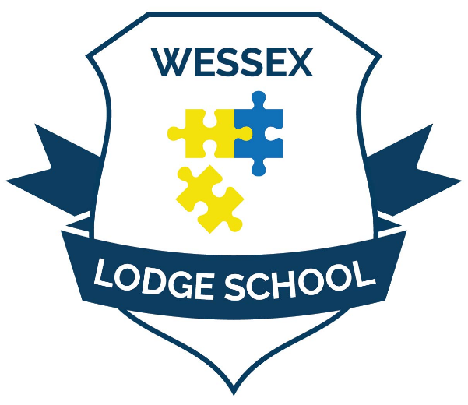

Wessex Lodge School Curriculum, Teaching, and Learning Policy

Be Safe
Be Kind
Be Respectful

Policy Number: | CO1 | Originator: | Bethany Vowles
Issue Number: | 3 | Authoriser: | Ben Coombes
Issue Date: | 01/09/2026 | Service Type: | Education
Next Review Due: | 31/08/2027 | Policy Location: | Wessex Lodge School Policy File

Contents Page
Executive Summary 3
Introduction 4
Intention 6
Implementation 9
Environment 9
Planning 13
Subjects 15
Impact 22
Assessment 22
Monitoring 24
Reporting 30
Independent School Standards 31
Appendix 1 32
Appendix 2 32

Executive Summary
The Wessex Lodge School Curriculum Policy sets out a broad, balanced and ambitious curriculum designed to meet the needs of students with Social, Emotional and Mental Health (SEMH) needs. Rooted in the principles of inclusion, high expectations and personalised learning, the curriculum aims to enable all students to make meaningful progress academically, socially, emotionally and personally.
Every student's Education, Health and Care Plan (EHCP) informs curriculum planning, intervention and support. A key feature of the school's approach is its "stage not age" philosophy, ensuring that learning is matched to developmental readiness rather than chronological age alone. This enables students to rebuild confidence, address gaps in learning and achieve success from their individual starting points.
The curriculum is delivered through three pathways: Attend (Enrichment), Attune (Vocational) and Attain (Attainment), providing a graduated framework that supports engagement, independence and academic achievement. Learning takes place across the school's specialist environments, The Hive, The Farm and The Ark, each offering distinctive opportunities that support students' progression from nurturing, highly structured provision towards increased independence and accreditation.
A strong focus is placed on literacy, numeracy, communication, personal development and preparation for adulthood. Alongside core academic subjects, students access a rich range of vocational, outdoor, creative and practical learning experiences designed to develop resilience, self-regulation, confidence and employability skills.
The impact of the curriculum is monitored through robust assessment, quality assurance and reporting systems, including STAR Assessments, Evidence for Learning, learning walks and annual subject reviews. Together, these processes ensure the curriculum remains responsive, evidence-informed and effective in preparing students for further education, employment and adult life while meeting the requirements of the Independent School Standards.

Introduction
At Wessex Lodge School, the safety, wellbeing and progress of our students are at the heart of everything we do. We are committed to providing every young person with opportunities to learn, explore, achieve and develop the knowledge, skills and personal characteristics needed for a successful future. Our curriculum reflects the belief that education should be ambitious, inclusive and responsive to individual need, ensuring that all students are able to experience success regardless of their starting point.
Wessex Lodge School is a specialist setting for children and young people with Social, Emotional and Mental Health (SEMH) needs, many of whom have experienced disruption to their education or barriers to learning within previous settings. SEMH needs can affect a student's ability to engage with learning, develop positive relationships, regulate emotions and access education consistently.[2] As a result, academic progress and personal development are viewed as equally important aspects of success within our curriculum.
Every student at Wessex Lodge School has an Education, Health and Care Plan (EHCP), which forms the foundation of their educational provision and informs decision-making across the school.[3] EHCP outcomes, identified needs and professional recommendations guide decisions regarding site placement, curriculum pathways, classroom groupings, therapeutic support and additional interventions. These plans are reviewed regularly by the SENCO and wider multidisciplinary team to ensure provision remains responsive to individual needs.
A key feature of our educational philosophy is our commitment to a "stage not age" approach to learning. Rather than being defined solely by chronological age, students are supported at a developmental and academic stage that reflects their current attainment, readiness for learning and individual circumstances. This flexible approach enables learners to rebuild confidence, address gaps in learning and experience appropriately challenging opportunities for success.
The unique environments available across Wessex Lodge School, including the Ark, the Hive and the Farm, provide diverse learning experiences that complement classroom learning and support student engagement. Therapeutically informed environments, trauma-informed practice, strong relationships and a culture of high expectations create the conditions in which students can feel safe, develop resilience and re-engage with education. Through this combination of personalised support, specialist provision and ambitious educational opportunities, the curriculum seeks to prepare students not only for qualifications and further education, but also for positive participation in their communities and adult life. This reflects the requirements of Independent School Standard 2.1, which requires the school to provide a written policy on the curriculum, and Standard 2.2(h), which requires schools to support pupils' personal development and preparation for the opportunities, responsibilities and experiences of later life.

Intention
Intention
At Wessex Lodge School, the curriculum is designed to provide a broad, balanced and ambitious educational experience that enables every student to achieve meaningful progress academically, socially, emotionally and personally. Recognising that many of our learners have experienced significant barriers to engagement and success within mainstream educational settings, our curriculum combines the academic expectations of the National Curriculum with specialist SEMH-informed approaches that prioritise participation, regulation, resilience and personal development.
Our curriculum aims to develop knowledgeable, skilled and self-aware young people who are prepared for successful futures in education, employment and adult life. In line with the Independent School Standards, it is carefully planned and adapted to meet the differing ages, aptitudes and needs of pupils, including those with special educational needs and disabilities. High expectations are maintained for all learners, while personalised pathways ensure that teaching, support and challenge are appropriately matched to individual strengths, interests and areas of need. This supports Independent School Standard 2(1)(b) by providing a curriculum that meets the needs of all pupils and 2(2)(h) through the promotion of personal development and wellbeing.
A key feature of our curriculum model is the use of three recognised pathways, which provide staff with a framework for understanding students' levels of engagement, readiness for learning and curriculum entitlement [Appendix 1]. These pathways ensure that educational provision remains responsive to the developmental, emotional and academic needs of each learner.
Enrichment Pathway: Attend
For students in the Enrichment pathway, the primary focus is developing the capacity to Attend. This extends beyond physical attendance at school and emphasises engagement with learning environments, routines, activities and relationships. Students are supported to build confidence in accessing educational experiences, establish positive learning habits and develop the foundational skills required for future academic success. Literacy and numeracy development remain central, but learning may be delivered through highly personalised approaches, practical activities and cross-curricular experiences rather than solely through discrete English and Mathematics lessons. The emphasis is on creating positive experiences of learning that increase confidence, participation and readiness for further challenge.

Vocational Pathway: Attune
Within the Vocational pathway, students are supported to Attune to the expectations, demands and opportunities of different learning environments. The curriculum helps learners develop flexibility, resilience and the ability to shift focus from preferred activities towards tasks that promote growth and achievement. Through vocational subjects, practical experiences and collaborative learning opportunities, students learn to engage with a wider range of adults, peers and settings while developing employability skills, independence and self-regulation. This pathway supports students in broadening their interests, discovering individual strengths and preparing for increasingly structured learning experiences.
Attainment Pathway: Attain
The Attainment pathway focuses on enabling students to Attain recognised qualifications and achieve their academic potential. Teaching and learning are structured around external accreditation requirements while maintaining appropriate levels of support, challenge and personalisation. Students follow programmes that provide clear progression towards qualifications that are both aspirational and achievable. Alongside academic success, the curriculum promotes independence, self-belief and future planning, ensuring that learners are equipped to progress confidently to further education, training or employment.
Central to all three pathways is our commitment to a "stage not age" philosophy. We recognise that students arrive with diverse educational experiences, interrupted learning and differing developmental profiles. As a result, learning is matched to students' current stage of development and attainment rather than chronologically determined expectations alone. Baseline assessments, diagnostic information, EHCP outcomes, engagement profiles and ongoing assessment inform curriculum planning and intervention. This allows staff to identify strengths, address gaps in knowledge and understanding, and provide targeted support that enables sustained progress over time.
Student engagement is recognised as a fundamental prerequisite for learning and achievement. Evidence suggests that motivation, interest and meaningful participation significantly influence attention, persistence and learning outcomes. Consequently, the curriculum is designed to be relevant, purposeful and engaging, enabling students to see value in their learning and develop positive attitudes towards education. Subject content is contextualised through practical application, enrichment opportunities, vocational experiences and real-world learning that connect with students' interests, aspirations and future destinations.
The curriculum is structured across the school's specialist environments to provide a coherent journey from engagement and exploration through to accreditation and future pathways. At The Hive, students benefit from nurturing provision enriched by regular access to The Farm, where learning is enhanced through animal care, horticulture, land-based education, Forest School and practical outdoor experiences. The Farm curriculum operates through a carousel model that exposes students to a wide range of vocational and practical disciplines, supporting the development of skills, interests and career aspirations. As students progress to The Ark, they are increasingly supported to specialise, make informed option choices and work towards recognised qualifications alongside a strong core curriculum in English and Mathematics. This graduated approach enables students to move confidently towards adulthood while maintaining access to broad and enriching learning experiences.
Across all sites and subjects, literacy, communication and numeracy are explicitly developed as fundamental life skills. Consistent individual targets, adaptive teaching and opportunities for application across different contexts ensure that students develop transferable knowledge and skills that extend beyond the classroom. The curriculum therefore supports Independent School Standard 2.2(a) through the development of speaking, listening, literacy and numeracy skills, 2.2(g) through effective preparation for adult life, and 2.2(h) through the promotion of pupils' personal development, self-confidence and wellbeing.
Ultimately, the intention of the Wessex Lodge School curriculum is not simply to secure academic achievement, but to re-engage learners with education, develop emotional resilience, foster independence and equip every young person with the knowledge, qualifications, skills and confidence needed to thrive in their future lives.
Implementation
Environment
At Wessex Lodge School, the learning environment is a fundamental component of the curriculum. Our provision is delivered across three distinct sites, each offering a different level of structure, independence, and specialisation. Together, they provide a coherent pathway through which students develop academic knowledge, emotional wellbeing, social understanding, and the skills required for adulthood. As students progress through the school, they are supported to build confidence, resilience, adaptability, and independence through experiences that are carefully matched to their developmental, educational, and SEMH needs. A visual overview of this pathway is provided in the Three Site Provision Model [Appendix 2].
Hive
The Hive provides a nurturing, primary-style learning environment designed to support younger learners and those requiring a high level of structure and relational support. Consistency of staffing, predictable routines, and strong relationships with trusted adults create the conditions in which students can develop emotional security, confidence, and readiness for learning. This supports Independent School Standard 2.2(1)(a) by providing full-time supervised education for pupils of compulsory school age and Standard 2.2(h) through the promotion of personal development and emotional wellbeing.
Each class is led by a dedicated class teacher, supported by an Education Support Worker, enabling academic learning and pastoral support to be closely integrated throughout the school day. Curriculum planning is overseen by Subject Leads to ensure progression in knowledge and skills, whilst class teams adapt learning to meet individual needs, EHCP outcomes, and developmental readiness. This adaptive approach ensures that the curriculum is appropriately tailored to pupils' ages, aptitudes, and needs, in line with Independent School Standard 2.1(b).
Particular emphasis is placed on the development of literacy and numeracy. Literacy is taught up to four times each week, with provision ranging from systematic synthetic phonics through the Rocket Phonics programme to reading comprehension, vocabulary development, speaking and listening, and writing. Reading Planet provides additional support and continuity across the wider school. Mathematics is taught through the White Rose Maths programme, supporting the development of fluency, reasoning, and problem-solving through carefully sequenced learning. Together, these approaches support Independent School Standard 2.2(a) by enabling pupils to acquire speaking, listening, literacy, and numeracy skills.
PSHE forms a significant part of the Hive curriculum, supporting students to develop emotional literacy, self-awareness, relationship skills, personal safety knowledge, and strategies for self-regulation. Teaching draws upon guidance from the PSHE Association and is closely aligned with students' social and emotional development. This contributes to Independent School Standard 2.2(d) by encouraging respect for others and 2.2(h) through the promotion of personal, social, and emotional development.
Alongside core subjects, students access a broad range of learning experiences that include Science, Humanities, Careers Education, Art, Home Cooking Skills, and practical vocational activities. Wherever possible, learning is delivered through meaningful and engaging contexts that encourage curiosity, creativity, and the application of knowledge across subjects. These opportunities contribute to the broad curriculum expectations outlined within Independent School Standard 2.2, which requires pupils to experience linguistic, mathematical, scientific, technological, human and social, physical, aesthetic, and creative education.
A key feature of the Hive curriculum is its focus on developing the foundations for future success. Through life skills activities, educational visits, and community experiences, students learn to communicate effectively, work collaboratively, solve problems, and apply their learning beyond the classroom. The Hive therefore provides the secure foundation from which students can begin to access increasing levels of independence and wider curriculum opportunities whilst supporting the preparation-for-adulthood principles embedded within Independent School Standard 2.2(h).

The Farm
To meet differing levels of readiness, the Farm operates two curriculum pathways. The curriculum is designed to develop academic competence alongside the organisational, social, and emotional skills required for successful participation in secondary education and beyond. In doing so, it supports Independent School Standard 2.2(h) through promoting pupils' personal development and preparation for their future lives.
Students following the class-based model benefit from a stable classroom environment led by a dedicated class teacher. This model provides continuity and predictability whilst maintaining access to a broad and balanced curriculum. Core subjects, including English, Mathematics, Science, Humanities, and PSHE, are delivered within the class base, with teaching adapted to individual learning profiles, EHCP outcomes, and social-emotional needs. This reflects the requirement of Independent School Standard 2.1(b) for the curriculum to take account of pupils' ages, aptitudes, and needs.
Literacy remains a key priority, with targeted interventions available through Rocket Phonics and Reading Planet where required. This graduated approach ensures students continue to develop the speaking, listening, reading, writing, and numeracy skills required by Independent School Standard 2.2(a). Through explicit and systematic support, students develop the functional literacy skills necessary for learning, communication, and participation in wider society.
Students additionally access a rotating programme of specialist subjects through the carousel, enabling them to experience a wider range of curriculum areas, specialist facilities, and practical learning opportunities whilst retaining the security of their main class base. This contributes to the breadth of educational experiences required under Independent School Standard 2.2, ensuring access to scientific, technological, creative, social, and physical learning opportunities.
For students demonstrating greater independence, the hybrid movement model introduces aspects of a traditional secondary school experience. Students begin moving between different learning environments and are taught by subject specialists for subjects such as English, Mathematics, and vocational pathways. This approach provides opportunities to develop organisation, resilience, self-management, and confidence whilst practising the transition skills needed for future educational settings. The model particularly supports Independent School Standard 2.2(h) through the development of independence, responsibility, and personal effectiveness.
Across both pathways, the Farm places a strong emphasis on exploration and preparation for future pathways. Vocational learning, specialist subject experiences, and increased responsibility support students to identify strengths, interests, and aspirations whilst continuing to develop academically. As a result, the Farm acts as an important bridge between supported learning and greater independence, ensuring students are equipped with the knowledge, skills, and personal qualities required for successful next steps.

The Ark
The Ark represents the most independent stage of the Wessex Lodge curriculum journey. Operating through a movement-based model, students follow individual timetables and move between specialist learning environments throughout the day. This structure mirrors the expectations of mainstream secondary schools, further education, and employment settings, providing meaningful preparation for life beyond school. The model directly supports Independent School Standard 2.2(h) through the promotion of personal development, self-management, and readiness for adulthood.
Students are taught by subject specialists across a broad and balanced secondary curriculum, including English, Mathematics, Science, Humanities, PSHE, and Physical Education. Specialist teaching enables greater depth of subject knowledge while ensuring learning remains responsive to individual SEMH and educational needs. This contributes to the requirements of Independent School Standard 2.2, which expects pupils to experience linguistic, mathematical, scientific, technological, human and social, physical, aesthetic, and creative education.
A distinctive feature of The Ark is its strong connection to the local community. Community-based learning opportunities are embedded throughout the curriculum to develop independence, social communication, travel confidence, and real-world problem-solving skills. These experiences provide practical opportunities for students to understand their responsibilities as members of society and support Independent School Standard 2.2(d) through encouraging respect for others, as well as 2.2(h) through preparation for life beyond school.
Students also continue to access specialist vocational and practical opportunities at the Farm through the Options programme. These courses utilise specialist facilities and provide pathways that align with individual interests, strengths, and career aspirations. Through this combination of academic study, vocational learning, and community engagement, students are supported to develop the qualifications, confidence, and independence required for successful progression into further education, employment, training, and adult life. This reflects the wider aims of Independent School Standard 2.1 and 2.2(h), ensuring that the curriculum effectively prepares pupils for the opportunities, responsibilities, and experiences of later life.

Planning for an SEMH Curriculum
Effective planning at Wessex Lodge School ensures that learning is ambitious, coherent and responsive to the social, emotional and mental health (SEMH) needs of our students. Planning frameworks provide consistency across sites and subjects whilst allowing teachers the flexibility to personalise learning, build positive relationships and respond to individual needs, interests and barriers to learning.
Long-Term Planning
Each subject has a Long-Term Plan (LTP), or Curriculum Map, which outlines the key knowledge, skills and concepts to be taught across the academic year. These documents provide an overview of curriculum progression and coverage, enabling leaders and teachers to ensure that learning is sequenced appropriately and that students are able to build upon prior knowledge and experiences over time.
Within the primary model, curriculum planning is organised according to students' developmental stage and learning needs rather than chronological age. This recognises the diverse educational experiences of students with SEMH needs and ensures that learning is appropriately scaffolded and accessible. Decisions regarding curriculum pathways are informed by STAR Assessment data, teacher observations, ongoing formative assessment and a detailed understanding of each student's strengths, needs and aspirations.
Long-term planning is designed to provide clear curriculum intent whilst remaining sufficiently flexible to accommodate the varying rates of progress, engagement and readiness for learning often seen within an SEMH setting. Long-term planning is designed to provide clear curriculum intent whilst remaining sufficiently flexible to accommodate the varying rates of progress, engagement and readiness for learning often seen within an SEMH setting. This reflects the expectations of Independent School Standard 2.1(b) by ensuring the curriculum takes account of pupils' ages, aptitudes and needs, including those identified within EHCPs.

Medium-Term Planning
Each unit or topic identified within the Long-Term Plan is supported by a Medium-Term Plan (MTP). These are developed by Subject Leads and provide a structured framework for teaching, identifying the key knowledge, skills, vocabulary and intended learning outcomes for each sequence of learning.
Whilst Subject Leads establish the curriculum content and progression, class teachers are empowered to determine the most effective methods of implementation for their learners. This reflects the school's commitment to a relational and adaptive approach to teaching, recognising that students with SEMH needs often require personalised strategies, flexible pacing, additional opportunities for overlearning and targeted intervention to achieve success.
Medium-Term Plans also support teachers in making meaningful connections between learning and the wider world. Where appropriate, Subject Leads identify opportunities to promote:
- Fundamental British Values
- Spiritual, Moral, Social and Cultural (SMSC) development
- Employability skills
- Digital literacy and the effective use of technology
- Environmental awareness and sustainability
These themes are woven throughout teaching and learning to help students understand the relevance of their education beyond the classroom and to support their development as responsible, informed and active members of society. This approach contributes towards meeting the requirements of Part 2 of the Independent School Standards, which promotes students' spiritual, moral, social and cultural development and preparation for life in modern Britain.
To ensure learning remains highly personalised, teachers use Medium-Term Plans alongside Education, Health and Care Plans (EHCPs), STAR Assessment Instructional Planning Reports and ongoing assessment information. This enables teachers to incorporate individual literacy, numeracy, communication, emotional regulation and EHCP outcomes into curriculum delivery, ensuring that all students can access learning and experience success from their individual starting points.
Planning across all subjects therefore combines a consistent curriculum framework with the flexibility required to meet the complex and changing needs of learners with SEMH needs, supporting both academic achievement and personal development.
By combining a structured curriculum framework with responsive adaptation, Medium-Term Planning supports compliance with Independent School Standard 2.2, ensuring pupils experience a broad range of linguistic, mathematical, scientific, technological, human and social, physical and aesthetic learning opportunities whilst making good progress according to their ability [Appendix 3].
Subjects
At Wessex Lodge School, we provide a broad, balanced, and highly engaging curriculum that is carefully designed to meet the diverse educational, social, emotional, and mental health needs of our students. We recognise that many of our learners have experienced barriers to education and may have previously found traditional classroom approaches challenging. As a result, our curriculum is built around providing meaningful, relevant, and accessible learning experiences that re-engage students with education and support long-term success.
The breadth of our curriculum is fundamental to our educational approach. Alongside core academic subjects, students have access to a wide range of vocational, practical, creative, outdoor, enrichment, and therapeutic learning opportunities. This enables every student to discover their strengths, develop confidence, and experience success in a variety of contexts. By combining academic achievement with personal development and wellbeing, we ensure that learning is both purposeful and motivating.
Across all subject areas, Wessex Lodge School adopts an evidence-informed approach that recognises the complex needs of students with Social, Emotional and Mental Health (SEMH) difficulties. Teaching is underpinned by research relating to metacognition, self-regulation, literacy, positive relationships, and engagement. Learning experiences are designed to build confidence, resilience, independence, and wellbeing alongside academic achievement, ensuring students are effectively prepared for their next stage of education, training, employment, and adult life. The Education Endowment Foundation identifies metacognition and self-regulation as among the highest-impact approaches for improving pupil outcomes when embedded within subject teaching.
The curriculum across all subject areas is designed to fulfil the requirements of Independent School Standard 2.2, which requires schools to provide experience in linguistic, mathematical, scientific, technological, human and social, physical and aesthetic and creative education. Assessment, curriculum monitoring and progress tracking are aligned with Independent School Standard 2.10, ensuring that pupils' performance is assessed, progress is monitored and information is used to inform future teaching and learning. The breadth of practical, outdoor and vocational provision available through the Farm and wider curriculum further supports engagement for pupils with SEMH needs while enabling them to access the full curriculum offer.
Art
Art is taught across all three Wessex Lodge School sites and provides students with a valuable opportunity to develop self-expression, emotional regulation, creativity, and confidence. The subject encourages students to explore a range of artistic techniques and media whilst developing their ability to communicate ideas, emotions, and experiences in a safe and supportive environment. At The Hive, Art is taught by a subject specialist who works closely with class teachers to ensure lessons are accessible and engaging for all learners. At The Farm, Art forms part of the carousel curriculum, enabling students to experience a wide range of creative opportunities throughout the year. At The Ark, students may choose Art as an option subject and can also access Art through enrichment activities, allowing them to further explore their creativity, build resilience through project work, and develop skills that may support future education and employment pathways.
Creative Technology
Creative Technology combines creativity, digital literacy, and practical technology skills to provide students with engaging and meaningful learning experiences. Delivered across The Hive, The Farm, and The Ark, the subject enables students to develop confidence in using technology alongside exploring music production, digital creativity, and collaborative working. Through team teaching with specialist staff, students learn technical skills whilst also developing communication, teamwork, problem-solving, and self-management skills. At The Farm, Creative Technology forms part of the carousel curriculum, ensuring all students have the opportunity to discover new interests and strengths within a structured and supportive environment.
Design Technology (DT)
Design Technology is a highly practical subject that promotes engagement, resilience, problem-solving, and employability skills. Students participate in projects that develop their understanding of design processes alongside practical woodworking and construction skills. Through the safe use of tools and equipment, students learn to plan, create, evaluate, and improve their work while developing perseverance and confidence when overcoming challenges. At The Hive, students have regular access to the DT workshop throughout the year. At The Farm, DT forms part of the carousel curriculum, whilst students at The Ark may choose DT as an option subject. The subject provides valuable opportunities for students to experience practical learning and to develop transferable skills that support future employment and independent living.
English
English is a core subject taught consistently across all three sites and forms a central part of the school's curriculum. The curriculum is designed to develop students' reading, writing, speaking, and listening skills whilst recognising the unique barriers to learning often experienced by students with SEMH needs. Medium Term Plans are developed centrally by the English Subject Lead and are adapted by teachers to meet the needs, interests, and abilities of individual classes. Planning is organised by key stage rather than year group, allowing greater flexibility for mixed-age and mixed-attainment cohorts.
The curriculum is informed by the National Curriculum and carefully sequenced to support students' confidence and progress without overwhelming them. Reading development is prioritised through regular assessment using Renaissance STAR Reading, alongside targeted interventions and personalised reading programmes. Writing and Speaking and Listening assessments are linked to termly topics and real-life contexts to promote engagement and meaningful communication. These regular assessment opportunities support the school's compliance with Independent School Standard 2.10, which requires schools to implement a framework for assessing pupils' performance and monitoring their progress.
Qualifications are available from Entry Level 1 through to Functional Skills Level 2 and GCSE English Language, ensuring students can access appropriate pathways and achieve recognised outcomes that support their future aspirations.
Forest School
Forest School provides students with opportunities to learn through exploration, challenge, and managed risk within natural environments. Delivered by trained staff across all three sites, Forest School supports the development of confidence, independence, teamwork, and emotional wellbeing. Activities encourage students to build resilience, improve problem-solving skills, and strengthen their connection with the natural world. The programme is particularly beneficial for students with SEMH needs, as it promotes self-regulation, positive relationships, and a sense of achievement. Specialist Forest School provision is available at The Hive and The Farm, while students at The Ark participate in two dedicated half-term blocks throughout the academic year.
Home Cooking Skills
Home Cooking Skills focuses on developing practical life skills that support healthy living, independence, and personal wellbeing. Students learn how to prepare and cook a variety of meals while gaining knowledge about nutrition, food safety, budgeting, and healthy lifestyle choices. The subject encourages responsibility, planning, and organisation whilst helping students build confidence through practical success. Home Cooking Skills is delivered at The Hive, The Farm, and The Ark, with Farm students accessing the subject through the carousel curriculum. At The Ark, students may also choose Home Cooking Skills as an option subject, where they can work towards a BTEC qualification, supporting both future employment and independent living.
Humanities
Humanities enables students to develop their understanding of the wider world through the study of Geography, History, and Religious Education. The curriculum encourages curiosity, critical thinking, empathy, and respect for different cultures, beliefs, and experiences. At The Hive and The Farm, Humanities is delivered through a topic-based approach, informed by planning from a subject specialist and taught by class teachers. The subject alternates with Science each half term, allowing students to engage deeply with key themes and concepts. Lessons are designed to make learning relevant and accessible, supporting students in making meaningful connections between their studies and the world around them. At The Ark, students also have the opportunity to study GCSE History as part of the options curriculum.
Information Technology (IT)
Information Technology equips students with the digital skills necessary for education, employment, and everyday life. Students develop their understanding of computer systems, online safety, communication technologies, and practical digital applications. At The Ark, IT is taught as a discrete subject with students working towards Digital Functional Skills qualifications where appropriate. Across The Hive and The Farm, digital skills are integrated through Creative Technology and collaborative teaching between subject specialists. The curriculum promotes responsible technology use whilst developing confidence, independence, and the digital literacy skills required in modern society.
Land Based Studies
Land Based Studies is a distinctive feature of the Wessex Lodge curriculum and offers significant educational and therapeutic benefits for students with SEMH needs. Through practical experiences involving animals, agriculture, horticulture, and environmental activities, students develop confidence, resilience, self-esteem, emotional regulation, and a greater sense of responsibility.
Research supports the positive impact of outdoor and animal-assisted learning for young people experiencing emotional and behavioural difficulties. A study by the Faculty of Health and Social Sciences at Bournemouth University found that participation in equine-assisted interventions led to significant improvements in self-esteem, mindfulness, resilience, and psychological flexibility in adolescents with mixed mental health needs. These findings align closely with the outcomes sought for many students within an SEMH setting and reinforce the value of practical, nature-based learning experiences.
Students at The Hive regularly access farm-based activities to build confidence and develop practical skills. At The Farm, Land Based Studies forms part of the carousel curriculum, whilst students at The Ark may choose the subject as an option and work towards a BTEC qualification. The subject provides an alternative pathway to success, supporting students to develop employability skills, responsibility, teamwork, communication, and independence.
Maths
Mathematics is taught across all three sites and provides students with essential knowledge and skills that support both academic achievement and everyday life. The curriculum aims to develop fluency, reasoning, and problem-solving skills whilst building confidence and reducing anxiety often associated with mathematical learning. Primary classes follow adapted planning based on the White Rose Maths programme, with subject specialists providing guidance and oversight to ensure progression and consistency.
Assessment is carried out regularly using Renaissance STAR Maths, enabling staff to identify strengths and areas for development and to provide targeted support where required. Teaching is carefully differentiated to meet the needs of individual learners and ensure students experience success and progress. Qualifications are available from Entry Level 1 through to Functional Skills Level 2 and GCSE Mathematics. Students who demonstrate strong aptitude in the subject may also access Further Mathematics qualifications.
Outdoor Education
Outdoor Education provides students with rich opportunities to learn beyond the classroom through practical, active, and experiential learning. Delivered through full-day sessions, the programme develops confidence, resilience, communication skills, and independence whilst promoting positive physical and mental wellbeing. Students engage in a wide range of activities that develop problem-solving, teamwork, leadership, literacy, numeracy, and planning skills in real-world contexts.
At The Hive and The Ark, students participate in Outdoor Education through dedicated half-term blocks throughout the year, while students at The Farm access the subject weekly. The programme supports students in developing perseverance, self-belief, and social skills whilst encouraging healthy lifestyles and positive engagement with learning.
Physical Education (PE)
Physical Education plays an important role in promoting physical health, emotional wellbeing, self-confidence, and positive social interaction. The curriculum is designed to encourage participation and enjoyment whilst helping students develop teamwork, resilience, leadership, and communication skills. The introduction of new gym facilities has significantly increased engagement and participation across the school.
The PE curriculum offers a broad range of activities throughout the year and makes effective use of on-site facilities, community sports venues, and outdoor spaces. This provision supports compliance with Independent School Standard 2.6, which requires schools to provide appropriate physical education opportunities that encourage participation and promote healthy lifestyles.
All students at The Hive and The Farm participate in weekly PE lessons, while students at The Ark access PE through dedicated half-term blocks. Students who demonstrate leadership potential may also work towards the Sports Leaders Award, developing coaching skills and supporting physical activity across the school community.
PSHE
Personal, Social, Health and Economic (PSHE) Education forms an integral part of Wessex Lodge School's wider Personal Development curriculum. Through a planned, progressive and protective programme of study, young people develop the knowledge, understanding and skills needed to manage their wellbeing, build positive relationships, stay safe, make informed decisions and prepare for adulthood. PSHE is delivered through a trauma-informed, relational and neurodiversity-affirming approach and works alongside RSHE, SMSC/Lifeskills, Careers Education and other Personal Development opportunities to support young people to thrive both within school and beyond.
Science
Science provides students with opportunities to develop curiosity, critical thinking, and an understanding of the world around them through practical investigation and enquiry-based learning. The curriculum encourages students to ask questions, explore scientific concepts, and apply their knowledge to real-life situations.
At primary level, students access adapted White Rose Science programmes taught by class teachers and overseen by the Science Subject Lead. At Key Stage 3, students engage in a structured discovery-based curriculum that promotes investigation, experimentation, and active learning. At Key Stage 4, students who are ready and engaged access a curriculum aligned to national qualifications. Teaching is adapted to meet the individual needs of learners, ensuring accessibility whilst maintaining high expectations. Students at The Ark may work towards GCSE Double Award Science as part of the options curriculum, providing progression routes into further study and employment.

Impact
Assessment
STAR Assessment
We use the Renaissance Place product STAR Assessment to track progress and attainment in students’ Reading and Numeracy. Every term there is a two-week assessment block where all students will complete their STAR Assessments. All students will complete the Maths assessment and either the Reading or Early Literacy Assessment depending on their reading levels.
Not only do these tests assess the levels of students, but they also create targets to support teachers in focused planning. After each assessment staff will download the targeted planning sheet and use this to support them in their teaching for the next term. The ‘Learning Progressions’ included by Renaissance Learn support student progress and focused teaching whilst also not increasing staff workload. This information means that the Medium-Term Plans provided by the Subject Leads are differentiated and targeted to support the support the requirements of Independent School Standard 2.10, ensuring that assessment information is used to monitor pupils' performance, inform planning and support good progress.
Evidence for Learning
Evidence for Learning allows us to evidence, assess, review and plan for meeting the unique needs of all of our learners. Evidence for Learning supports an ‘Inquiry-based approach’ to education and provision, that allows all stakeholders in a young person’s learning and development to gather photo and video evidence quickly and easily, linked to the individual’s profound curriculum. EFL also supports any assessment framework and any assessment model – including evidencing and tracking progress against individual learning intentions and targets related to EHCPs. EFL has transformed how parents/carers and the learner themselves are engaged and involved in the entire learning process and journey. The use of Evidence for Learning supports Independent School Standard 2.10 by providing a framework through which progress can be recorded, evaluated and used to inform future provision.
Internal Assessment
For students who are not currently accessing an externally accredited curriculum, progress will be assessed and monitored within each subject area to ensure that learning, engagement, and skill development are recognised and celebrated. This enables students within the Enrichment and Vocational Pathways to demonstrate progress and supports staff in identifying when students may be ready to access the Accreditation Pathway and begin working towards qualifications such as Functional Skills, BTECs, or GCSEs. Assessment processes are designed to be accessible and meaningful for students and to facilitate effective communication with parents and carers regarding progress and achievement.
Subject Leads are responsible for assessing and reviewing progress once per term. For subjects delivered through a carousel model, progress will be assessed and reviewed at the end of each carousel block. These assessment points will contribute to the school's monitoring and reporting cycle, ensuring that progress is tracked consistently across the curriculum.
For students working towards externally accredited qualifications, assessment will be based on the criteria and requirements of the relevant awarding body or qualification specification. Teachers will use these qualification-specific criteria to monitor progress, inform planning, and support students in achieving their accreditation outcomes. These assessment arrangements support compliance with Independent School Standard 2.10, ensuring that progress is monitored consistently across subjects and pathways.

Monitoring
Learning Walks
Senior Leaders undertake regular learning walks across all sites, with the aim of visiting every teacher at least once each half term. Learning walks are brief, informal visits to lessons, typically lasting no longer than 10-15 minutes, and form an important part of the school's quality assurance and professional development processes.
At Wessex Lodge School, learning walks are not used as a judgemental or compliance-driven activity. Instead, they are designed to provide a supportive and collaborative opportunity to explore how the curriculum is being implemented, how pupils are engaging with learning, and how classroom practice is responding to the complex social, emotional and mental health (SEMH) needs of our learners. In addition to curriculum implementation, leaders consider the extent to which lessons promote engagement, emotional regulation, positive relationships, participation, and sustained progress.
Each learning walk has a specific developmental focus linked to school improvement priorities, curriculum development, or identified areas of professional learning. Examples may include adaptive teaching, literacy across the curriculum, behaviour regulation strategies, communication and interaction, metacognition, or the effective implementation of subject-specific curriculum plans. Leaders also gather evidence of how classroom environments support pupils' emotional wellbeing and readiness to learn, recognising that engagement and regulation are often precursors to academic success for pupils with SEMH needs.
Following the learning walk, the observing leader meets with the teacher to engage in a professional dialogue about the lesson. Feedback is provided through reflective discussion and questioning rather than a top-down evaluative approach. This enables teachers to explain the rationale behind their decisions, reflect on the impact of strategies used, and identify areas of strength and future development. The process promotes professional trust, encourages reflective practice, and supports continuous improvement through collaboration.
The school's approach aligns with the principles outlined by Tom Sherrington (Teacher Head), who advocates for learning walks that are developmental, low-stakes, and focused on understanding teaching and learning across the school rather than making high-stakes judgements about individual teachers. Through regular and transparent implementation, learning walks have become embedded within the culture of the school and are viewed as a constructive mechanism for professional learning, curriculum development, and quality assurance.
Learning walk evidence contributes to wider curriculum evaluation and subject review processes. Findings are triangulated with pupil voice, work scrutiny, assessment information, attendance data, behaviour information, and other monitoring activities to build a comprehensive understanding of curriculum effectiveness. This enables leaders to identify strengths, respond to emerging needs, share effective practice, and ensure that the curriculum continues to meet the educational, social, emotional and developmental needs of all pupils.
Annual Subject Review Cycle
To ensure that the curriculum remains ambitious, relevant and responsive to the needs of our pupils, every subject undergoes a comprehensive review process over the course of the academic year. Each half term, a small number of subjects are selected for an in-depth review led by the Head of Education. This cyclical approach ensures that all curriculum areas receive detailed scrutiny and support, enabling Subject Leads to develop a secure understanding of strengths, areas for development, and the consistency of provision across all school sites.
The purpose of the review process is not simply to evaluate performance, but to promote continual improvement, strengthen subject leadership and ensure that the curriculum is having a meaningful impact on pupils' academic, personal and emotional development. Findings from subject reviews directly inform departmental action plans, professional development priorities and whole-school curriculum development.
The review process is informed by the principles of the Education Inspection Framework and focuses on how effectively the curriculum is designed, delivered and experienced by pupils. Particular attention is given to how subjects support engagement, attendance, resilience, self-regulation and academic achievement for pupils with Social, Emotional and Mental Health (SEMH) needs.
Each subject review is centred around four key areas:
Teaching
The teaching review focuses on the quality and consistency of curriculum implementation across the school. Learning walks and lesson visits are undertaken with the Subject Lead and staff delivering the subject across different classes and sites.
The review considers:
- Teachers' subject knowledge and confidence in delivering the curriculum.
- The extent to which lessons reflect the curriculum intent and medium-term planning.
- The use of adaptive teaching strategies to meet the diverse needs of pupils.
- Quality of questioning and discussion to deepen understanding.
- Staff understanding of common misconceptions and how these are addressed.
- The effectiveness of scaffolding, modelling and explanation.
- Classroom routines that support emotional regulation, participation and learning.
- The use of assessment information to inform teaching.
- Consistency of expectations across different classes and sites.
In an SEMH setting, effective teaching is evaluated not only through academic outcomes, but also through the extent to which staff create psychologically safe learning environments where pupils are able to engage, take risks in their learning and develop confidence.
Learning
The learning review focuses on the experiences of pupils and the quality of learning over time. Evidence is gathered through scrutiny of work, discussions with pupils and review of curriculum materials from across the Ark, Hive, and Farm.
The review considers:
- The quality and quantity of work completed over time.
- Curriculum coverage and progression through planned content.
- Evidence that pupils are building and retaining key knowledge and skills.
- How effectively feedback moves learning forward.
- The presentation and organisation of work appropriate to pupil needs.
- Opportunities for pupils to revisit and apply prior learning.
- Adaptations made to support engagement and success.
- Evidence of challenge for all learners.
- The extent to which pupils can articulate what they have learned and why it is important.
Whilst Subject Leads establish the curriculum intention through long and medium-term planning, classroom teachers retain professional autonomy in how learning is implemented to meet the needs of individual pupils. Therefore, reviews seek to evaluate whether intended learning outcomes are achieved while recognising that successful implementation may look different between groups of pupils.
Progress and Assessment
The purpose of assessment within Wessex Lodge School is to provide meaningful information that supports learning and curriculum development. During subject reviews, the focus is not on the volume of data collected but on how effectively assessment information is being used to improve outcomes for pupils.
The review considers:
- The clarity and suitability of assessment systems.
- The consistency of assessment practice across classes and sites.
- How assessment information identifies strengths, gaps and misconceptions.
- Whether assessment captures progress for all pupils, including those working below age-related expectations.
- How Subject Leads monitor progress over time.
- Use of assessment information to adapt planning and resource development.
- The accuracy and reliability of teacher judgements.
- How assessment supports ambitious curriculum pathways and accreditation outcomes where appropriate.
Particular consideration is given to recognising the often non-linear nature of progress for pupils with SEMH needs and ensuring that assessment systems are sensitive enough to capture small but significant steps in learning, engagement and independence.
Staff and Student Voice
Understanding the lived experience of those who teach and learn within each subject is an essential component of curriculum evaluation.
Staff voice is gathered from all colleagues who contribute to the delivery of the subject. Discussions focus on:
- Confidence in delivering the curriculum.
- Availability and quality of resources.
- Access to training and support.
- Assessment processes.
- Strengths and challenges within the subject area.
- Suggestions for future development.
Student voice is equally important in evaluating the effectiveness of the curriculum. Discussions with pupils focus on:
- Their understanding of what they are learning.
- Feelings of success and achievement.
- Levels of challenge and support.
- Relationships with staff.
- How the subject supports their future aspirations.
- Opportunities to develop confidence, independence and resilience.
In line with the school's SEMH ethos, student voice places significant emphasis on belonging, self-efficacy and emotional wellbeing alongside academic progress.
Subject Leader Review and Strategic Development
At the conclusion of each review cycle, Subject Leads produce a summary evaluation of their subject and present their findings to the Senior Leadership Team. This process encourages reflective practice, strengthens leadership capacity and supports Subject Leads in developing a strategic overview of their curriculum area.
Presentations typically include:
- Evaluation of curriculum intent, implementation and impact.
- Strengths identified through the review process.
- Areas requiring further development.
- Analysis of assessment and pupil outcomes.
- Findings from staff and student voice activities.
- Professional development needs.
- Short, medium and long-term improvement priorities.
The outcomes of subject reviews directly inform departmental action plans, school improvement priorities and staff development programmes, ensuring that curriculum development remains responsive, evidence-informed and focused on securing the best possible outcomes for all pupils.
This process supports compliance with Part 1 (Quality of Education Provided), Part 8 (Quality of Leadership in and Management of Schools) and Part 3 (Welfare, Health and Safety of Pupils), ensuring that curriculum leadership, teaching quality and pupil outcomes are regularly monitored, evaluated and improved.

Reporting
At Wessex Lodge School, regular reporting ensures that parents and carers are kept informed about their child's academic progress, personal development, engagement with learning, and wider achievements. Effective communication between home and school is particularly important within an SEMH setting, where progress is often measured through both academic outcomes and the development of social, emotional, and behavioural skills that enable successful learning.
Staff maintain ongoing records of student achievement, engagement, attendance, and personal development throughout each term. This internal monitoring enables leaders to identify strengths, address barriers to learning promptly, and ensure that appropriate support and challenge are in place for every student. Information gathered through lesson observations, work scrutiny, assessment activities, behaviour monitoring, attendance tracking, and pastoral support is reviewed regularly by education leaders to maintain high standards of provision and curriculum delivery.
Parents and carers receive a formal written report each term. These reports provide an overview of the student's progress across their curriculum subjects, highlighting achievements, areas of strength, levels of engagement, and next steps for learning. Reports also recognise progress in personal development, resilience, independence, communication, emotional regulation, and other key skills that support success both within school and beyond. The reporting process celebrates individual achievement while identifying clear targets to support continued progress.
Termly reports are supported by regular communication between school and home, enabling parents and carers to remain actively involved in their child's educational journey. Through this partnership, the school seeks to ensure that students receive consistent messages, appropriate support, and opportunities to build confidence and achieve success across all areas of the curriculum.
Information gathered through internal monitoring and termly reporting contributes to whole-school evaluation and curriculum development, ensuring that the curriculum continues to meet the academic, social, emotional, and developmental needs of all learners. This ongoing cycle of review helps maintain high expectations, supports continuous improvement, and ensures that the curriculum remains responsive to the needs of students within an SEMH environment. Reporting processes support Independent School Standard 2.10 through providing clear information about pupil progress and attainment, whilst also contributing to Part 8: Quality of Leadership and Management by enabling leaders to monitor the effectiveness of curriculum provision and outcomes across the school.

Independent School Standards
The curriculum, teaching and learning provision at Wessex Lodge School has been designed to meet all of the requirements of the Independent School Standards, particularly:
- Standard 2.1 – A written policy on the curriculum supported by appropriate plans and schemes of work.
- Standard 2.1(b) – Curriculum provision that takes account of pupils' ages, aptitudes and needs, including those with EHCPs.
- Standard 2.2(a) – Development of speaking, listening, literacy and numeracy skills.
- Standard 2.2(c-f) – Provision of scientific, technological, human and social, physical, aesthetic and creative education.
- Standard 2.2(g) – Opportunities for physical development and participation.
- Standard 2.2(h) – Promotion of pupils' personal development and preparation for adulthood.
- Standard 2.10 – A framework for assessing pupils' performance and monitoring progress.
- Part 3 – Welfare, health and safety of pupils.
- Part 8 – Quality of leadership and management.
Through these standards, the curriculum ensures that all pupils receive a broad, balanced, ambitious and therapeutic education that prepares them successfully for future learning, employment and adult life.

Appendix 1
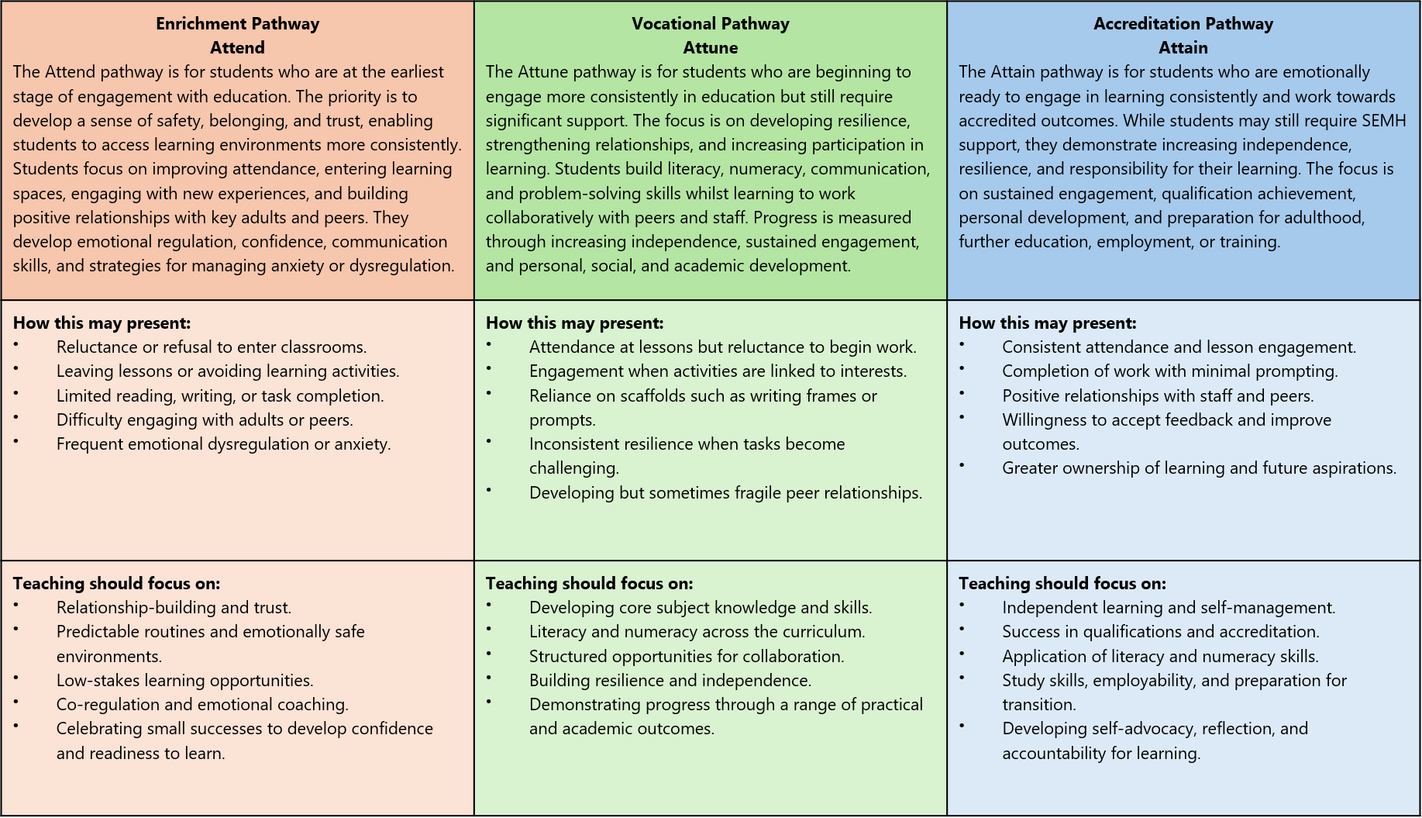
Appendix 2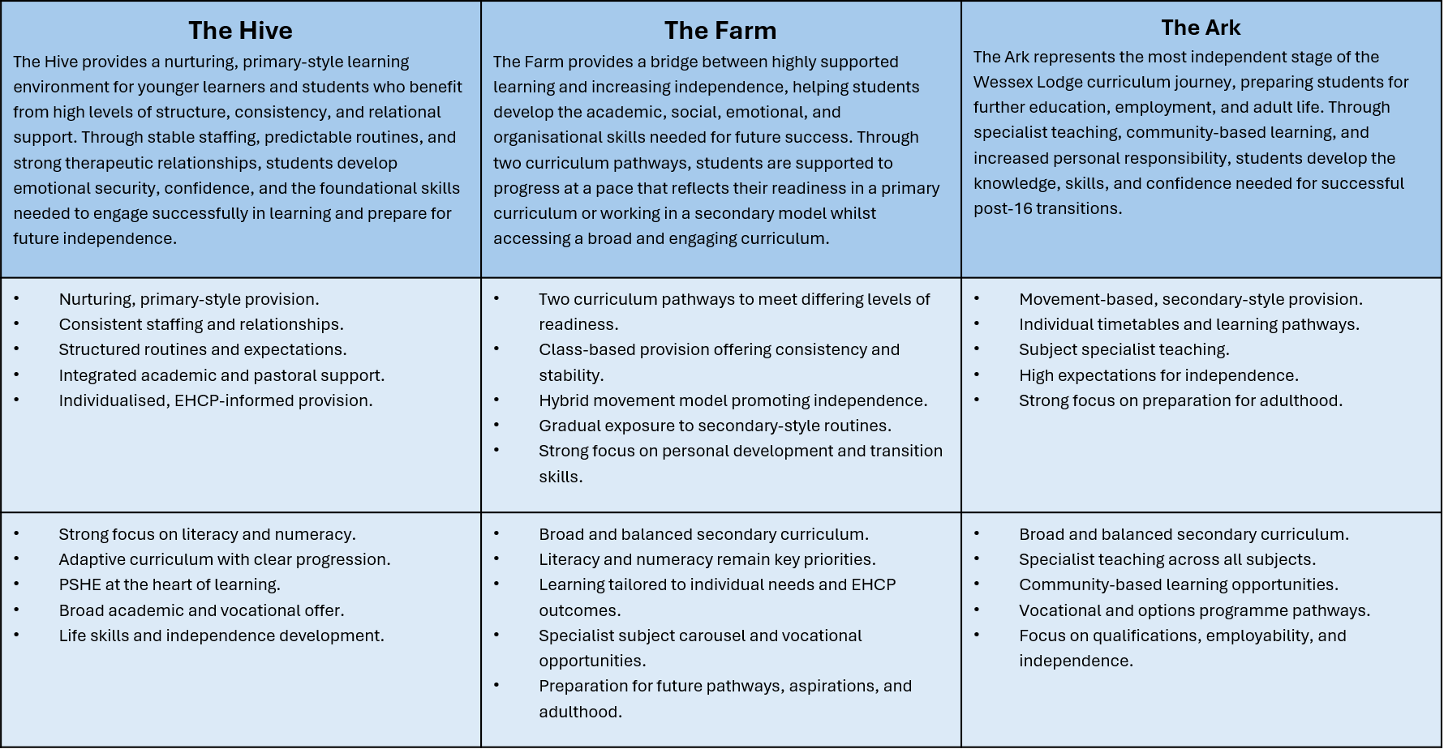

Appendix 3
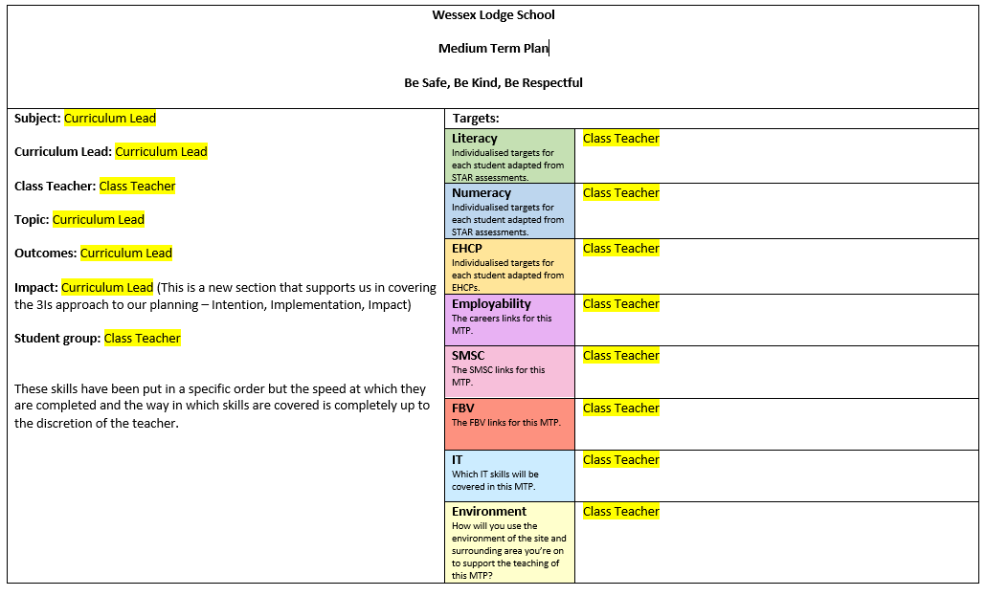
Equality Impact Statement
All relevant persons are required to comply with this policy and must demonstrate sensitivity and competence in relation to diversity in race, faith, age, gender, disability and sexual orientation. If you, or any other groups, believe you are disadvantaged by this policy please contact the Regional Director. Acorn Care and Education will then actively respond to the enquiry.
This policy was written by Bethany Vowles Date: 23/09/2026
Signed:

This policy is quality assured by Ben Coombes, Head Teacher.

Signed 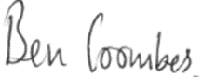
Date: 23/09/2026

Tes magazine https://www.tes.com/magazine/archive/stage-not-age-key-better-learning-specialist-schools Accessed on 22.2.24
Gov.uk Independent School Standards https://assets.publishing.service.gov.uk/media/69c3d64593cc6e8b87a6f636/Independent_school_standards_guidance_April_2026.pdf Accessed on 24.9.26
Education Endowment Foundation - Metacognition and Self-Regulated Learning | EEF Accessed on 24.9.26
Wilson, K. et al. (2019). A Study Exploring the Implementation of an Equine Assisted Intervention for Young People with Mental Health and Behavioural Issues. International Journal of Environmental Research and Public Health, Faculty of Health and Social Sciences, Bournemouth University.
Renaissance Learn https://www.renlearn.co.uk/star-assessments/learning-progressions-new-national-curriculum-england/ Accessed on 23.2.24
Evidence for Learning https://www.evidenceforlearning.net/ Accessed on 23.2.24
Sherrington, T. (2022). Making the Most of Learning Walks. Teacher Head. Accessed 24.9.26

